CalGary Mru lions club  charter night  When  October 6th  6pm (cocktails) 7pm (dinner)  Where  Lions Village  2528 Bowness Road Northwest Calgary  Guest Speaker: PID Lion Dr. Patti Hill  MC: Kevin Padillo | 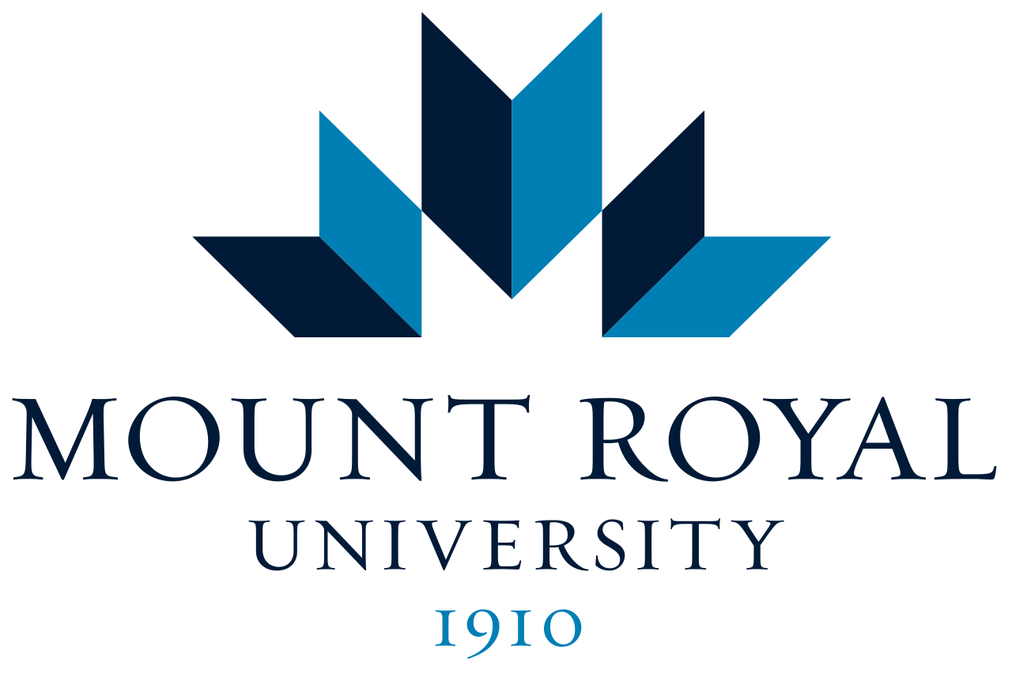  Tickets  $15 Students  $25 Non Students For tickets email: calgarymrulionsclub@gmail.com  In lieu of club paraphernalia, the club would be happy to receive monetary gifts.

