**MDC News (website version)**

*“****Where There's A Need There Is A Lion”***

**Report on Milan by PIP Judge Brian Stevenson**

Volume 1, Issue 1, July 2019

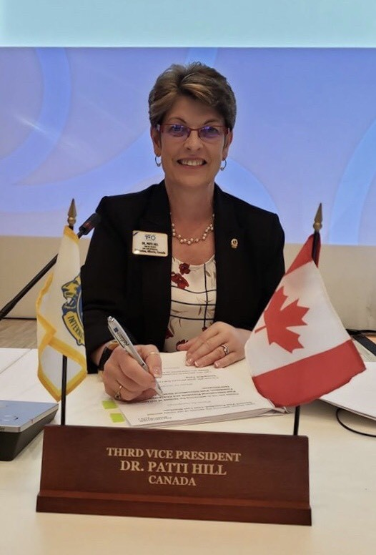"History happened in Milan on Tuesday, July 9th, when our own **Dr. Patti**

**Hill** was elected to the position of International Third Vice President of

Lions Clubs International. Patti is only the fifth Canadian to hold the

position and will proceed to the International Presidency on July 5, 2022 at

the 105th International Convention in New Delhi, India.

In Milan Patti received overwhelming support from the approximately

20,000 Lions and their families from around the world. The Milan

Convention saw a "sea of red' shirts with the emblem "Yes Patti" in the

International Parade of Nations held on Saturday, July 6th, and they

continued to be the dominant dress throughout the balance of the

Convention.

When Patti was nominated at the first Plenary Session by Past

International President Dr. Wing-Kun Tam of Hong Kong, the Milan MiCo

Convention Centre erupted with a huge demonstration - a demonstration

that lasted for at least ten minutes, with delegates from all over the world

waving Patti posters and chanting "Patti-Patti-Patti".

The demonstration would probably have continued for many more minutes but for the time limit imposed

by the Convention rules. And when the voting results electing Patti were announced on Tuesday

morning, the Centre was again filled with a deafening outburst of approval from delegates from all over

the world. It was a moment of unbridled joy for Patti and Greg (and their daughter Jessica), for the

several hundred Canadian Lions present, and for the vast majority of representatives of the more than

210 nations and geographic areas of our International Association. As many of the Executive Officers

and members of the International Board of Directors were heard to say: "Its a great day for Patti and

Greg, a great day for Canada, and, just as important, a great day for the Association".

Another great and happy event was held on Sunday evening on the Convention when hundreds of Lions

from all over the world came to our Canadian Reception to show their support for Patti.

It was also an opportunity for our Canadian Lions Family to thank **Tom and Gillian Gordon** for their

outstanding two years representing Canada on the International Board, and to Welcome **Past Council**

**Chairperson Allan and Sonja Hunt** from Chilliwack, British Columbia, who will represent us for the

next two years.

Great credit must be given to Patti's Campaign Committee, Chaired by Past International

Director Marvin Chambers from Saskatchewan (and his wife Lynne), and the following Campaign

leaders, all of whom worked countless hours organizing the huge Canadian and International volunteer

force, with a special mention to our great friends Past International Director Dave Hajny, his wife Lion

Marie, and Past Council Chairperson Ben Apeland, all from Montana, and our Committee members Past

International Directors Bill Webber from MDC, Carl Young from MD "A", Yves Leveille from MD "U", our

MD "C" Secretary Betty Ann Robson, our new MD Council Chairperson Pauline Cooper, and Past

District Governor Christine Lank.

Needless to say. many, many others made huge contributions leading up to and in Milan, and especially

our brothers and sisters from across our great nation. It will be great to see our Canadian Flag flying

frequently in front of our International Headquarters in Oak Brook, Illinois, USA for the next five years!"

Brian