 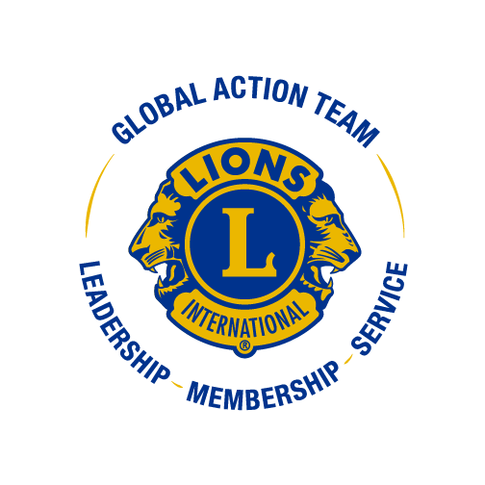

***PDG Jackie Miller, GLT District Coordinator***

August 5, 2024

District Governor Toni,

**Leadership Training**

* Held June 8, 2024 for this Lions Year
* Follow up trainings have been set for **September 19, 2024** in Troy, OH and **October 14, 2024** in Marion, OH – Flyers have been in the Pride Report to inform the Districts and gone out to the Zone Chairs for communication to all Lions.
* Next year’s leadership training will be held on **June 21, 2025** at Tolles Technical Career Center again.

**Zone Chair Training**

* Held on **Saturday, June 15, 2024** at the State Office - all but 2 zone chairs were in attendance. We have a great group of ZC’s this year. I will be attending as many zone meetings as my schedule allows this year.
* Next year’s training will be **Sunday, June 22, 2025** at the State Office
* I am available to all ZC’s for any assistance they need

I have put together a **Zone Portal training** for club officers to help them get around a bit in the new Lions website and will continue to let clubs know I’m available to help them with any issues they have finding their way around. We are all trying to learn this together, including many LCI employees.

At the State level, they had hoped to hold an Emerging Lions Leadership Institute (ELLI) in the fall, but that did not pass the Council of Governors at their August meeting. Maybe we’ll get something through for next year.

As always, I am available to anyone in the District who need my assistance for any training in their club or zone.

Yours in Lionism,

**PDG Jackie**