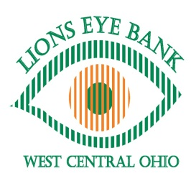
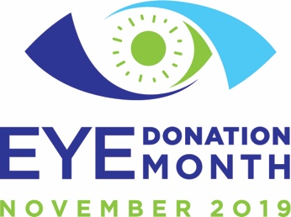

November is eye donation month! Since being proclaimed the first National Eye Donor Month in 1983, a member of Congress has annually read a proclamation into the Congressional Record to support eye donation. The Eye Bank Association of America (EBAA) promotes November as “Eye Donation Month” annually to raise eye donation awareness, honor donors, celebrate recipients, and acknowledge eye bank and physician efforts in the donation process. The EBAA, established in 1961, is the oldest transplant association and was formed by a group of ophthalmologists and eye bankers.

For Eye Donation Month 2019, the EBAA is focusing on all the individuals who make the gift of sight possible. Eye bank staff, funeral directors, medical examiners/coroners, hospital administrators, cornea donor families, and cornea recipients are the enduring champions for the millions of people around the world whose lives were transformed through cornea donation and transplantation.

Lions Eye Bank of West Central Ohio will once again join the EBAA in commemorating Eye Donation Month by bringing awareness to eye donation locally. One of our ongoing goals is to highlight the benefits of having an eye bank in our community and to educate the public on the importance of becoming an eye donor.

Lions Eye Bank of West Central Ohio continues to serve many of the Lions Clubs OH-5 county hospitals. This year through October LEBWCO has recovered over 50 donors for transplant, research, and education from those hospitals. There were two additional hospital/outpatient facilities added to our service area over the summer. Troy Hospital opened, as well as an Enon outpatient hospital. Nurse orientation was held for both of these facilities to provide education on cornea/eye donation.

Lions Eye Bank of West Central Ohio has received donations this year from a few different OH-5 Lions. We would like to thank you for your generous contributions. A detailed list of those Lions Clubs donations will be compiled and provided after the close of the calendar year. These donations are crucial in our efforts to fight blindness, both in our community and worldwide. Each Lions Club can designate how they want the donated money to be used. Examples of ways that the donations are used: keeping the technology of laboratory equipment in the eye bank up to date, allowing us to offer cutting edge transplant grafts; humanitarian funding for surgeries for patients in need; and/or programs and family services. Our efforts to serve the community are greatly enhanced through your donations and support of our organization and for that we thank you.

