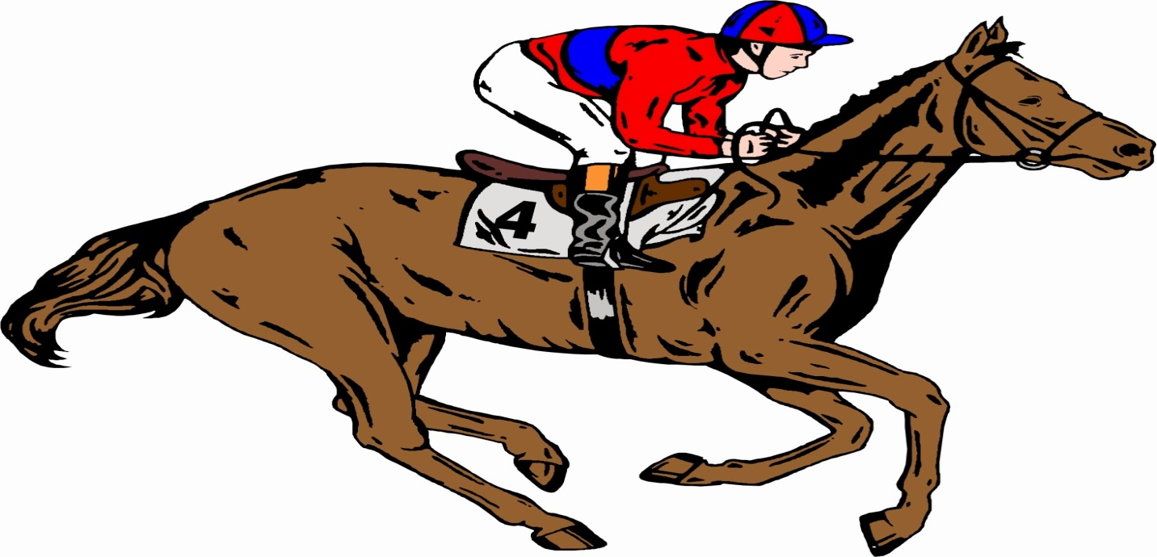
We're off to the Races - Horse Races that is, Planning for the 2021 OH5 District Convention at the Columbus/Worthington DoubleTree is underway and it will start off on Friday night with a Night at the Races. Buy a horse for $25/per horse, for one of the 8 races that night. (see attached flyer). Friday night fun: Free.
On Saturday morning we will start off with our business meeting, memorial service honoring those LIons we've lost this year, and of course enjoy great fellowship. Blue Frog will also be there along with several exhibit tables, and voting on issues and leaders for the incoming 2021 Lions year; and of course trying your luck on winning a raffle or two.
The cost of the full registration is: $75 and includes meals and all of the events of the convention. Of course there will be other options if you can just be there for lunch or dinner. Hotel rooms will be $85/+tax a night and includes breakfast. Ask for the Ohio Lions District OH5 rate.
Come for the fun, fellowship, and meet our International Guest ID Robert Block and his wife Brenda from Illinois,
Registration forms will be available soon on the OH5 website and in December Pride Report.
You can buy your horses though your Zone Chairs, Governor Team and Convention Committee members,
Looking forward to seeing you all soon.
Lion Jennifer Luttrell
Convention ChairCommittee Members: Lion Toni Gray Lion Amy Hawkins, Lion Linda Rosine, 2nd VG Debbie Luttrell and Lion Chris and Dennis Waller

