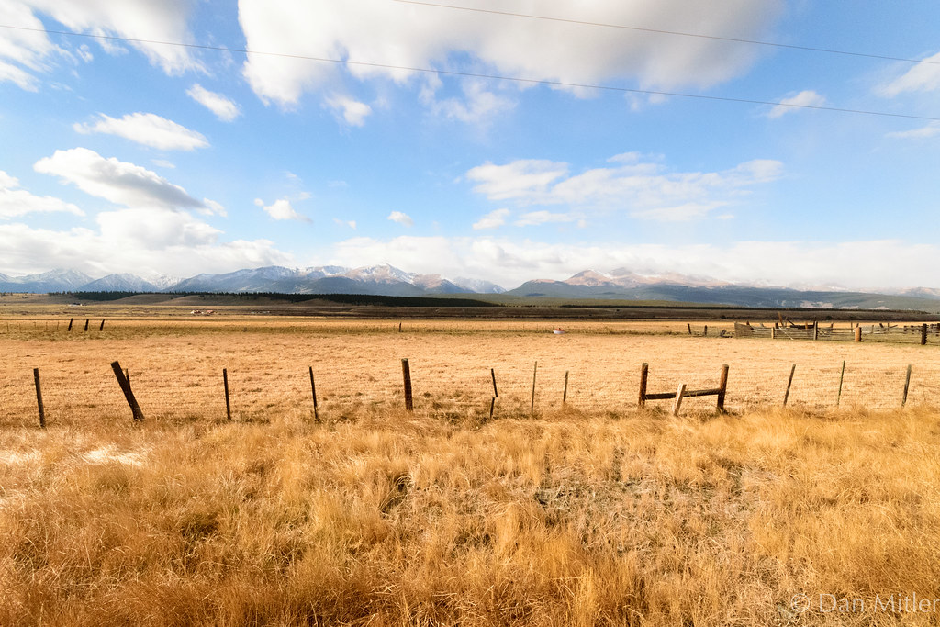

High Plains District Newsletter

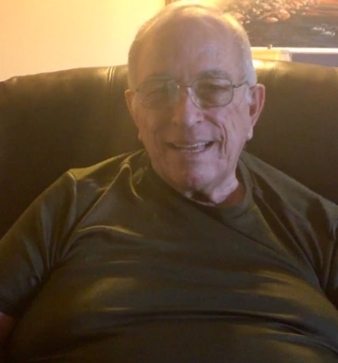
District 6-NE
District Governor Gary Sampson
Greetings Lions and Leos of 6 NE,
I am extremely excited and proud to be serving as your District Governor this year. Our district is filled with lots of great people, many I am hoping to meet for the first time. In this surreal year, our motto is still the same, “WE SERVE.” The ways we serve, might be adjusted to meet the new needs of our communities. I have been preparing for this year by observing Immediate Past District Governors Penn and Michelle and their stellar leadership.
“We are on the Brighter Side” is my motto, and I hope all the Lions of 6 NE will buy in to this. We have endured many challenges during the last year. It is a new year, and our communities are in need of the projects and services that Lions provide. Be willing to do a little more in life. Do not let uncertainty slow you down. The main thing is to keep active and help make the world a better place.
Let us embrace the time with our fellow club and district members. Because when we work together there is power. Where there is power, we can make more of a change. I think our time together brings a sense of friendship, which is powerful stuff too. Let others know what your club is doing, whether in our District newsletter, the district webpage, or some other source. We have Lions that are just looking for other club events to drop in on.
You voted me in as your Governor, PUT ME TO WORK!!! Let me know how I can help your club. I will try to respond to emails and texts in a timely manner. It is my job to help you succeed, but that is a two-way street, I may contact you for ideas or your help. We are always looking for new leaders to help our district remain vibrant and to maintain a line of succession.
I look forward to a special year ahead! We have the best Lions. We have a great cabinet. Go out there and challenge yourself!
Yours in Lionism,
Lion Gary Sampson | gary@sampsong.net, cell 970/215-5195 home 970/663-9392
District Governor Gary Sampson Bio
Gary became a Lion in 2013 joining the Loveland Lions Club. He has served the club as a Club Director, Club Secretary, Club Vice-President, and Club President. In addition, he has served as Membership Chair, Service Delivery Chair, and has been on numerous committees.
Gary served as Zone Chair, 2VDG, and 1VDG for District 6-NE before his selection as District Governor for District 6-NE for 2021-2022.
In his professional career, he was a law enforcement officer in Lawrence, KS; American Red Cross Staff Member completing his service in 2005 as the Senior Associate covering the western United States; and served as the Victim Services Director for the 8th Judicial District of Colorado before retiring in 2013.
He has been married 52 years to his high school sweetheart, Sherlyn. They have 2 children and 5 grandchildren.
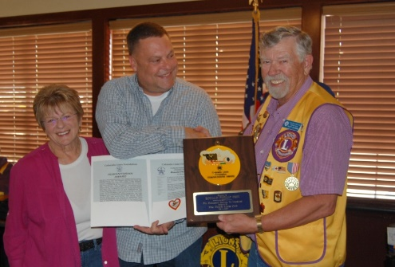
1VDG Scott Hayward Bio
Born 1952 in Omaha Neb. Moved to Montana after high school graduation Farmed and ranched with relatives Worked as an airplane mechanic In 1976 moved to Colorado to help start Colorado Precast Concrete. Moved back to Montana in 1982 and started Haywards Muffler, Brakes, Tires, and Quick Lube & PS Charter Montana. 1995 moved to Colorado to join Colorado Precast Concrete and purchased the company from family in 2005. Sold company in 2016. Married Penny in 1995. Together have 6 children (4 girls, 2 boys) 14 grandchildren, 3 great grandchildren. Scattered in Colorado, Roade Island, Nebraska, Montana and Wyoming. My interests are in new and old cars especially street rods and golfing.
2VDG Denise Clynes Bio
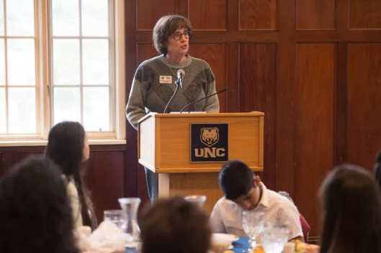
I am very proud, and humbled to be serving as one of the Lions International Vice District Governors of MD6, Colorado!
Colorado is my "adopted home" since 2014! After starting teaching swimming and lifeguarding at age 15, I went onto college (CSU Long Beach) where I received my BA and MA in Education and Administration. In 1975 I performed my student teaching in Orange County, CA and completed my 37+ years of being a teacher and administrator in the same school district (Garden Grove Unified School District) in 2012. While in Garden Grove, I became involved in city and county government and was honored to serve as Chairman of the Board for the Garden Grove Chamber of Commerce. I have been a Fort Collin Lion since 2015. I've served on various committees (Pancake Breakfasts, KidSight, Bingo, Club Communications, Ensight Board Member, Membership Chairman, Club Board Director and was elected as the FCL President in 2018-2019. I served as one of the 6-NE Zone Chairpersons in 2020-2021 and elected 2VDG in July, 2021! I love the Lions and really enjoy working our various projects! Best pancake breakfasts Colorado!!
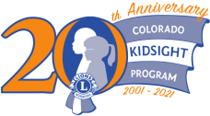

Colorado Lions KidSight Program
We are Celebrating! We are celebrating our 20th anniversary this year. Did you notice our new anniversary logo? During this time our KidSight Colorado program has screened more than 500,000 children and referred more than 50,000 to an eye doctor due to detection of a vision problem. Thank you, Lions of Colorado and KidSight Colorado volunteers, for your tremendous support. As part of our celebration, we will be holding celebrations in eight areas across the state - Fraser, Sterling, Loveland, Lamar, Pueblo, Durango, Grand Junction and Denver! We hope you can attend one of these celebrations near you! Invitations will be going out in the next few weeks and celebrations will occur from August through October. I hope that all Lions and KidSight volunteers will join us for food, Lion fellowship, a trip down the KidSight memory lane and a special thank-you gift for all who attend. We can’t wait to celebrate with you!
Save the Date for Celebrations in 6NE Friday October 8 4 pm - Loveland location TBA

The 2021-2022 Poster Contest Theme... “We Are All Connected”
• November 15: Postmark deadline for a club to send 1(one) winning poster to DG Gary Sampson
429 Red Sunset Place Loveland. CO 80538
6NE Photo Contest
Fellow Lions, I have a deal for you! When we started bringing back the district web page, I found a picture that somewhat represented the High Plains District, and it had a double rainbow. I thought it would be a good picture to put on our home page. Now it is a couple of months into the new year. It is time to find a picture that that is taken by a Lion. It needs to help members be proud to live and serve in the High Plains District.
Sounds like its time to have a photo contest! The winning picture will be used in the district’s branding. It will be used on the web page and with our new newsletter.
If you have a picture that sings “winner, winner, winner”, please forward your entry electronically (jpg, pin preferred) to the District Secretary, Michelle McGowen. Judging will begin October 1st. The prizes haven’t been determined but I am sure they will be value.

Ensight’s Halloween Eye Ball
The Eye Ball is Ensight’s annual fundraising gala. The Eye Ball is Halloween themed event that is held Friday, October 29th, 2021. This year will mark the 9th anniversary of the Halloween Eye Ball! The 2021, the Halloween Eye Ball will be held at the pop-up Rio Grande Mexican restaurant located at 125 S. College Avenue in Old Town Fort Collins. The event will be held on Friday October 29th from 6:30-10:00PM. We expect this year’s attendance to be approx. 120-140 people, but of course with the pandemic we aren’t able to guarantee that amount. The target audience for this year’s Eye Ball will be community leaders, local business owners/employees, local organizations, and those who share in our mission to provide people with low vision the tools, counseling, and training that empowers independent and productive living. We hope you will join us… if you dare.
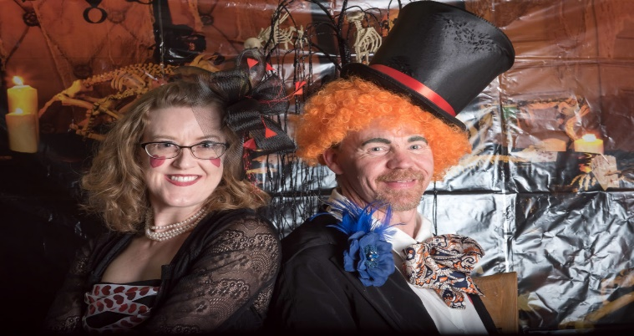

2021 Northern Co ChildhoodCancer Awareness Walk
125 Participants
20 Lion Volunteers
Raised 3350$ for Cure Search
5 cancer families came and represented their child
4 new children were added to our angel table
In accordance with ALL of the other cure search walks this month of September- a total of 30,000 was raised!!! This is a new record for Colorado.
6NE Childhood Cancer Chair Lion Kathleen Sullivan
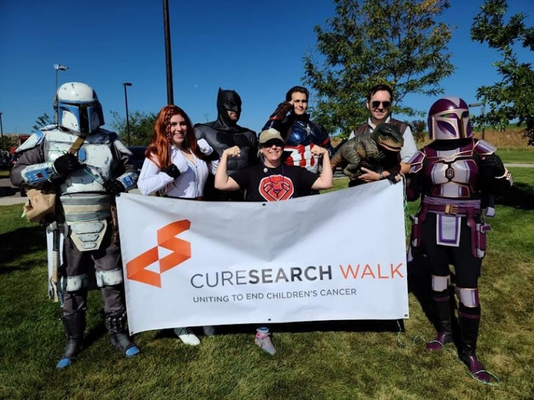

Colorado Lions Eyeglass Recycling Problem

Colorado Lions Clubs have been collecting used eyeglass for many years. Some 20 years ago, the Sterling Lions took on the job of processing these eyeglasses. Some of that processing has been done through collaboration with the Sterling Correctional Facility (SCF). At the beginning of the Pandemic, the SCF had to curtail processing. At this time, it is not clear when or if, the SCF will resume processing. Eyeglass collections have continued and there is currently an estimated 350,000 pairs of unprocessed eyeglasses in Sterling.
Inventory Problem: As mentioned above, 350,000 pairs of unprocessed glasses have brought the storage units to near capacity and Sterling is on the wait list for another unit. Even if processing were to resume at SCF or if clubs around the state were to process, it is not likely this backlog of glasses can be processed anytime in the foreseeable future. It appears that an organization in California called ReSpecs (www.respecs.org) could alleviate some of the backlog. Based on a review of their website, it appears they take a variety of used eyeglasses either for restoration or break down into individual commodities for recycling. Could this be an almost immediate outlet for some of the backlog of eyeglasses? Other places that recycle eyeglasses that may be able to use some of the Colorado backlog: New Eyes for the Needy, OneSight, VSP Global Eyes of Hope, Respectacle. The Alberta Canada Lions recycling center may be able to take a UHaul load. The book Pass It On: A Resource-Full Guide to Donating Usable Stuff may be helpful.
Processing Problem: It is not clear when or if the SCF will resume processing. Some clubs have indicated an interest in processing glasses (Gill, Gill Leos, Pueblo, Denver). The two lensometers owned by the Colorado program are currently on loan to clubs. If processing by clubs is going to be able to handle any significant volume, additional lensometers will be needed. Clubs will need to be able to sort, wash, sanitize, dry, read and box up for shipment to Sterling where they will be sorted by prescription. To minimize transport, Clubs could also do the final sort and package glasses suitable for shipping to Missions or to Feed the Children. Sterling would continue to receive orders and then ask Clubs that have final processed glasses to fulfil the order. Processing by clubs around the state may not be a viable long-term solution, but it can be enormously helpful.
Creating a Permanent Processing Center: Longer term, the Colorado Council of Governors may want to consider District level processing centers. Location in each District would be a key issue to be considered. Getting affordable space is probably the most difficult obstacle. LCI guidelines may be found at https://www.lionsclubs.org/en/search-results?keys=Lions+Eyeglass+Recycling+Center+%28LERC%29+Guidelines.
A center would need around 1000 to 1200 square feet of space, with heat, AC, water, bathrooms and electricity. Sterling is currently using about 600 square feet just for storage.

Training
There are several courses available that are offered during the year. Some are available after Cabinet meeting. Some are offered in Zone meetings. Let us know if you would like to have courses in your area.

I have charged the GAT to put together a training calendar. It will be published when it is finalized. If their specific topics you would like, please let us know

We will always support and encourage Lions to take advantage of virtual and on-demand learning opportunities such as (but not limited to):
Lions University - Provided by the Forum since 2014; you can take all the courses you want for free; however, graduation requirements do include attendance at events.
Lions Learning Center - LCI's online learning portal. Courses are available for club officers and for various topics. Check them out.
Lions Virtual - Ongoing Zoom educational and social activities, and a mobile app that incorporates social sharing and other resources.
Global Lions Forum - Facebook Group with great discussions on topics of interests to Lions.
DG Gary Sampson
Global Action Team
Leadership
6NE will be sending 2 to the PAUL BARBOUR LIONS LEADERSHIP INSTITUTE on October 15-17 Hosted by MD6 Council Chair Lion Holly Rutherford-Allen (Recent Faculty Development Institute Graduate). CC Lion Holly and her 6C team will train candidates from Colorado, Idaho, New Mexico, Utah and Wyoming with Lions Clubs International syllabus to train Lions for leadership growth.
Any Lion member in 6NE thinking about attending next year’s PAUL BARBOUR LIONS LEADERSHIP INSTITUTE, the District pays for application fee. Contact PID Lion Ken Schwols 970-669-5365
Membership
Total New Members – 24
FORT COLLINS: 1
FORT COLLINS POUDRE VALLEY: 3
GILL: 11
LOVELAND: 4
LYONS: 1
MTN LIONS OF RED FEATHER LAKE: 1
STERLING: 3
New Lions Club
Gill Millennials (148516) - Pending Charter
New Lions Club Branch
Counrtyland Lions

Service
People served 147,738
Diabetes 10,544
Environment 42,682
Childhood Cancer 10,734
Hunger 15,376
Vision 42,567
Other 25,835

To report your Club metrics, go to MyLion or send to IPCC Lion Michelle email:district6nesec@gmail.com

Club Brags

Red feather lakes
Our mountain Lions club celebrated the 4 th of July with the adding 8 names on the Monument in our Park
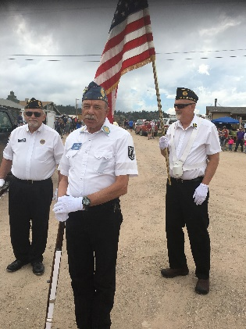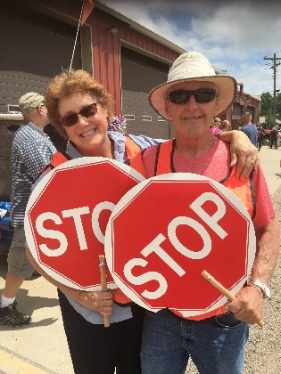

Holyoke Lions Club
Fishin' Hole marks 30 years in 2021. Lion Larry Stein, as one of the initial planners, dedicated countless hours to the pond. After his death earlier this year, a memorial bench was dedicated on May 29th.
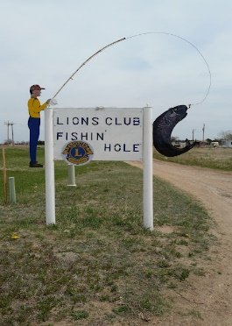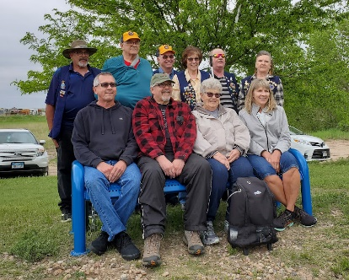

Fort Collins Lions Club
I was listening to the Dan Caplis program this afternoon and he had booked aguest, National Miss Amazing. Turns out, it was Savannna Overturf, who with her mother has played bingo with us for some time (they live in Loveland); we also had her as a speaker and have supported her at the Lions Camp. She presented herself very well on the radio. She came out on top of several hundred contestants. Her mother is now the National Director of the organization, as well. PDG Bob Kitchell
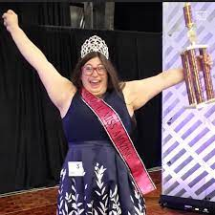

Akron Lions Club
Like most other clubs, the Akron Lions Club’s fundraising opportunities looked bleak when the pandemic hit. However, with the help of the community we’ve been able to adjust as needed and keep our fundraising level close to the same as years past.
Our initial fundraiser when the pandemic hit was the “Light It Blue” campaign in which we sold and installed blue light bulbs throughout the community in support of frontline staff and essential workers who were (and still are) confronting COVID-19 in hospitals, grocery stores, and other essential businesses in our community. It was great to see the blue light bulbs lighting up the Akron community and surrounding area. With the profits from this fundraiser, we were able to donate $4,000 to local businesses that had to shut down due to COVID-19!
Another new fundraiser born during the pandemic were “Cruise Nights”. All the people around town took their old cars out for a stroll and made stops along the way to pick up curbside to-go orders of various food and beverages. The Akron Lions cooked their famous Fair Burgers at four of these “Cruise Nights”.
Some of our typical fundraisers in 2020 were canceled, while we were able to continue with others. Our largest fundraiser each year is our Fair booth at the Eastern Colorado Roundup, where we serve burgers, brats, hot dogs, ice cream, pie, and various other refreshments. We were able to have our Fair booth in both 2020 and 2021, netting over $20,000 for the two years combined.
Other fundraisers that we’ve had over the past year and a half include the 2nd and 3rd Annual Lions Club BBQ Cook-Off and Beer Garden; Lions Club Garage Sale; Lions Club Golf Tournament; Lions Club Pancake Supper; Lions Club March Madness Sweet 16 Pool; and we cooked burgers for the Akron High School Homecoming football game and 8th Annual Akron Car Show.
Non-fundraising activities we’ve had include the Annual Lions Club Easter Egg Hunt; Senior Fruit Baskets; Friends of Lions Appreciation Dinner; setting out American flags for holidays; handing out candy bars for the Akron High School FBLA’s Trick or Treat on Main Street event; and cooking hot dogs for the Akron Public Library’s Summer Reading program and Akron Swimming Pool’s Free Swim and Food event.
In total, since the beginning of the pandemic, the Akron Lions Club has raised approximately $50,000 and gave the same amount back to the local community and various Lions Club causes. When times are tough, it feels good to be able to help out and give back.

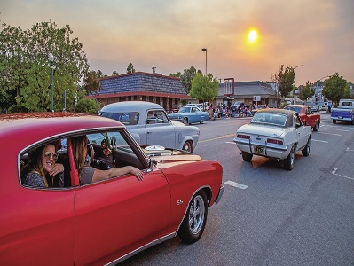

Loveland Lions Club
The Loveland Lions Club celebrated becoming one hundred years old (May, 1920) by having a Centennial Picnic, Train Tunnel Ribbon Cutting and Dedication at North Lake Park in Loveland.
For our 100 Year anniversary, a new tunnel was erected largely through donations secured by the committee chair, Scott Hayward. At our centennial picnic, the Loveland Chamber of Commerce hosted a ribbon cutting. The tunnel is a centennial gift to the Loveland community. The tunnel was dedicated “Hayward’s Mountain Tunnel elev 4,993’”. Everyone enjoyed a barbeque hotdog and hamburger lunch.
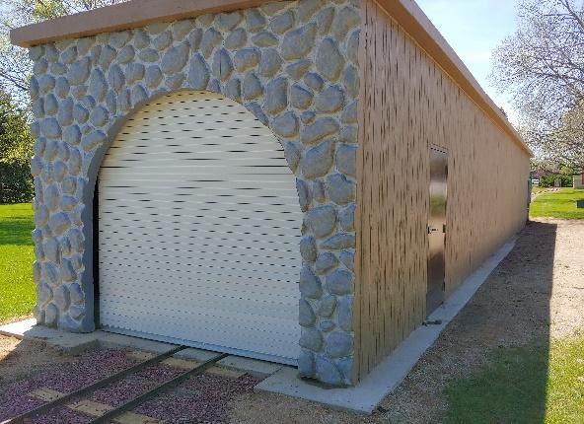
The club operated the Buckhorn Northern Railroad replica train all summer. Attendance is near normal levels and should be over 24,000 for the season. There was one record broken so far. The previous youngest rider was two weeks old. Now the youngest, and the most attentive (or not) was a three (3) days old baby.
In June we hosted our 20th annual Golf Tournament with around eighty golfers and 55 sponsors. The club also provided breakfast burritos and hosted a silent auction and provided lunch during the award presentation.
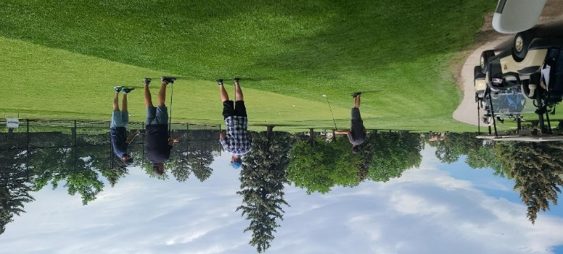
The club has been busy this spring & summer. In April 2021, we held our Timber Dan Toy Show, the largest toy show in Colorado. It had 190 tables of toys and collectibles. There were over nine hundred people in attendance. The Fall show is October 2nd and is held at the Larimer County Fairgrounds.
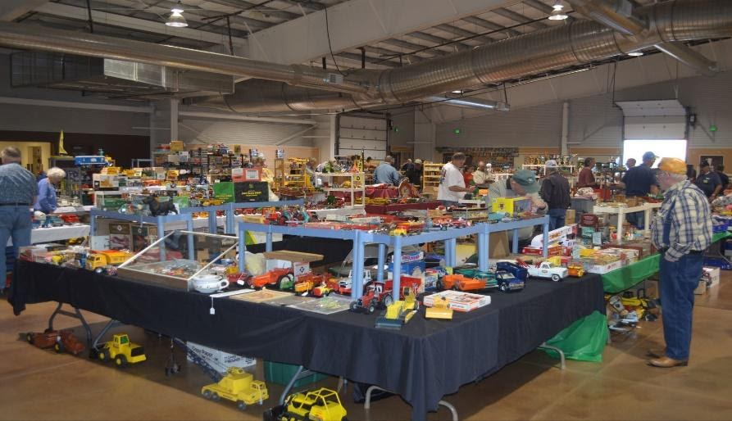
In July, the club served as “Parade ambassadors” for the Larimer County Fair Parade. Members in our yellow vests, greeted the public and distributed fair brochures along the parade route. In addition, the club had a pickup pulling our pancake trailer with club members and Leo’s marching in the parade.
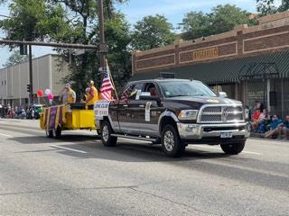
Our August activities included cooking pancakes for the Larimer County Fair Pancake Breakfast. The club was prepared to serve 1,000 but didn’t have that many attending.
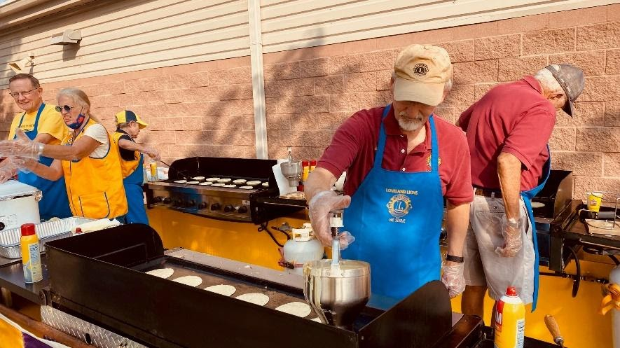
The club conducted a 3-day garage sale to support our Kenya Project. Proceeds support scholarships for orphaned or disabled Kenyan students. The scholarships cover room and board for the upcoming school year.
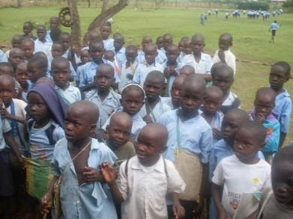
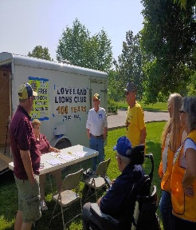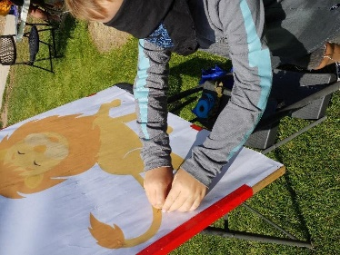
The club also hosted the first annual “Kids Vision Day in the Park. It consisted of several kid yard games (pin the tail on the Lion, cornhole, etc.) with carnival type prizes. KidSight screening for children 2 to 6 were provided. There were three referrals identified during the day. It was in the park near the train. There were 60 participants and outreach to over a hundred. The club will hold its’ annual picnic on August 30th. The club will be proving a rest stop for the Tour des Trees bike ride. It is a national ride that selected Colorado for 2021. The Tour des Trees is an annual long-distance cycling adventure which serves as the primary public outreach and community engagement event for Tree Research and Education Endowment Fund (TREE Fund). Since 1992, Tour des Trees riders have cycled through communities in the U.S., Canada and the U.K., planting trees, educating children and shining a light on the work done by arboriculture professionals and the importance of science-based tree care. They partner with Lions Clubs to increase awareness.
The club has added eight new members. Sadly, we have lost six members five of which were due to the death of long-time members. The last was a resignation by a long-time member due to his age. Resignation was accepted over everyone’s objections.
We meet the 1st, 2nd, 3rd, & 4th Wednesdays at noon at the Golden Corral in Loveland. All Lions have a standing invitation to join us.

District 6 NE Deceased Members
AKRON LIONS CLUB
LION DAVE SCHUTZ

FORT COLLINS LIONS CLUB
LION A LEE BROWN

LOVELAND DOWNTOWN LIONS CLUB
LION SHANNON WALDO
SOUTH WELD COUNTY L C LIONS CLUB
Lion LOIS LANTER

UPCOMING EVENTS
MD6 Council Meeting October 23rd Denver
6NE Cabinet Meeting November 6th Holyoke
MD6 Council Meeting January 29th Virtual
6NE Cabinet Meeting February 5th TBD
6NE District Convention April 22nd-23rd Loveland
MD6 State Convention May 13th-14th Canon City

