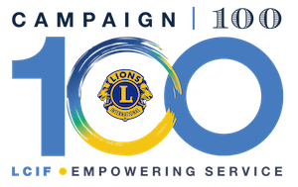

LCIF Donations
Donations can be made online at www.lcif.org/donate or they can be sent to LCIF.
Make checks or bank drafts payable to "LCIF." Write the purpose of the donation, such as "Melvin Jones Fellowship/recipient's name", "club plaque," "36 contributing memberships," "toward Melvin Jones Fellowship," etc. as well as “Empowering Service Fund” if designating for Diabetes.

In the U.S., it is best to send personal or bank checks. Checks should be sent to LCIF’s lock box address, not LCIF’s physical address.
All US checks drafted on a US bank should be sent to:
Lions Clubs International Foundation
Department 4547
Carol Stream, IL 60122
LCIF accepts charitable donations charged to Visa, MasterCard, American Express and Discover credit cards. Donations can be made safely and instantly online. We do not accept credit card donations over the phone. If you need assistance making your donation online, please contact Donor Assistance.
Standard processing time for a MJF is two to four weeks.
LCIF asks that donors give to the Empowering Service Fund, which is a donation to Campaign 100 and supports all of LCIF’s causes (INCLUDING DIABETES!) or the Disaster Relief fund, which is also a donation to Campaign 100, but reserved specifically for disaster relief. Unfortunately, LCIF is not able to accept donations to specific local projects.
For inquiries on previous donations, making a new donation or requesting recognition, such as a Melvin Jones Fellowship, contact Donor Assistance at 630-203-3836 or DonorAssistance@lionsclubs.orgsistance@lionsclubs.org

