Vision Screening RESULTS:

Child: _______________________________

Date Tested: _________________________

TEST RESULTS:
IF YOUR CHILD DID NOT PASS THE SCREENING:

What you should do:
- Make an appointment for your child with an eye doctor.

Options for follow up care:

- Passed and nothing more needs to be done at this time.

- Child is being referred.

❑ The following observations were made:
____________________________________
____________________________________
____________________________________

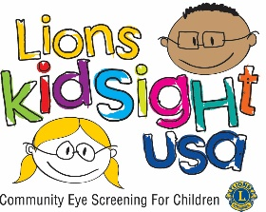

If you have a private Vision Insurance Plan – please check with your plan to find an eye doctor.
If you have BadgerCare Plus - please contact the BadgerCare Plus recipient hotline at 800-362-3002 for a list of eye doctors covered under your plan.
If you do not have a private vision insurance plan or BadgerCare Plus, Prevent Blindness Wisconsin may provide you a VSP voucher that will cover an eye exam and a pair of glasses.
Please visit Prevent Blindness Wisconsin at https://wisconsin.preventblindness.org/healthy-eyes-and-sight-for-students-applications-and-criteria/ for an application if:
- Family income is at or below 200% of poverty level
- Child is not covered by Medicaid or any other vision insurance
- Child is 18 years old or younger and has not graduated high school.
- Child or parent is U.S. citizen or documented immigrant with a social security number.
- Child has not used a voucher during the last 12 months.
Or, you may call Lions (NAME HERE) (715-XXX-XXXX) or (NAME HERE) (715-XXX-XXXX) for additional assistance.

Parent Follow-Up is Important!
Young children with eye problems often do not know that the way they see the world is not the way everyone sees it. Without early treatment, children’s vision problems can lead to permanent vision loss or learning difficulties.

