2021
Zone 1 Newsletter
Zone Chair: Ken Cain Phone: 250-545-2722
Email markencain@telus.net
UPCOMING CLUB, ZONE D1 AND DISTRICT EVENTS
April 10 Virtual Cabinet Meeting – anyone may
attend.
April 17 19D Virtual Spring Conference
Registration FREE
Must register at 19DLions@gmail.com
There are currently 67 registered, the goal is 100 so please register now.
June 3-6 Northwest Lions Leadership Institute
Harrison Hot Springs CANCELLED
IN CANADA FOR 2021
With the Canadian US border showing no signs of opening and Canada not allowing groups to gather, the disappointing decision has been made to cancel the NWLL at Harrison Hot Springs, BC June 3-5, 2021. Plans are being made to offer an Institute in Canada once the border is open and groups can gather again, although the location may not be the same as the prices have increased considerably.
Because Idaho is allowing groups to gather, there will be an Institute in Post Fall, Idaho at the Ross Point Camp and Conference Center for June 3-6, 2021

June 25-29
Online registration is officially open for LCICon 2021.
A once in a life-time opportunity to attend for $50US, no travel or accommodation costs. Let’s look at the bigger picture together. Now that it is April – the cost is now $75 US.
Officer Training Dates
There will be 3 dates for the officer training which is being put on by MD19. These are all virtual and will take place on Saturdays for approx. 4 hours. You only need to attend 1 of the training sessions, but are welcome to take in all if you wish. The dates are May 22nd, July 24th and September 25th from 8:30 AM to 12:30 PM. There will be more information coming on this. Please, all Presidents, Secretaries, Membership Chairs, and Club Administrators - take this opportunity to learn something new. There are always changes coming about and this is a great way to get that information.
ZONE Chair Ken’s message . . .
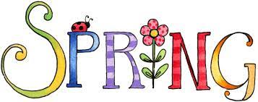
Spring is in the air. Birds are singing, grass is growing, and Lions in our Zone have a reason to be optimistic about returning to a somewhat normal year of meetings and activity with many of you already having your Covid shots. Just be extra vigilant because of the upswing in variant cases in our province. Continue to wear masks, social distance and limit outings and follow the rules re: number of people allowed at gatherings and non-essential travel.
Your club elections will be well underway. Don’t forget to forward a copy of your 2021-2022 Board of Directors to myself (ZC), Joe Nilles (DG), MyLionLCI (by April 15) and a hard copy by email or snail mail to MD19 (by
May 15).
Zone Meeting on March 21
A very successful zone meeting was held via zoom with 9 people representing 4 clubs present.
Membership within our clubs has decreased by 5 over the past year. Let’s all get busy and bring new members to our clubs.
Many club events have been cancelled this year however, I would like to congratulate all clubs for doing service work in their communities all year long.
Club visitations by zoom are happening. Please let me know the number of visits your club has made for the 2020-2021 year.
We are planning a BBQ year end zone meeting/awards in June – will keep you posted as time gets closer.
District Cabinet Meeting on Apr.10
Some tidbits of info from the Cabinet meeting include:
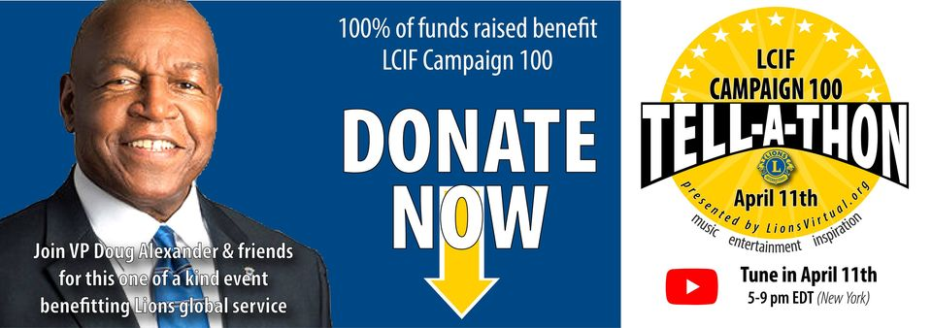
The Tell-A-Thon is Sunday, April 11, 2021 from 5-9 PM EDT (New York time). Watch the live Campaign 100 Tell-A-Thon on YouTube 2-6 PM here in BC.
One of the main concerns for most areas is lack of club reporting. Please learn how to report. It is recommended that each club appoint or have someone volunteer to be the Club Administrator. This person can take a huge load off of Secretaries and can report for the club as well.
Our Virtual Spring Conference on Apr. 17
I am sure you are all registered to attend the Spring Conference next week end. We do need you to register for the conference at 19DLions@gmail.com There is still time to get your name in – and it is FREE!!
- ZC Ken

Club Reports
Armstrong Lions Club
The Armstrong Lions have just purchased bingo equipment so that they can run online Bingos. They have received approval from BC Gaming and now they want to get the word out to let people know how to sign up so they can play. If you can pass this information on to anyone who enjoys bingo it would be greatly appreciated. The following webpage has been set up, please take a look and pass it on.
https://www.facebook.com/groups/1521241804748767
The first game was April 5 with a few things to work out but it went well.
Lumby Lions Club
The Lumby Lions Campsite is open for the season! We welcome Dale and Lisa Nicolls as our 2021 hosts. The 21 site campground is open April 1 - October 15. Phone 250-547-2005 for reservations
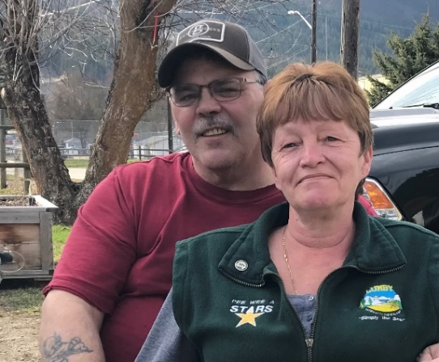
The Lumby Lions will award 4 - $1,000.00 scholarships to 2021 graduates from Charles Bloom Secondary School.
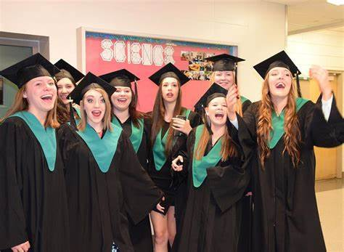
The Lumby Lions are celebrating Earth Day (April 22) by organizing a spring clean-up in the Village of Lumby.
Vernon Lions Club
Vernon continues to assist those in need. Lion Brian Barnett assists weekly with Red Cross and Habitat for Humanity, Lion Bobbe MacKenzie assists weekly with feeding those in need at the Vernon Mission, and driving seniors to appointments. Lion Marnie MacKenzie collects bottles and cans and pull tabs, Lion Mike Smith collects glasses at various outlets.
Other Lions also collect bottles and cans and drop off for the Vernon Lions account at the bottle depot.
We have our monthly executive meeting and General meeting by Zoom. Our visitation committee continue to contact those Ill or alone during this time to let them know we are here if they need us. We hope in April to start the preparation for our September golf tournament, Guide Dog fundraiser in July and Carnation Sales in October. We are also in hopes that we will get our food truck out to assist other Charities soon.
Our new board members have been selected and reported to LCI. They will be officially elected on April 18 at our General zoom meeting.
June Cole received an award from LCI for bringing 2 members into the club. Carole Kelly, Ken Cain and Nick Shaigec received Campaign 100 pins.
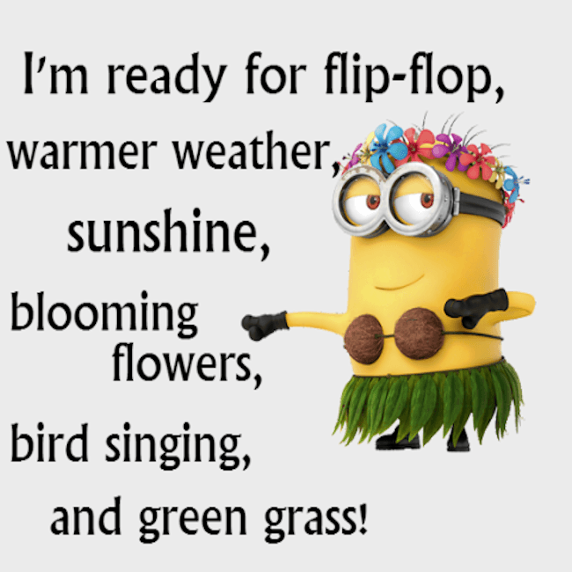

District Cabinet contacts:
District Governor: Joe Nilles
509-669-6766 Email: lionjoed2@gmail.com
1st Vice District Governor: Joyce Stevens
509-670-7527 Email: jstevens98826@gmail.com
2nd Vice District Governor: Debbie Allan
250-554-1498 Cell: 250-319-4293
Email: dandballan@telus.net
Cabinet Secretary: Jeanette Britton
509-548-1947 Email: brittonjeannette@gmail.com
District D Bulletin Editor: Shelley Costello
509-881-5103 Email: shelan1437@aol.com
District D Website Editor: Sharon Cain
250-545-2722 Email: sharoseh43@gmail.com
Websites:
MD19 https://lionsmd19.org
District D https://e-district.org/sites/19d
LCI https://lionsclubs.org
Border Crossing https://lionsmd19.org/newsletters.php
Armstrong Lions Club
https://e-clubhouse.org/sites/armstrong/
Enderby Lions Club https://enderbylionsclub.org/
Lake Country/Winfield Lions Club
www.lakecountrylions.com
Lumby Lions Club
https://e-clubhouse.org/sites/lumby_bc/
Vernon Lions Club
Https://vernonlionsclub.ca

