2021
Zone 1 Newsletter
Zone Chair: Ken Cain Phone: 250-545-2722
Email markencain@telus.net
UPCOMING CLUB, ZONE D1 AND DISTRICT EVENTS
Officer Training Dates
May 22 – contact tsmarsh@arr.net to register. State your name and club.
There will be 3 dates for the officer training which is being put on by MD19. These are all virtual and will take place on Saturdays for approx. 4 hours. You only need to attend 1 of the training sessions, but are welcome to take in all if you wish. The dates are May 22nd, July 24th and September 25th from 8:30 AM to 12:30 PM. There will be more information coming on this. Please, all Presidents, Secretaries, Membership Chairs, and Club Administrators - take this opportunity to learn something new. There are always changes coming about and this is a great way to get that information.
Online registration is officially open for LCICon 2021.
A once in a life-time opportunity to attend for $50US, no travel or accommodation costs. Let’s look at the bigger picture together. Now that it is May the cost is $75 US.
June (date to be determined) – award BBQ for presidents and secretaries of Zone 1. Watch your email for details.

ZONE Chair Ken’s message . . .
Congratulations to DGE Joyce Stevens, 1st VDGE Debbie Allan and 2nd VDGE Mike Livingstone on their election at the District 19–D spring conference, April 17, 2021. And Kudos, as well, to DG Joe Nilles and his entire convention team on a terrific spring conference!
Looking with optomism that the Covid situation keeps improving and as has been suggested that by July we may see things a bit more “pre-covid” normal. Zoom is fine but there is nothing like a great in-person meeting. Hopefully come fall, we will be able to get our Vision Screening program running in the schools.
Don’t forget the Officer training dates. It is important for all officers to attend the training, especially membership chairs as there has been a significant drop in membership in our clubs.
Thank you to the clubs who have reported regularly for this newsletter. It keeps us in touch and gives us ideas of what is working in other clubs.
Thank you all Secretaries and/or Club Administrators for your significant improvement in reporting membership and activities to LCI. Our zone is looking good.
Keep safe, keep well and keep on keepin’ on.
- ZC Ken
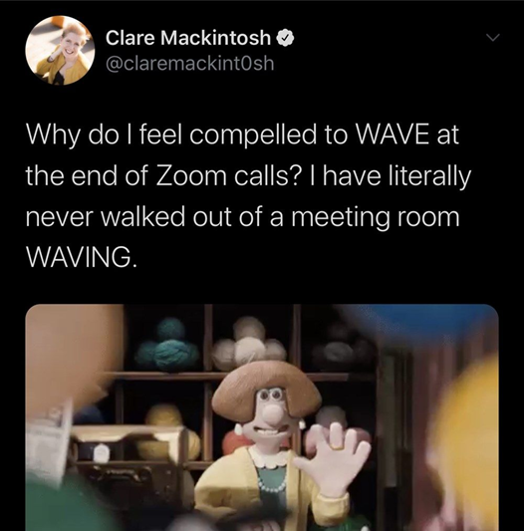

Club Reports
Armstrong Lions Club
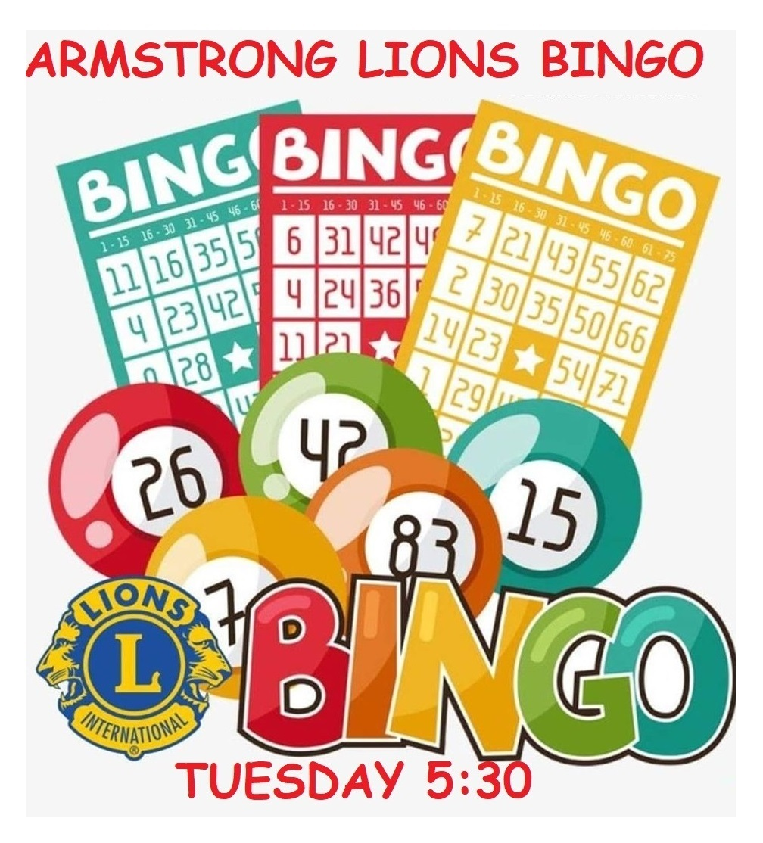
Our club has gotten our bingo machine up and running and we have held 6 successful bingos and our numbers continue to climb and our members are being trained on helping on our Tuesday night game.
Five of our Lions members volunteered their time at the Canadian Blood Service Clinic in Armstrong in April and May.
Lake Country Lions Club
April 24 - Community Clean-up Project: 18 Lions donated a total of 46 hours to clean up Winfield Memorial Hall grounds and parking lot. We collected two bins of garbage and cuttings. This was part of the Lake Country April Clean-up Drive.
Three Lake Country Lions have been consistently donating 9 hours per week (90 hours) at the Lake country Food Bank, collecting and delivering to the community.
One Lion, Bev Sorenson, has received $700 donation from the Lake Country United Church Thrift Store, and has created 12 gift baskets to been given to Healthcare workers in our community.
On other matters: We have committed to a clean-up project at Camp Winfield, but our preferred date, May 29, is booked for a rental. New date yet to been determined.
Our next project is Lake Country Cemetery Clean-up on June 12. We have also been developing a project to map the interned.
Lumby Lions Club
The Lumby Lions held an outdoor election and general meeting on April 11, 2021 at the Lumby Golf Course. President Mike Takahashi presented Lion Verne Abney with the prestigious Diamond Centennial Award. Congratulations Verne!
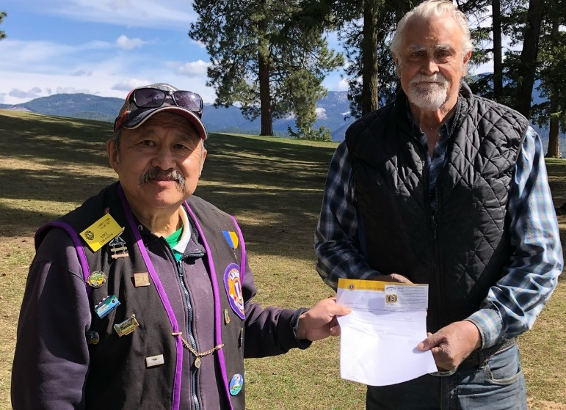
On Earth Day April 22, 2021, Lions Elsie Campbell, Rhea Abney, Linda Vlasveld, Verne Abney, Dave Stark and President Mike Takahashi cleaned up garage within the Village of Lumby. The 2021 Charles Bloom High School graduates assisted, along with Mercer Forestry Services and the general public.
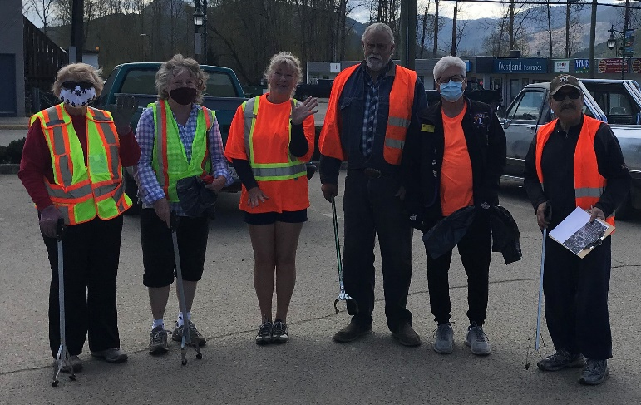
Vernon Lions Club
The Vernon lions continues to hold Zoom meetings each month, Executive and General.
Many Lions have volunteered their time collecting and adding to our funds at the bottle depot.
Lion Brian Barnett is busy again volunteering at the Red Cross and RCMP as well as being an ambassador for the Rail Trail, a true Lion.
Lion Bobbe Mackenzie is also busy being a true Lion volunteering at the Upper Room Mission, Towne Cinema fund raiser, Abbeyfield House and working the Hotline for AA and Addiction, wonderful causes.
Lion Marnie continues to pull those tabs off cans contributing to a great cause.
Lion Eric and Lion Al along with the President are working hard on developing an on-Line Auction for the Ducks for Dogs fundraiser. You will soon be able to track items being collected on our facebook page:
www.facebook.com/Vernon-Lions-Club-Vernon-BC
Lion President Sharon has been working hard on a new website for the Vernon Lions. The new address is:
https://e-clubhouse.org/sites/vernon_bc
Lion Ralph continues to collect from his area bottles and cans for our bottle fund, Lion Ralphs collection alone allowed us to make a $700 donation to Diabetes. The bottle collections do add up for those in need.
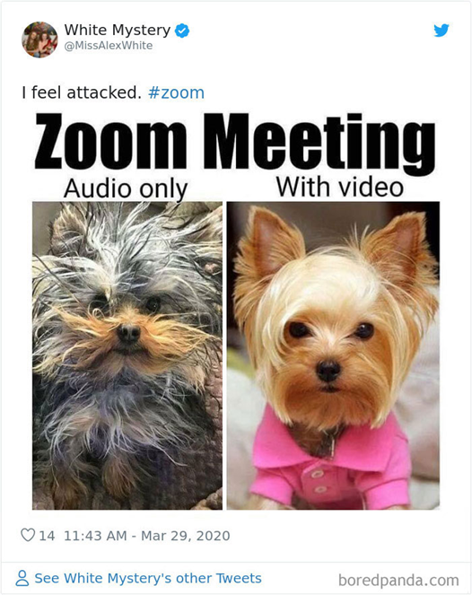

District Cabinet contacts:
District Governor: Joe Nilles
509-669-6766 Email: lionjoed2@gmail.com
1st Vice District Governor: Joyce Stevens
509-670-7527 Email: jstevens98826@gmail.com
2nd Vice District Governor: Debbie Allan
250-554-1498 Cell: 250-319-4293
Email: dandballan@telus.net
Cabinet Secretary: Jeanette Britton
509-548-1947 Email: brittonjeannette@gmail.com
District D Bulletin Editor: Shelley Costello
509-881-5103 Email: shelan1437@aol.com
District D Website Editor: Sharon Cain
250-545-2722 Email: sharoseh43@gmail.com
Websites:
MD19 https://lionsmd19.org
District D https://e-district.org/sites/19d
LCI https://lionsclubs.org
Border Crossing https://lionsmd19.org/newsletters.php
Armstrong Lions Club
https://e-clubhouse.org/sites/armstrong/
Enderby Lions Club https://enderbylionsclub.org/
Lake Country/Winfield Lions Club
www.lakecountrylions.com
Lumby Lions Club
https://e-clubhouse.org/sites/lumby_bc/
Vernon Lions Club
Https://vernonlionsclub.ca

