2021
Zone 1 Newsletter
Zone Chair: Ken Cain Phone: 250-545-2722
Email markencain@telus.net
UPCOMING CLUB, ZONE D1 AND DISTRICT EVENTS
June 13, 10 AM – award BBQ for presidents and secretaries of Zone 1.
VERY IMPORTANT: Officer Training Dates
July 24 – Officer Training – contact tsmarsh@arr.net to register
Sept. 25 – Officer Training – contact tsmarsh@arr.net to register.

ZONE Chair Ken’s message . . .
On June 13, members of the clubs in my zone gathered at my home for an end of year BBQ. Presentations were made for President of the Year, Secretary of the Year and a Club Visitation award.
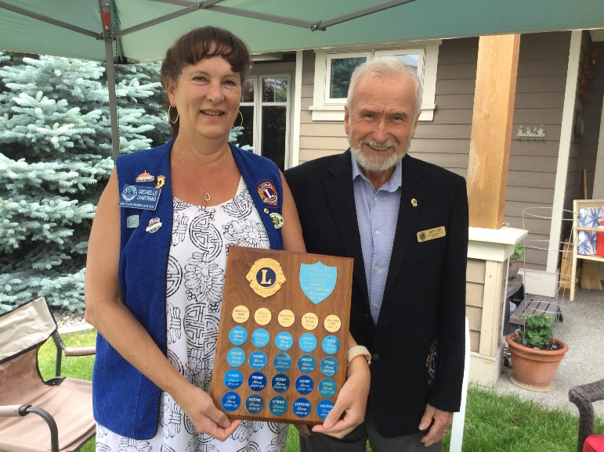 Michele Chartrand accepting the Visitation award for Lake Country Lions.

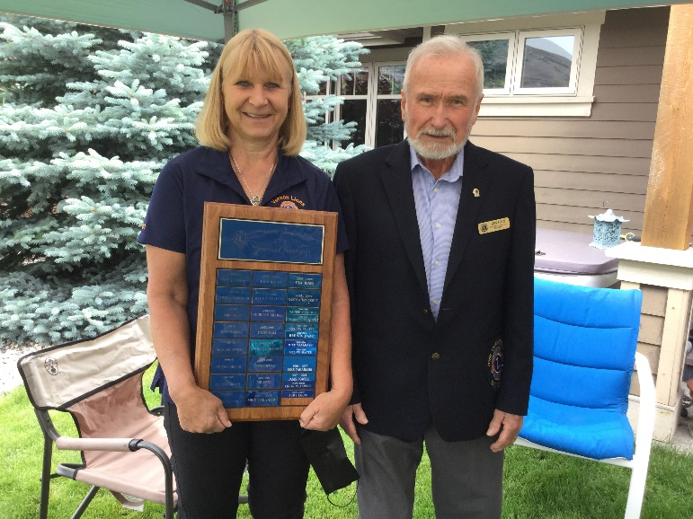
Judy Louis,Vernon Lions Cllub - Secretary of the Year
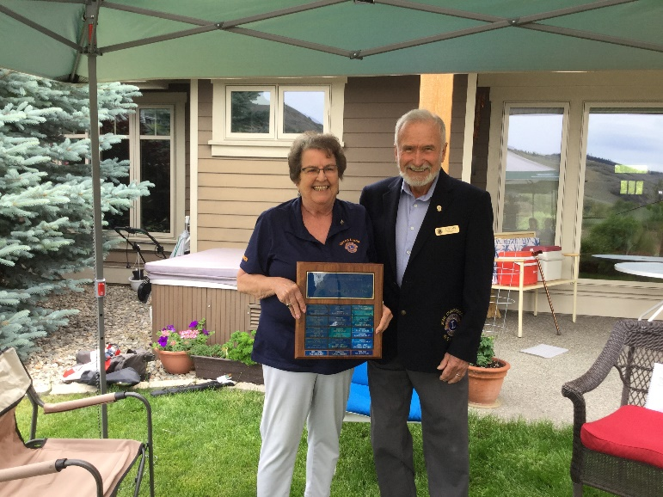
Sharon Cain, Vernon Lions Club -President of the Year 2020-2021
As you know, my time as your Zone Chairperson winds down at the end of June.
I still can't believe it, but it's been an absolute pleasure working with each of you these past two years. But don’t feel you are free of me – I have accepted the position of LCIF Chairperson North for District D cabinet.
Thank you for all your support, and please keep in touch. Feel free to shoot me an email or phone call at the connections listed above.
I look forward to seeing what you continue to accomplish in your clubs. I am fortunate in that your next Zone Chair will take me along to all her meetings and functions. I wish my wife, Sharon Cain, all the best as she takes over the position of Zone Chairperson on July 1.
All my best,
- ZC Ken
Club Reports
Armstrong Lions Club
The Armstrong club continues to grow the success of their On-line Bingo held every Tuesday night. The prizes are growing along with the expertise of Lions involved.
Enderby Lions
The Enderby Lions report their year end at 68 members including 6 life members. Dennis Morgan has stepped down and 1st Vice President Herb Hayes is leading the club.
Wood cutting and delivery has been the main activity of the club to date.
Lake Country Lions Club
Membership: Current membership 22
Two members have moved, and one member has resigned in good standing.
Activities:
1. Two Lions, Bill Deering and Al Stewart have collected, sorted, packaged and distributed to Calgary 1,113 eye glasses.
2. The club has installed two new Lake Country Lions signs, one each at the north and south approach to Lake Country.
3. 10 volunteers donated 3 hours each to Camp Winfield clean-up Saturday, June 5
4. Current project: Lake Country Cemetery Clean-up on Saturday, June 12.
Our club is also looking into designing an entry sign to the cemetery which will give direction to those who visit.
Year-end BBQ and installation of officers will be held Wednesday, June 16, now that further restrictions have been lifted.
Lumby Lions Club
Lumby Lions are not holding regular meetings yet, but we are still active in our community!
In May, the Lumby Lions donated $5,000.00 to the Lumby and District Health Services Society to help fund lab and diagnostic x-ray services for the community.
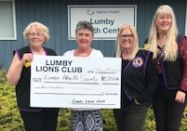
Pictured are Lion Elsie Campbell, Ev Reade from the Health Society, Lion Carla Lee and Lion Linda Vlasveld
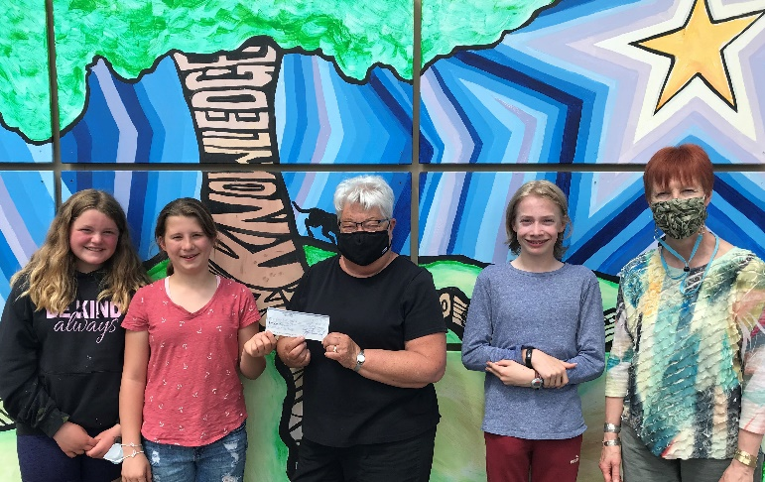
In May, we also donated $500.00 to help fund the J.W. Inglis Elementary School year-end field trip to the Oyama Zipline Adventure Park. The students collected bottles all year to fund their trip but found they fell short of their financial goal. We hope they have a fabulous time! Pictured: Lion Bev Lawrence presents the cheque to Grade 6 students and Principal Mary Takasaka.
The club made several donations:
$1,000.00 Lions International Dog Guide Walk
$5,000.00 to Lumby & District Health Services Society
$500.00 to J.W. Inglis Elementary School
They continue to support the Lumby Food Bank deliveries to isolated seniors (Ongoing - 12 hours/month)
The Lumby Lions plan to prepare meals for seniors July & August (twice a week), continue with Phase 2 new Signage for Salmon Recreational Trail system, install a horse shoe pit at the campground and tentatively assist with the installation of lighting for the youth skate board park.

Plans for the new Lion year include:
1. Tentative: Norton Motorcycle Rally beer garden September 7-11, 2021.
2. Tentative: Santa Toy Run beer garden – September 12, 2021.
3. Tentative: Halloween Dance October 30, 2021.
LUMBY CITIZEN OF THE YEAR
On Sunday, June 6 Lumby Lions held an in-person meeting and presentation for the Lumby Lions Citizen of the Year award. Zone Chair Ken Cain and Sharon Cain were guests at the meeting.
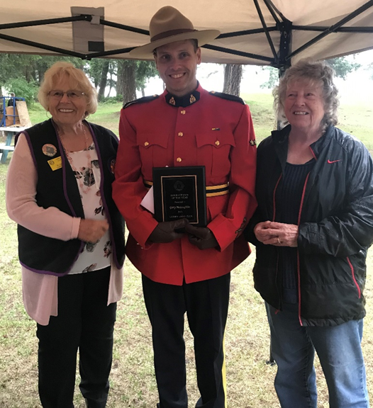
Lion Elsie Campbell, Gary McLaughlin and Lion Rhea Abney
One of the 2021 nominations for the Lumby Lions Citizen of the Year came from Makenna McLaughlin who asked us to “consider the most amazing guy I know, Gary McLaughlin!” The Lumby Lions agreed with Makenna and chose Gary McLaughlin to be Lumby’s 2021 Citizen of the Year.
Gary has been a devoted member of the Lumby Lions for over 8 years and has supported and improved life in the small town of Lumby, BC. Gary has accepted a position in the Maritimes and will be leaving Lumby at the end of June 2021.
Gary implemented the “With Me And The RCMP” reading program at JW Inglis, where students would be encouraged to read a select amount of books throughout the year. As a reward for their efforts, each student received a certificate and a ride to school in Gary’s police car. He also spearheaded the Emergency Services Food Drive which resulted in thousands of donated dollars and pounds of food for the Lumby Food Bank.
Gary organized Lumby’s Santa Claus Parade to support the annual Chamber of Commerce Christmas Light Up and made countless phone calls to involve local businesses, bagpipers and many community groups in the event.
Gary also researched information for fallen community soldiers resting in the Lumby Cemetery and donated his research to the Lumby and District Historical Society.
He found Lumby’s 1946 American LaFrance Fire Truck and lobbied the Village of Lumby to purchase the truck for the Lumby and District Historical Society. The fire truck now resides at the Lumby Museum and is used for special events.
Gary is always visible in our community, helping others, ringing the Salvation Army Christmas Bells, being a DJ for the Lumby Hockey games, helping anyone in need and countless other acts of kindness that we do not know about.
The Lumby Lions are honored to recognize Gary McLaughlin for this special award.
Vernon Lions Club
May 15, 8 Vernon Lions attended a Clean Up at Camp Winfield. A quote from one of our new Lions,” Just wanted to say yesterday was a wonderful experience and I found the facility absolutely amazing. The place is huge and must take a lot of work to keep it maintained. I don't know all who is responsible for the upkeep, but I now understand that Lions need to do what we can to keep it going now and in the future.”
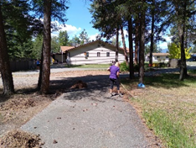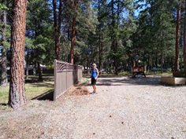
Brian Barnett, Bobbe and Marnie McKenzie continue their monthly volunteer hours. The original bottle drive has continued with drop offs at Chaser’s to the Vernon Lions account and we have raised over $2600 so far.
Eric Reckhard and Sharon Cain have done an amazing job with the on-line auction. Congratulations to you both for all the long hours and the efficient job. Another big thanks to all the Lions for your donations and sponsors it takes a team and what a good team the Vernon Lions is.
June 3 Good-bye zoom - we held our first in-person outdoor meeting at the home of our President with 17 members in attendance. Pizza and pop proceeded the AGM meeting and the installation of the 2021-2022 executive which was preformed by Zone Chair Ken Cain.
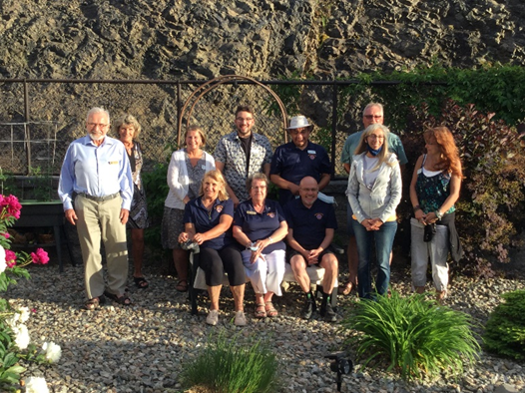
Our on-line auction is now in progress June 15-30,2021
Log into https://app.galabid.com/june2021auction to see the fabulous donations from our community. You won’t want to miss the opportunity to bid. Please share this website with your friends, neighbors and fellow Lions.
District Cabinet contacts:
District Governor: Joe Nilles
509-669-6766 Email: lionjoed2@gmail.com
1st Vice District Governor: Joyce Stevens
509-670-7527 Email: jstevens98826@gmail.com
2nd Vice District Governor: Debbie Allan
250-554-1498 Cell: 250-319-4293
Email: dandballan@telus.net
Cabinet Secretary: Jeanette Britton
509-548-1947 Email: brittonjeannette@gmail.com
District D Bulletin Editor: Shelley Costello
509-881-5103 Email: shelan1437@aol.com
District D Website Editor: Sharon Cain
250-545-2722 Email: sharoseh43@gmail.com
Websites:
MD19 https://lionsmd19.org
District D https://e-district.org/sites/19d
LCI https://lionsclubs.org
Border Crossing https://lionsmd19.org/newsletters.php
Armstrong Lions Club
https://e-clubhouse.org/sites/armstrong/
Enderby Lions Club https://enderbylionsclub.org/
Lake Country/Winfield Lions Club
www.lakecountrylions.com
Lumby Lions Club
https://e-clubhouse.org/sites/lumby_bc/
Vernon Lions Club
https://e-clubhouse.org/sites/vernon_bc
www.facebook.com/Vernon-Lions-Club-Vernon-BC

