**July, 2020  ZONE 1 NEWSLETTER **

**Zone Chair: Ken Cain Phone: 250-545-2722 Email: markencain@shaw.ca**

**ZONE NEWS**

As we begin this new Lion’s year, we welcome new club officers and many returning officers. It will be a pleasure to get to know each of you a little better and to work together to serve our communities. May all your club goals become reality.

This year my Zone goals are to:

Please keep me informed of your club events throughout the year so that I might attend and volunteer along with you and include all your events and pictures in the newsletter.

I really enjoyed attending the Dog Walk in Enderby last year and the Halloween Dance in Lumby and am looking forward to more events this year.

1) Get our Vision Screening project underway.   
2) Encourage membership increase in clubs.   
3) Have each club continue to share their projects and   
 accomplishments in the zone monthly   
 bulletin  
4) Encourage more visitations between clubs.  
5) Plan training sessions for your club leaders.  
6) Support our District Governor in his goals

**ZONE D1 CLUB MEETING INFORMATION**

**Armstrong Lions Lumby Lions  
President**: Linda Fisher Home 250 546-9340 **President:** Mike Takahashi Home 250-547-9335  
 Cell 250 306-1602 [linmf@telus.net](mailto:linmf@telus.net) [mftakahashi@shaw.ca](mailto:mftakahashi@shaw.ca)   
**Secretary:** Deb A Sarnowski Cell 604 223 7183 **Secretary:** Linda Vlasveld Home 778-473-5410  
 [debrasarnow@gmail.com](mailto:debrasarnow@gmail.com) [okanaganliv@hotmail.com](mailto:okanaganliv@hotmail.com)   
Meet: 2nd & 4th Wednesday @ 7:00 PM Meet: 1st & 3rd Tues. 7:00 PM  
at Lions Den, Royal Canadian Legion basement at Whitevalley Community Centre  
 2526 Pleasant Valley Blvd, Armstrong 2230 Shields Ave, Lumby

**Enderby & District Lions Vernon Lions  
President**: Dennis Morgan Home 250-838-9771 **President:** Sharon Hryciuk Home 250-545-2722  
 [sharonh43@shaw.ca](mailto:sharonh43@shaw.ca)   
**Secretary**: Janis Powell Home 250-515-3380 **Secretary:** Judy Louis Home 250-540-1148  
 [jr.powell@telus.net](mailto:jr.powell@telus.net) [judy.a.louis@outlook.com](mailto:judy.a.louis@outlook.com)   
  
Meet: 1st,2nd,3rd,4th Wednesday @6:30 PM Meet: 1st & 3rd Thurs. @ 6:30 PM  
at Royal Canadian Legion, 900 Belvedere St. Enderby at Eagles Hall, 5101-25 Ave. Vernon

**Lake Country/ Winfield Lions  
 President**: Kim Sylvestre Home 250-609-1960  
 [kimsylvestre@shaw.ca](mailto:kimsylvestre@shaw.ca)   
 **Secretary:** Laura Albrecht Home 250-215-2883  
 [lauraalbrecht@shaw.ca](mailto:lauraalbrecht@shaw.ca)   
 Meet: 1st & 3rd Wednesday @ 6:30 PM   
 at Winfield Memorial Hall, 10130 Bottom Wood Lake Rd, Winfield

I encourage all clubs to make an effort for visitation to at least one meeting at each of our clubs in the zone this year.

***Overcome obstacles, plan activities, SERVE***

**CLUB NEWS**

**Each month, please send me a story of what your club is doing. Pictures welcome. The newsletter will go out the end of each month – this one is early due to officer training announcements.**

July 12 **– Lumby Lions** met at the Lumby Golf Course, had an outdoor meeting and ZC Ken Cain attended to install the new 2020-2021 Executive. The Lions also presented a Lumby citizen, with their Citizen of the Year award.

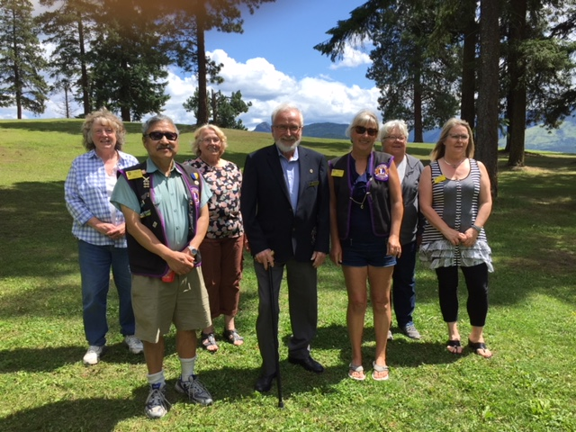

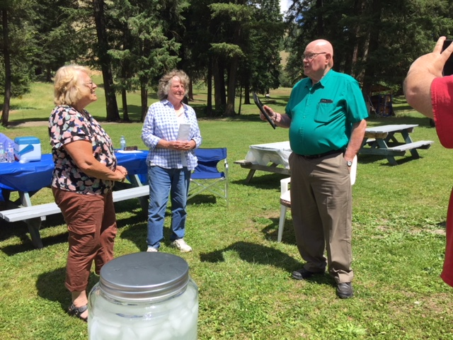

**UPCOMING CLUB, ZONE D1 & DISTRICT EVENTS**

**2020**

July 25 Officer Training (see page 3)

Aug 15 Officer Training (see page 3)

Aug 29 1st Cabinet Meeting  
 Chris Rose Therapy Center, Kamloops  
 via ZOOM

Sept (date TBA) Lions Zone D1 Meeting,   
 Host: Vernon Lions or ZOOM if necessary  


**Oct 15-16 99th MD Annual Convention   
 Penticton**

NOTE: The MD19 Council Of Governors has voted to cancel the MD19 Convention that was scheduled for October 15–17, 2020 in Penticton, British Columbia due to concerns over, and governmental restrictions in connection with the Covid pandemic.

**2021**

**March 5-6 19D Spring Conference  
 Ramada Inn, Kelowna**

**June 3-5,2021 Northwest Lions Leadership Institute  
 Harrison Hot Springs**  
 

Well, we have good news and we have bad news ...

First, the bad news is that with continued COVID-19 issues, we have to cancel the Institute as scheduled for **September 24-26, 2020.**

But the **GOOD NEWS** is that we plan to move the Institute to **June 3-5, 2021** at Harrison Hot Springs, BC. Current students should be receiving notification shortly. Prospective students should stay tuned for their chance to sign up!



**LIONS CLUB OFFICER LEARNING FOR 2020-21**

Be prepared to enhance your personal leadership skills and work with your Lions team—in environment whether virtual or face to face.

Join our experienced facilitators from MD19**. ALL LIONS, LEO’s and LIONESS WELCOME**

There are two sessions available. Presidents, Secretaries, Treasurers, Membership Chairs, Directors and all Lions - It will be well worth your while. Let your Zone Chair know who has completed one of these sessions.

**Saturday, August 15 8:30 AM—12:30 PM**

We’ll be learning virtually via Zoom.

All club officers should join for the entire session.

**Register by August 12**

e-mail Lion Frank Bega

<frankbega@frontier.com>

Respond with name, club and club position

Pre-assignment and ZOOM link sent a few days before event

**Saturday, July 25, 9:00AM — Noon**

We’ll be learning virtually via Zoom.

All club officers should join for the entire session

**Register by July 22**

e-mail Lion Mark Mansell

<mark.bgwa@gmail.com>

Respond with name, club and club position

Pre-assignment and ZOOM link sent a few days before event