 **2020**

** ZONE 1 NEWSLETTER **

**Zone Chair: Ken Cain Phone: 250-545-2722   
 Email:** [**markencain@shaw.ca**](markencain@shaw.ca)

**District Cabinet contacts:**

District Governor: Joe Nilles 509-669-6766   
 Email: [lionjoe2@gmail.com](mailto:lionjoe2@gmail.com)

1st Vice District Governor: Joyce Stevens 509-670-7527   
 Email: [jstevens98826@gmail.com](mailto:jstevens98826@gmail.com)

2nd Vice District Governor: Debbie Allan 250-554-1498  
 Cell: 250-319-4293 Email: [dandballan@telus.net](mailto:dandballan@telus.net)

Cabinet Secretary: Jeanette Britton 509-548-1947   
 Email: [brittonjeannette@gmail.com](mailto:brittonjeannette@gmail.com)

District D Bulletin Editor: Shelley Costello 509-881-5103   
 Email: [shelan1437@aol.com](mailto:shelan1437@aol.com)

**Websites:**

MD19 [https://lionsmd19.org](https://lionsmd19.org/)

District D <https://e-district.org/sites/19d>

LCI [https://lionsclubs.org](https://lionsclubs.org/)

Border Crossing <https://lionsmd19.org/newsletters.php>

Vernon Lions Club [https://vernonlionsclub.ca](https://vernonlionsclub.ca/)



**ZONE Chair Ken’s message . . .**

Lions Clubs International is actively working with our clubs around the world and monitoring the ongoing coronavirus (COVID-19) pandemic, which is changing the way we live, work and serve. Let’s continue to put our kindness in action by putting the health and safety of our communities first.

It’s an uneasy time from a non-profit fundraising perspective, especially when we receive large portions of our annual revenues from annual events. So, let’s think about doing a version of these events on-line. There are many websites available to help you get set up and started. Just Google Virtual Fund Raisers and choose a site that fits your idea.

 I have heard from both Salmon Arm and Vernon School districts regarding the Vision Screening. Being realistic, they are considering vision screening in the schools in October. We will be in touch about the 3rd week in September to create a schedule that will work for both the schools and the Lions clubs.

 As the border continues to stay closed to international travel and DG Joe cannot cross to visit the Canadian clubs, 2ndVDG Debbie Allen from Kamloops is putting together a visitation schedule so that she can visit the clubs on the BC side of the border. If you feel it would be safer either 2nd DG Debbie Allan, 1st DG Joyce Stevens or DG Joe Nilles are willing to do visitations by ZOOM.

Our District Cabinet Meeting was held on Oct. 29 by ZOOM. It was great to see everyone and give virtual hugs. This is a great way for your clubs to meet. It was also suggested that clubs could do visitations by ZOOM. When holding your zoom meeting, invite another club to join you. This will count as a visitation and if you do 2 visits a month, you will be rewarded from LCI – just be sure to report it.

Have fun and share your stories in this newsletter. Include projects completed and upcoming events scheduled. Pictures are always welcome.

**ZC Ken**

**DG Joe’s Service Goals**

Let’s help achieve our District Governors goals:

* 50% of all clubs do a Diabetes activity of some sort
* 50% of all clubs do a new environmental project
* Make the community aware of the need to support these activities
* 90% of all clubs to report their service activities on MYLION.
* All clubs continue to support the Lions Clubs International Global Causes – Environment, Diabetes, Hunger, Childhood Cancer and Vision.

If Joe can help you to reach these goals, please do not hesitate to contact him. He is here to help you have a great year.

**UPCOMING CLUB, ZONE D1 AND DISTRICT EVENTS**

**2020**

***Sept* 13** Lions Zone D1 Meeting 10 AM  
 Host: Vernon Lions Club – location of meeting – 3708 Razorback Crt. Vernon – back yard.  
Lunch will be served. Bring a lawn chair and wear a mask until seated socially distanced..  
**Oct 15-16 CANCELLED** 99th MD Annual Convention  
Note: The MD19 Council of Governors has voted to cancel the MD19 Convention that was scheduled for October 15-16, 2020 in Penticton, BC due to concerns over, and governmental restrictions in connection with the Covid pandemic.

**2021**  
**March 5-6** 19D Spring Conference  
 Ramada Inn, Kelowna

**June 3-5** Northwest Lions Leadership Institute,   
 Harrison Hot Springs

Well, we have  . . . .

First, the bad news is that with continued COVID-19 issues, we had to cancel the Institute as scheduled for September 24-26, 2020.

But the **GOOD NEWS** is that we plan to move the Institute to June 3-5, 2021 at Harrison Hot Springs, BC. Current students should be receiving notification shortly. Prospective students should stay tuned for their chance to sign up!

**June 25-29, 2021**

Online registration is officially open for LCICon 2021 Montréal, where Lions and Leos from around the world will come together to celebrate a life of service while indulging in the culture and life of Montréal.  
**NEW MD19 MAILING ADDRESS FOR BC LIONS** — Sometimes it is the little things, like… maybe… a pandemic… that triggers big things… like, maybe… having a mailing address on the BC side of MD19 where our terrific, BC Lions clubs, Governors, Zone Chairs, coordinators and committee chairs cancorrespond with, orderparaphanalia from, make dues, CAREand LCIFpayments, or get whatever to MD19 without having to pay international postage and without waiting weeks for mail to clear customs or otherwise make its way 20 miles south of the International border to the MD19 office in Bellingham. The new address is:   
**Multiple District 19, Lions Clubs International,   
P.O. Box 1621, Aldergrove, BC V4W 2V1.**



# **Club News**

Vernon Lions Club

Vernon Lions Club will resume their regular meetings September 3 2020

Vernon Lions will be doing a drive through bottle drive on September 12.

Awards will be presented for the 2019/2020 year on September 17

Vernon Lions are working with the City of Vernon to organize a COVID safe employee appreciation BBQ.

Lumby Lions Club

Due to limitations surrounding in-person gatherings, the Lumby Lions are not yet holding regular meetings. We continue to serve our community where we can:

1. Lumby Lions Elsie Campbell, Bev Lawrence and Linda Vlasveld, along with the White Valley Community Resource Centre hosted an afternoon social get-together for Lumby's seniors. Lemonade was delivered to attendees as well as residents of the MEWS adult facility who were unable to physically attend the outdoor event.

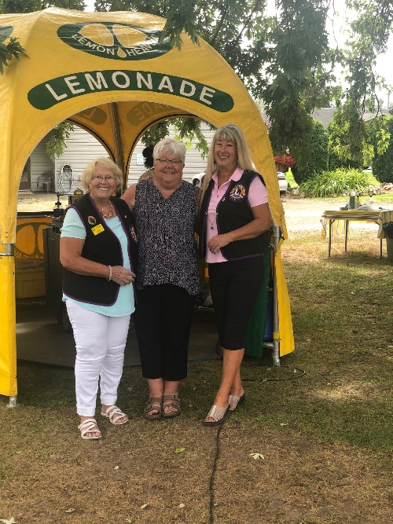

2. The Lumby Lions will once again provide security services for the Dog "O" Pogo Agility Event on Sept. 19 & 20, 2020. We hosted this event in June 2020 and were amazed by these dogs - they just love to compete!

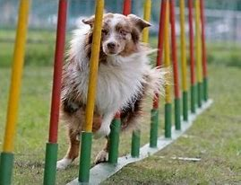

3. The Lumby Lions campground is busy this year as outdoor enthusiasts chose to staycation in Canada. Funds raised from the campground support children, young families and seniors in our community. 