2020
Zone 1 Newsletter
Zone Chair: Ken Cain Phone: 250-545-2722
Email markencain @shaw.ca
ZONE Chair Ken’s message . . .
It was great to see representatives of the clubs at our zone meeting on Sept. 13 at my home with the Vernon Lions Club as host.
During the meeting the President and Secretary of the Year awards were presented.
Linda Fisher, Armstrong Lions Club was awarded President of 2019-2020
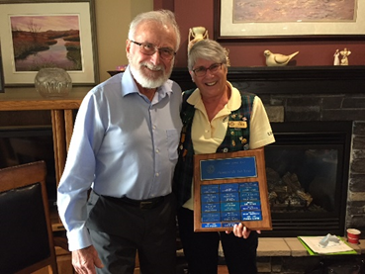

Linda Vlasveld, Lumby Lions Club was chosen as Secretary of 2019-2020 and President Mike Takahashi accepted the award on her behalf.
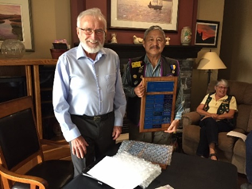
A note from Peter Anderson, Executive Director, MD 19 Lions, Lions International. “ If clubs “send” two or more of their members to “visit” another club via the internet, they should report that as a club visitation”.
Still awaiting news from the school districts as to a date we can begin Vision Screening.
Minutes from Secretary Jeannette Britton: On Tuesday evening, September 22nd, 2020 DG Joe Nilles sent the cabinet members information regarding the devastation caused by wildfires in central Washington. After talking with the Mansfield Lions about needs following the fires Joe learned that the greatest need was for livestock. Upon contacting LCIF, Joe learned that their emergency help was for humans only. Since the greatest need at this point is for livestock, Joe thought using some of the ALERT funds would be appropriate.
Anita Wilkie made a motion: “Move that $5000 of the ALERT account funds is provided to the Mansfield Lions Club for the specific use of funding livestock feed and new fencing for the local farmers impacted by the wildfires”. Norma Bent seconded the motion. Over the course of the next several hours the motion was voted on by over 86% of the cabinet and carried unanimously.
Thank you to the following: Debbie Allen, Barry Armbrust, Margaret Ashley, Wayne Atkinson, Bob Ayotte, Sonia Ayotte, Karen Bassett, Angus Benedict, Norma Bent, Debbie Bostock, Ken Cain, Kim Davis, Carolynn Dufresne, Wanda Eddy, Al Fennig, Hannah Gerard, Sharon Hrycuik, Mike Livingstone, Kathryn McGaughey, Dorothy Nilles, Linda Schaffrick, Dave Shalanski Patti Sparks and Anita Wilkie.
ZC Ken
UPCOMING CLUB, ZONE D1 AND DISTRICT EVENTS
2020
Oct. 14 ZC Visitation to Armstrong Lions Club
Nov. 7 Virtual MD19 Convention
You can now register via Eventbrite whe you follow the link at www.lionsmd19.org
Your opportunity is:
• MD19 Annual convo via Zoom, beginning
November 7th at 9am
• Only $20US registration. Yes, you read that
right— US$ 20.00! No hotels, no $35.00
luncheons, no add–ons, no 3–gas–stop
travel. US$ 20.00 gets you in the door and
access to everything the convention has to
offer.
• First 300 registered get a Convo pin
• That registration gives you access to 50, yes,
50 sessions and seminars!
• Your access code will let you view those 50
sessions and seminars for 30 days.
• Go to https://lionsmd19.org/ click on
Let’s Go to an MD19 Virtual Convention
to register.
Nov. 14 Virtual Cabinet Meeting
Nov. 19 Vernon Lions Club 75th Anniversary
Due to Covid 19 it will be a club only
celebration.
Nov. Zone D1 meeting. Date TBA.
Armstrong Lions Club hosting.

2021
March 5-6 19D Spring Conference
Ramada Inn, Kelowna
June 3-5 Northwest Lions Leadership Institute
Harrison Hot Springs
June 25-29
Online registration is officially open for LCICon 2021 Montréal, where Lions and Leos from around the world will come together to celebrate a life of service while indulging in the culture and life of Montréal.
Club News
Vernon Lions Club
The Vernon Lions Club are once again holding in person meetings following all the rules outlined by Interior Health and Work Safe BC.
An induction ceremony for Eric Reckhard was held during my official Zone Visit to Vernon on Sept. 3.
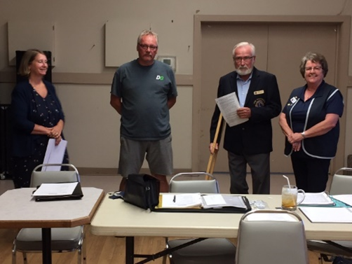

Vernon Lions Club held another successful Drive-Through Bottle Drive on Sept. 13 raising over $800. We are so appreciative of Keith Chase of Chasers Bottle Depot for all their help with our Drive. Below is Chair of the project Judy Louis accepting the cheque from Keith of Chasers
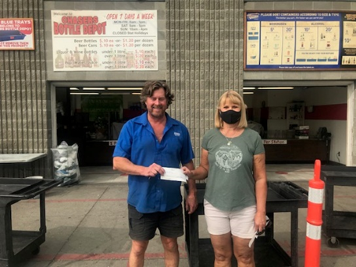
Armstrong Lions Club
The Armstrong Lions Club is going to do some work at the Lions park on Hunter St; replacing a tree, putting in a bench or 2, painting the back board for the basketball hoop and
a community bulletin board. Also, we are donating $2500 towards Memorial Park for new play equipment for the 2 to 12 year olds.
The club haven't started their bingo yet due to limited space for social distancing.
The Armstrong Club has been meeting outdoors and have just moved their meetings back to their den.
Enderby Lions Club
The Enderby Lions Club continue to do their firewood chopping for people in the area. They have not been meeting in person.
Best wishes to President Dennis Morgan for successful surgery at this time. Take care of yourself Dennis and continued health for you.

District Cabinet contacts:
District Governor: Joe Nilles 509-669-6766
Email: lionjoed2@gmail.com
1st Vice District Governor: Joyce Stevens
509-670-7527 Email: jstevens98826@gmail.com
2nd Vice District Governor: Debbie Allan
250-554-1498 Cell: 250-319-4293
Email: dandballan@telus.net
Cabinet Secretary: Jeanette Britton 509-548-1947 Email: brittonjeannette@gmail.com
District D Bulletin Editor: Shelley Costello
509-881-5103 Email: shelan1437@aol.com

Websites:
MD19 https://lionsmd19.org
District D https://e-district.org/sites/19d
LCI https://lionsclubs.org
Border Crossing https://lionsmd19.org/newsletters.php
Armstrong Lions Club
https://e-clubhouse.org/sites/armstrong/
Enderby Lions Club https://enderbylionsclub.org/
Lake Country/Winfield Lions Club
https://e-clubhouse.org/sites/winfieldwv/index.php
Lumby Lions Club
https://e-clubhouse.org/sites/lumby_bc/
Vernon Lions Club https://vernonlionsclub.ca

