2020
Zone 1 Newsletter
Zone Chair: Ken Cain Phone: 250-545-2722
Email markencain@telus.net
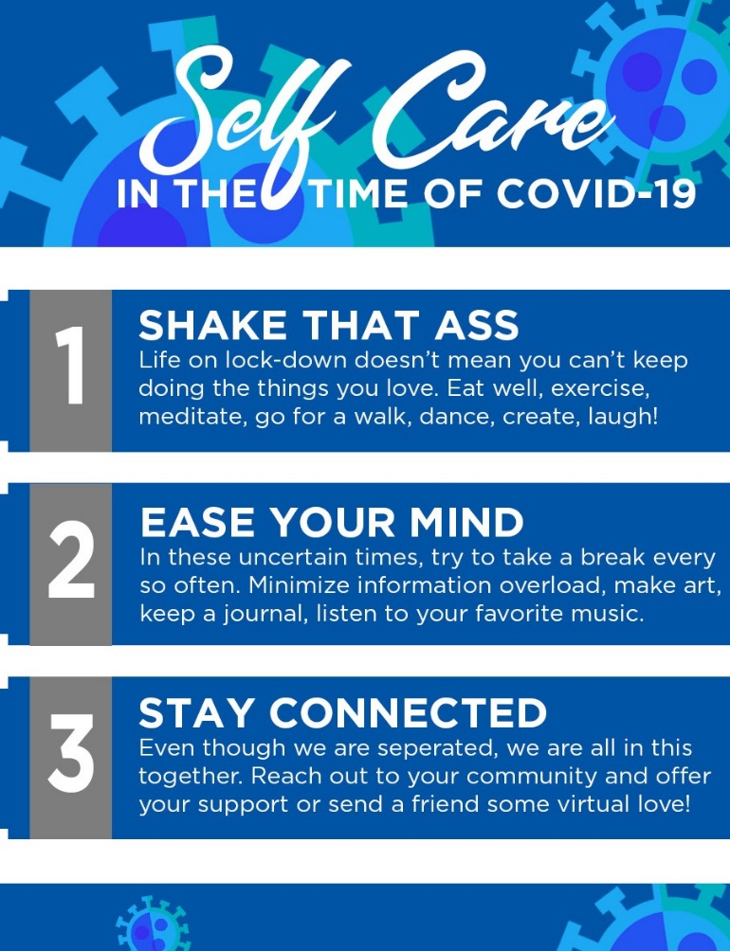
ZONE Chair Ken’s message . . .
Quote from Wanda Eddy: “During COVID we as Lions need to make changes. We need to find new ways to meet, new ways to give service and new ways to raise funds. But we can’t STOP – where there is a need there is a Lion. We know there are needs so now we need to create new dreams. List the things that are important and create that dream.”
Quote from Allan Hunt, International Director: “Look to our MD19 Website for new ideas during COVID. The GAT Team will work to post ideas from Clubs in our District to inspire you to create a new dream. “
There are opportunities to do things differently, just look at the number of people who are working from home, quite successfully. Is there any reason that a Lions project could not be executed from your homes.
We need to become comfortable in taking risks when dealing with change.
We have our Code of Ethics, our Purposes, Our Vision and Mission Statement. Our Vision is to be the global leader in community and humanitarian service. You cannot be a Leader when you are waiting for some one else to show you the way to go. We also must realize that not everyone is comfortable being a Leader. When a Leader happens to surface, let us not get in their way. There is nothing wrong with forming a Team to work with a Leader. Our Motto is “We Serve” so whomever is in a Leadership role needs others to work with them to achieve the collective goals of the organization.”
Let’s move forward and do great things.
ZC Ken
UPCOMING CLUB, ZONE D1 AND DISTRICT EVENTS
2020
Nov. 7 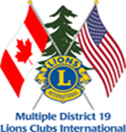 Virtual MD19 Convention
You can now register via Eventbrite when you follow the link at www.lionsmd19.org
Your opportunity is:
• MD19 Annual convo via Zoom, beginning
November 7th at 9am
• Only $20US registration. Yes, you read that
right— US$ 20.00! No hotels, no $35.00
luncheons, no add–ons, no 3–gas–stop
travel. US$ 20.00 gets you in the door and
access to everything the convention has to
offer.
• First 300 registered get a Convo pin
• That registration gives you access to 50, yes,
50 sessions and seminars!
• Your access code will let you view those 50
sessions and seminars for 30 days.
• Go to https://lionsmd19.org/ click on
Let’s Go to an MD19 Virtual Convention
to register.
Nov. 14 Virtual Cabinet Meeting
Nov. 19 Vernon Lions Club 75th Anniversary.
Due to Covid 19 it will be a club only
celebration. The Vernon Lions Club
would welcome your greetings to be read
at the event.
2021
Feb. Zone D1 meeting. Date TBA.
Armstrong Lions Club hosting.
March 5-6 19D Spring Conference
Ramada Inn, Kelowna
June 3-5 Northwest Lions Leadership Institute
Harrison Hot Springs
June 25-29
Online registration is officially open for LCICon 2021 Montréal, where Lions and Leos from around the world will come together to celebrate a life of service while indulging in the culture and life of Montréal.

Club News
Vernon Lions Club
Oct. 1 Our 2nd Vice District Governor Debbie Allan visited the Vernon Lions Club. Her husband Brian and granddaughter Leo Hannah Gerard came with her. She had words of encouragement and passed along a message from District Governor Joe Nellis.
2nd VDG Debbie assisted in presenting the Vernon Lions Club 2019-2020 awards.
Congratulations to Judy Louis for achieving the Lions Journey certificate.
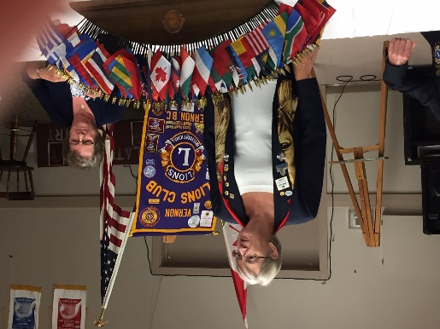
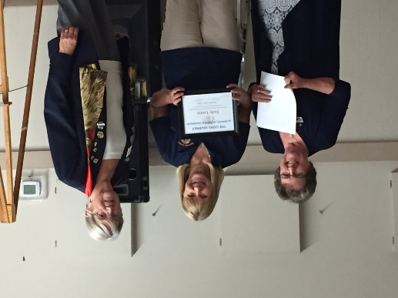
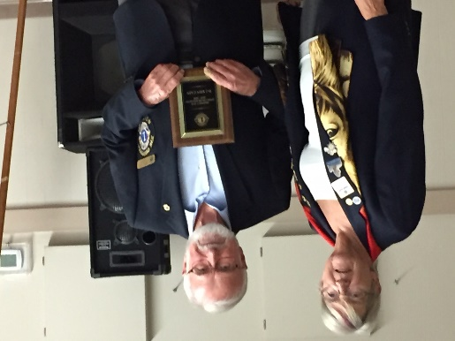
The Vernon Lions continue in-person meetings with covid protocol in place.

Armstrong Lions Club
Armstrong Lions Club salutes sister club with tree
Red Canadian Maple planted in Lions Park pays tribute to Lions Club in Banbridge, Northern Ireland
ROGER KNOX Oct. 22, 2020
A newly planted red maple tree in Armstrong’s Lions Park on Hunter Avenue has some extra special meaning.
The tree, planted by the city, signifies the Armstrong Lions Club’s twinning agreement with the Banbridge Lions Club in Northern Ireland, the closest such Lions organization to Armstrong’s sister city of Rathfriland.
Close to 20 Armstrong Lions Club members and dignitaries were on hand Wednesday, Oct. 21, for the official dedication of the twinning tree.
“I’m so proud of this club,” said organizer Linda Fisher. “When the going gets tough, the tough get going. We may be a small club in numbers but we are big in heart.”
Mayor Chris Pieper praised the work of the Lions on yet another project in the city.
“We’re very fortunate to have the Lions Club,” he said. “They do projects all over the city. Their volunteerism is absolutely amazing.”
Diann Boyd from the Armstrong Lions Club said her group is committed to the sister relationship with the Banbridge club.
Banbridge Lions Club was founded in 1965. Its members organize various fundraising events throughout the year for a variety of charities including pancreatic cancer, Sight Savers and Southern Area Hospice.
In the two years leading up to the club’s 50th-anniversary celebrations in 2015, the club raised more than $25,000 (€16,000 Euros) for local and international charities.

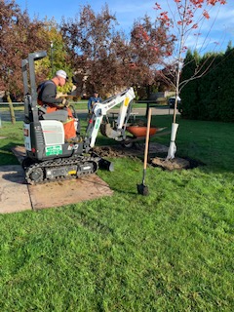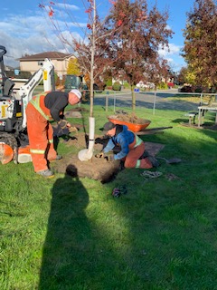
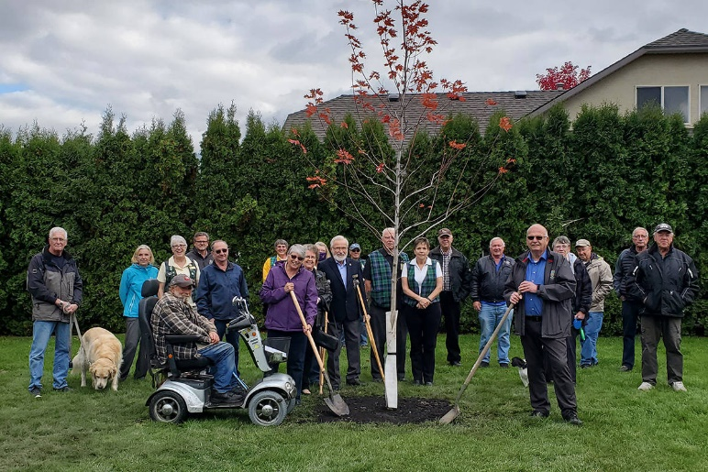
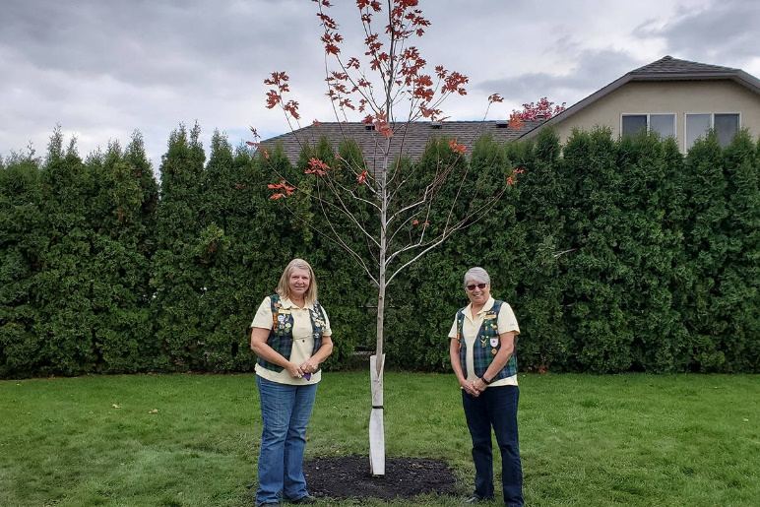
Oct. 28 ZC Ken Cain visited the Armstrong Lions Club with 8 members in-person and 3 on speaker phone. Great meeting ending with birthday cake for two of the members.

Enderby Lions Club
Good News
Dennis Morgan, President Enderby Lions Club is at home recovering from heart surgery.
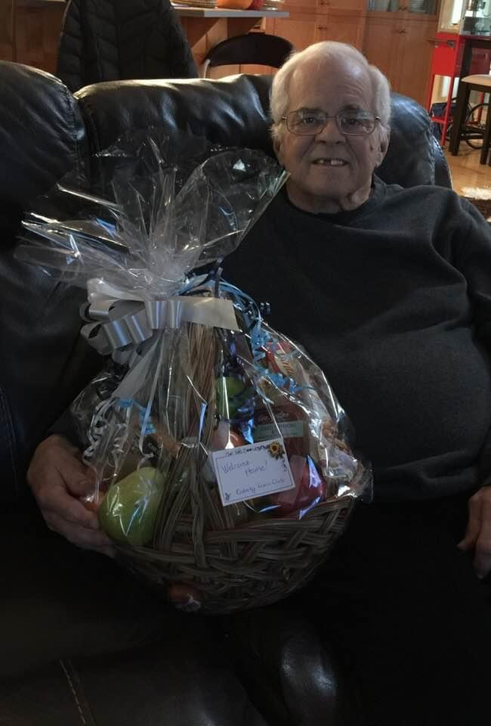
Lake Country/Winfield Lions Club
Lake Country Lions are holding in-person meetings once a month (3rd Monday) with social distancing and Covid protocol in place. They will not be holding a Christmas party this year.
The Shredding event held in October involved 14 Lions. They shredded 1340 KG of paper and netted $875. Great environment project.
Plans are in place to sort and collect gifts for the food bank as well as to make a monetary donation for the Christmas season.

District Cabinet contacts:
District Governor: Joe Nilles 509-669-6766
Email: lionjoed2@gmail.com
1st Vice District Governor: Joyce Stevens
509-670-7527 Email: jstevens98826@gmail.com
2nd Vice District Governor: Debbie Allan
250-554-1498 Cell: 250-319-4293
Email: dandballan@telus.net
Cabinet Secretary: Jeanette Britton 509-548-1947 Email: brittonjeannette@gmail.com
District D Bulletin Editor: Shelley Costello
509-881-5103 Email: shelan1437@aol.com

Websites:
MD19 https://lionsmd19.org
District D https://e-district.org/sites/19d
LCI https://lionsclubs.org
Border Crossing https://lionsmd19.org/newsletters.php
Armstrong Lions Club
https://e-clubhouse.org/sites/armstrong/
Enderby Lions Club https://enderbylionsclub.org/
Lake Country/Winfield Lions Club
https://e-clubhouse.org/sites/winfieldwv/index.php
Lumby Lions Club
https://e-clubhouse.org/sites/lumby_bc/
Vernon Lions Club https://vernonlionsclub.ca

