2020
Zone 1 Newsletter
Zone Chair: Ken Cain Phone: 250-545-2722
Email markencain@telus.net
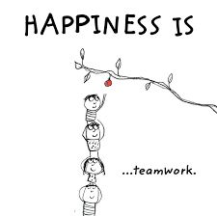
ZONE Chair Ken’s message . . .
This has been a very busy month in my life. The first big event was the MD19 Annual Convention via Zoom on Nov. 7 where 383 Lions connected with each other and attended several very informative and inspiring learning sessions. Viewing several of the On-Demand sessions is an added bonus. I hope those of you who attended enjoyed it as much as we did.
Nov. 12, I married my best friend Sharon Hryciuk in a lovely ceremony in our home with four of our best friends, wedding officiant, and photographer (granddaughter) in attendance.
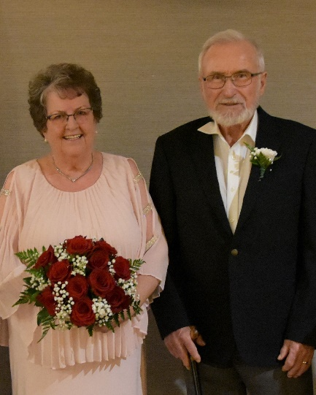

Nov. 14 we attended the Zoom Cabinet meeting. Some notes of interest include:
- LCIF – don’t forget club and individual donations
- You have until Dec. 7 to view the MD19 videos
- Spring Conference in Kelowna is cancelled – possibly will be via Hubb or Zoom. Refunds will be sent by mail as soon as possible (be patient). The 2022 Conference will be in Leavenworth, WA April 20-22.
- BC Lions Society is offering $10 memberships. Great way to become involved and to sponsor the society.
- The Global Action Team is having a challenge getting clubs to report – membership, activity. Note to secretaries – PLEASE UPDATE MEMBERSHIP LISTS TO INCLUDE EMAIL. Many members are not receiving information from LCI because email addresses are incorrect or non-existent. Even though your membership has not changed you must file a WMMR monthly.
- We are all encouraged to visit the Lions Learning Center on MyLion. Make yourself familiar with NAMI (North American Membership Initiative), SWOT (Strengths, Weaknesses, Opportunities, Threats) and SMART goals. A well-developed goal is specific, measurable, actionable, realistic and time-bound.
Nov. 19 – We attended the 75th Anniversary of the Vernon Lions Club. See the Vernon Lions report for more information and pictures.
Nov. 25 – I attended the Campaign 100 zoom meeting. Don’t forget to send what you can to LCIF.
The end of the month has been a catch up time for us. A time to relax, enjoy and begin to decorate for Christmas.
Bless our American friends as they celebrate Thanksgiving this month.
Until next month - - - ZC Ken

UPCOMING CLUB, ZONE D1 AND DISTRICT EVENTS
2020
Happy Winter everyone

2021
Feb. Zone D1 meeting. Date TBA.
Armstrong Lions Club hosting.
March 5-6 19D Spring Conference
In-person Cancelled
Plans being made for virtual
June 3-5 Northwest Lions Leadership Institute
Harrison Hot Springs
June 25-29
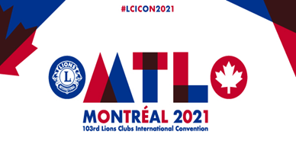
Online registration is officially open for LCICon 2021 Montréal, where Lions and Leos from around the world will come together to celebrate a life of service while indulging in the culture and life of Montréal.
Plans for the Convention may be both in-person and virtual.

Club News
Vernon Lions Club
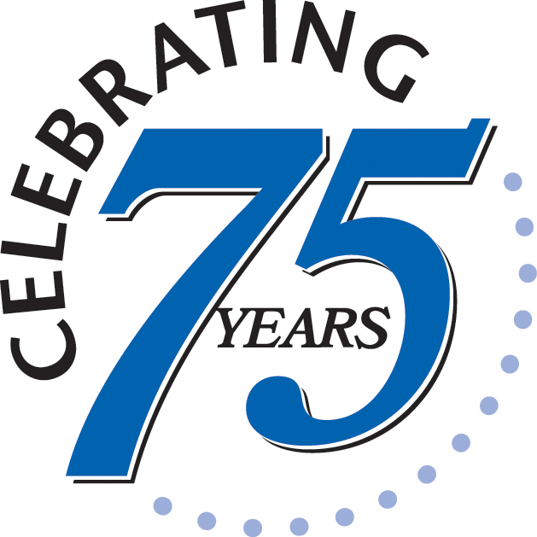
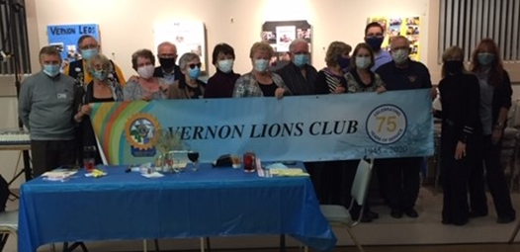
The Vernon Club has continued with COVID safe meetings.
During November three vision requests have been investigated and we have assisted financially.
One request for assistance for a seeing eye dog vaccinations was accepted.
Construction for parade float for the Vernon Carnival has commenced.
Refurbished glasses continue to be collected by Lion Mike Smith in several areas of Vernon.
Lion Bobbe MacKenzie and Lion Brian Barnett have been assisting different charities in Vernon, Habitat for Humanity, Upper Room Mission, Red Cross, and more.
A wonderful 75Th anniversary dinner was organized by Lions Bobbe Mackenzie and Brian Willows.
Lion Bobbe and Lion Brian put together a beautiful display with the help of Lion Simon in the downtown store front in Vernon.
This display allowed the people of Vernon to enjoy the history and pictures of past and present of the Vernon Lions.
The anniversary dinner was small in adherence to the COVID restrictions, an enjoyable evening with great prizes
The big door prize of a beautiful basket done by Lion Carole was won by Lion Anne Adams.
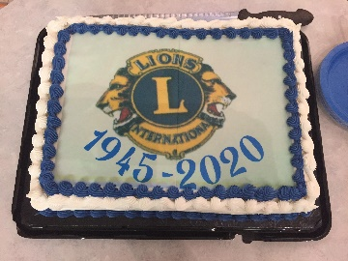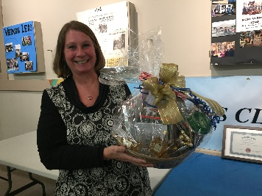
A thank you to all the sponsors and big thank you to Lions Bobbe, Brian and Simon.
A big congratulations to Lion Sharon and Lion Ken in their marriage on November 12 2020.
Armstrong Lions Club
The Armstrong Lions have shipped 392 glasses this month (56 ½ pounds).
Pres. Linda Fisher received an award for increasing membership during the Centennial.
Going to purchase the Zoom program for meetings.
The Armstrong Lions held their AGM in November.
Enderby Lions Club
The Enderby Lions are doing wood cutting for fireplaces as usual.
They are getting gift cards for Children and their families over Christmas even though we were unable to hold the Christmas Auction for Children this year.
Lake Country/Winfield Lions Club
The Lake Country Christmas Project is to donate to and help assemble Family Christmas Gift Boxes for the Lake Country Food Bank.

Lumby Lions Club
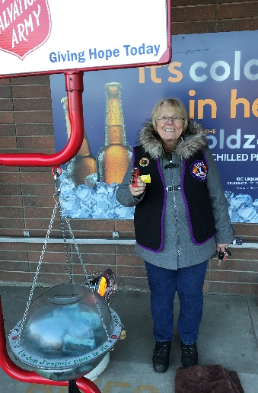
Lion Elsie Campbell ringing the bells for the Lumby Salvation Army Campaign.
The Lumby Lions have suspended meetings due to the pandemic but continue to support the community through donations and volunteering. Donations have been made to Teens Count Too, Annual Christmas Toy Drive, Seniors Christmas Dinner and other individuals in need.
Our annual Salvation Kettle Drive begins the last weekend in November. We hope to meet or beat last year's kettle total of $3,391.25.
We continue to support the Lumby Food Bank by delivering food hampers to seniors in isolation or unable to come to the food bank in person.
We wish all Lions the very best for the holiday season and 2021. Stay well. We value our connection and look forward to the time we can meet again in person.
For submitting all your reports. My zone clubs are the best.
District Cabinet contacts:
District Governor: Joe Nilles 509-669-6766
Email: lionjoed2@gmail.com
1st Vice District Governor: Joyce Stevens
509-670-7527 Email: jstevens98826@gmail.com
2nd Vice District Governor: Debbie Allan
250-554-1498 Cell: 250-319-4293
Email: dandballan@telus.net
Cabinet Secretary: Jeanette Britton 509-548-1947 Email: brittonjeannette@gmail.com
District D Bulletin Editor: Shelley Costello
509-881-5103 Email: shelan1437@aol.com
District D Website Editor: Sharon Cain
250-545-2722 Email: sharoseh43@gmail.com
Websites:
MD19 https://lionsmd19.org
District D https://e-district.org/sites/19d
LCI https://lionsclubs.org
Border Crossing https://lionsmd19.org/newsletters.php
Armstrong Lions Club
https://e-clubhouse.org/sites/armstrong/
Enderby Lions Club https://enderbylionsclub.org/
Lake Country/Winfield Lions Club
https://e-clubhouse.org/sites/winfieldwv/index.php
Lumby Lions Club
https://e-clubhouse.org/sites/lumby_bc/
Vernon Lions Club https://vernonlionsclub.ca

HEY, LIONS CLUB SECRETARIES &/OR CLUB SERVICE REPORTERS!!

For those still struggling with service reporting, here are some important bits of info to help you with successful service reporting:

The Lions Club International website has material to help make your job easier. Here’s how:

Go to lionsclubs.org/service-reporting and snoop around. There you will find pdfs that you can view. One that is particularly helpful is MyLion: How to Report and Celebrate Service Guide. Check it out!!

Also, if you go to Member Resources and search “service reporting”, you’ll get some results. There’s also a spot, if all else fails, where you can connect to a real person or connection is provided for a real person. You can’t beat that!

Don’t be afraid to explore! By exploring, I found out that service can consist of:
Time spent advocating for Lions
Donations to charitable causes, including
LCIF, club or personal
Raising funds to enable service
Lions events and meetings
Time spent in the reporting of volunteer activities….who knew?!

So, let’s educate ourselves in the reporting of service and what qualifies for service. Our numbers will soar! We Serve

