2020
Zone 1 Newsletter
Zone Chair: Ken Cain Phone: 250-545-2722
Email markencain@telus.net
ZONE Chair Ken’s message . . .
It’s fair to say 2020 has been a year like no other for the world and by default Lions clubs. But among all the challenges there have also been many things worth celebrating.
The global pandemic has spurred us on to be more agile, more creative and more inventive than before, and there have been plenty of lessons learned along the way. I’ve really learned inspiration can come from anywhere. Chatting to friends, family and fellow Lions in person can easily be replicated by doing so over Zoom, facetime and other social media. We can meet each other’s kids, puppies, babies etc, which goes a teeny way towards making up for not being able to talk to them in person. One day, one day.
Embrace the change, try something new. While the pandemic brought on many challenges, it also presented us with the opportunity to get ourselves out of our comfort zones to try new ways of working and playing. It was therefore a total delight to see our people rally together and quickly learn how to conduct our first Zoom meetings. This has really brought home that adage ‘Tough times don’t last, but tough people do’.”
What I hope we will carry into 2021 is new-found energy and passion to conceive and deliver top-notch communications, no matter what. 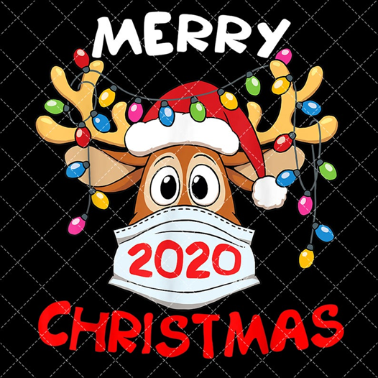 and health and happiness for 2021 - ZC Ken

UPCOMING CLUB, ZONE D1 AND DISTRICT EVENTS
2020
Nominations for 2021-2022 D1 Zone Chair position should be filed with your current Zone Chair Ken Cain and your District Governor Joe Nellis by Dec. 31, 2020. Forms are available at https://lionsmd19.org/forms.php
2021
Feb. Zone D1 meeting. Date TBA.
Armstrong Lions Club hosting.
March 5-6 19D Spring Conference
In-person Cancelled
Plans being made for virtual
June 3-5 Northwest Lions Leadership Institute
Harrison Hot Springs
June 25-29 Online registration is officially open for LCICon 2021. Plans for the Convention may be both in-person and virtual.
Club News
Armstrong Lions Club
This has been a quiet month for the Armstrong Lions Club, we donated $100 towards a Christmas hamper. We would like to wish everyone a Merry Christmas and a safe and Happy New Year.
Enderby Lions Club
No report was received this month.
Lake Country/Winfield Lions Club
Lake Country Winfield Lions had a busy December. First we completed our Christmas Lights, Saturday, December 4.
Our traditional Christmas Light Celebration was different because of Covid, but the Lights still hang in the trees at Winfield Memorial Park. LC Lions bravely risked life and limb (tree limb) to string the lights to brighten our way into the New Year.
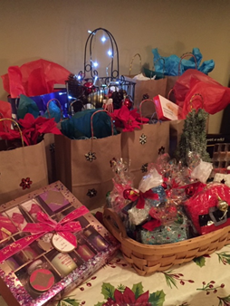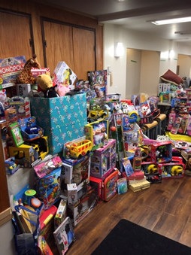
Our second project partnered with the LC RCMP "Most Wanted" Toy Drive, and the LC Food Bank. LC Lions bought gifts for single adults and senior couples. These were given out with the toys and warm clothing donated to the LC Food Bank. 10 Lions were involved in collecting, sorting, shopping and packaging for 60 families in our community.
"Lake Country is so generous", said President Kim Sylvestre. "If we asked for one basketball, we got six". Lions are proud to serve families in our community who may be having a difficult time this Christmas.
Lumby Lions Club
Lumby Lions President Mike Takahashi, along with Lion Carla Lee deliver a sack full of unwrapped toys to help Santa deliver much needed joy to children in need in our community. Santa and Mrs. Claus arrived in Lumby Museum's 1947 fire truck. The Lumby Lions have also provided furniture and household goods to a senior who recently lost their home.
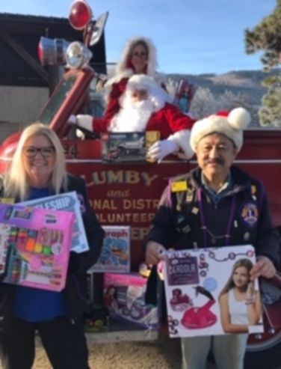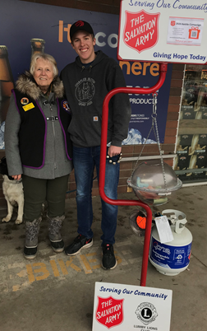
Lumby Lion Elsie Campbell, together with her grandson Rory Campbell ring the bells for the Salvation Army Kettle Campaign. Over $1,300.00 has been raised each weekend of December in the small community of Lumby with two more weekends to go.
Vernon Lions Club
The Vernon Lions continues to help those with sight and hearing issues. Lions Brian and Eric are a great addition to these site visits.
Delivery of goodie bags was done for our Lions club members who are shut in due to health or other issues.
Our first Zoom Meeting was held with the executive to deal with outstanding issues.
All General meetings and events were cancelled for the month of December.
The Vernon Lions would like to Wish all Lions a Merry Christmas and Hopes for a great New Year.
All the Best Always
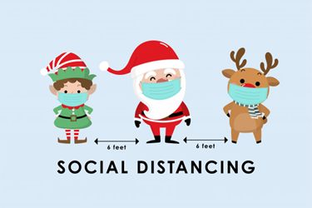
Vernon Leo Club
During this year of uncertainty and struggles due to the Covid-19 Pandemic the Vernon Leos Club took the opportunity to step up and continue to support our community! This holiday season the Vernon Leos Club made 3 donations to 3 very worthwhile community causes including the Women’s Transition House, Teen Junction as well as the Salvation Army Food Bank!
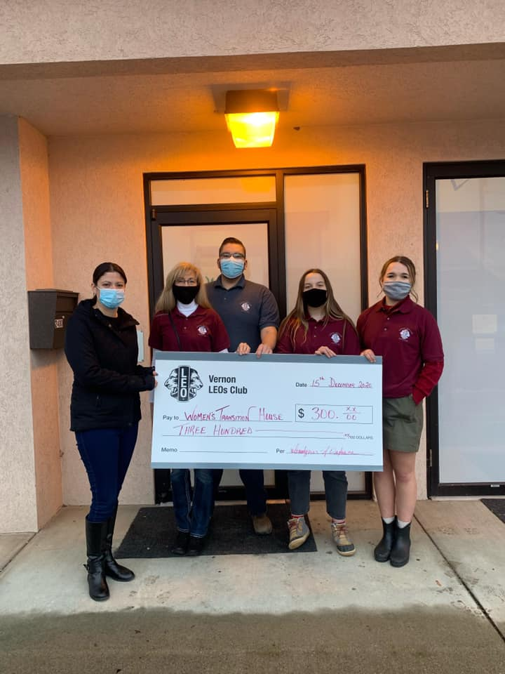
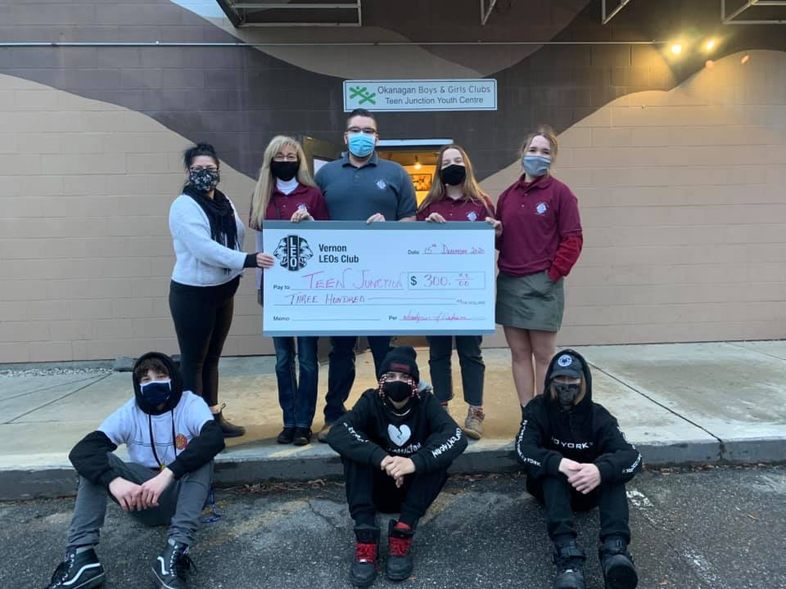
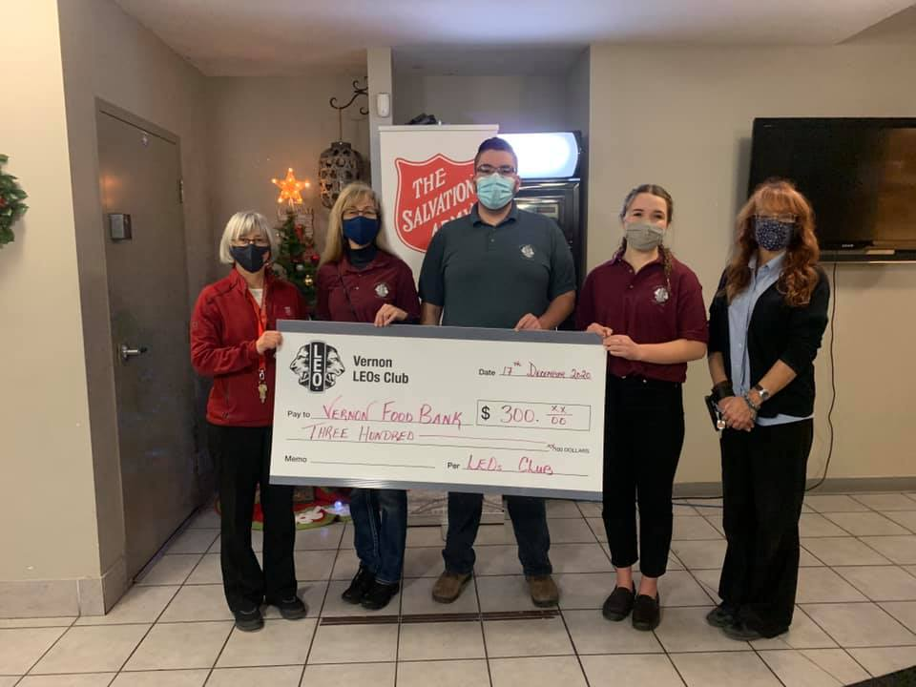
District Cabinet contacts:
District Governor: Joe Nilles 509-669-6766
Email: lionjoed2@gmail.com
1st Vice District Governor: Joyce Stevens
509-670-7527 Email: jstevens98826@gmail.com
2nd Vice District Governor: Debbie Allan
250-554-1498 Cell: 250-319-4293
Email: dandballan@telus.net
Cabinet Secretary: Jeanette Britton 509-548-1947 Email: brittonjeannette@gmail.com
District D Bulletin Editor: Shelley Costello
509-881-5103 Email: shelan1437@aol.com
District D Website Editor: Sharon Cain
250-545-2722 Email: sharoseh43@gmail.com

Websites:
MD19 https://lionsmd19.org
District D https://e-district.org/sites/19d
LCI https://lionsclubs.org
Border Crossing https://lionsmd19.org/newsletters.php
Armstrong Lions Club
https://e-clubhouse.org/sites/armstrong/
Enderby Lions Club https://enderbylionsclub.org/
Lake Country/Winfield Lions Club
https://e-clubhouse.org/sites/winfieldwv/index.php
Lumby Lions Club
https://e-clubhouse.org/sites/lumby_bc/
Vernon Lions Club https://vernonlionsclub.ca

