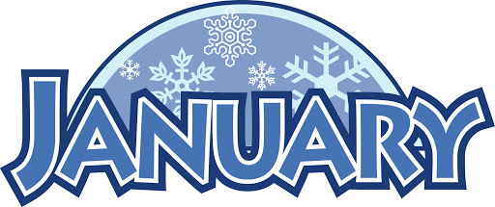
2021
Zone 1 Newsletter
Zone Chair: Ken Cain Phone: 250-545-2722
Email markencain@telus.net

UPCOMING CLUB, ZONE D1 AND DISTRICT EVENTS
2021
Feb. 7 Zone D1 meeting.
A link will be sent to each President and
Secretary and they may forward the link to
other club members who might like to attend.
March 5-6 19D Spring Conference
In-person Cancelled
Plans being made for virtual
June 3-5 Northwest Lions Leadership Institute
Harrison Hot Springs
(see information on page ___)

June 25-29
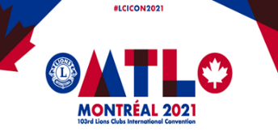Online registration is officially open for LCICon 2021. Plans for the Convention may be both in-person and virtual.
ZONE Chair Ken’s message . . .
POSITION AVAILABLE
DO YOU LIKE TO TRAVEL?
MEET PEOPLE FROM A FOREIGN COUNTRY?
HAVE FUN AND SPREAD GOOD WILL?
LIKE CHALLENGES AND ADVENTURE?
RESPONSIBLE, POSITIVE, AND A SELF-MOTIVATED LEADER?
BELIEVE IN TEAM WORK?
WILLING TO LEARN NEW IDEAS?
GOOD COMMUNICATOR – WRITTEN AND ORAL?
* * * *
WORLD-WIDE ORGANIZATION HAS OPENING
EFFECTIVE JULY 1 FOR ZONE CHAIRPERSON OF MD19-D1
ONLY EXPERIENCE NECESSARY: SERVED OR WILL HAVE SERVED AT THE TIME OF BECOING ZONE CHAIRPERSON, AS A PRESIDENT AND/OR SECRETARY FOR A FULL TERM OR A MAJOR PORTION THEREOF, AND AS A MEMBER OF THE CLUB’S BOARD OF DIRECTORS FOR NO LESS THAN TWO (2) ADDITIONAL YEARS.
ON THE JOB TRAINING BY CURRENT ZONE CHAIRPERSON
PAY COMMENSURATE WITH THE DESIRE AND WILLINGNESS TO “SERVE TOGETHER”
TO HELP OTHERS!!
Please consider writing a letter of intent to become D1’s next zone chairperson. There are several zones without a chair this year and they miss out on much information that is passed along through the zone chairperson.
Our Zone also have a sight screener waiting to be put to use. We need a zone chair to coordinate that project.
Ask me for help – I have a form letter you can use.
SPECIAL ANNOUNCEMENT:
The Lions of Canada have Launched YOUR new CANADIAN Website! The Website promises to be a valuable resource of information for Lions and non-Lions across Canada - from coast to coast to coast.
The website address is www.lionscanada.ca and is available in both French and English.
I wish all of you a wonderful 2021 and may our lives as Lions get back to normal real soon.
- ZC Ken
Club News
Armstrong Lions Club
Armstrong Leo Club
Enderby Lions Club
Lake Country/Winfield Lions Club
January has been a quiet month for Lake Country Lions. We continue our meetings through Zoom.

Lumby Lions Club
The Lumby Lions, together with the Lumby Historical Society are working together to update aging signage along Lumby's scenic Salmon Trail. These trails follow Bessette and Duteau Creeks and were made possible through a legacy fund dedicated by Weyerhaeuser Canada when they closed their Lumby sawmill operation. The Salmon Trail logo was designed by Lumby Lion Sheron Regamy and the historical design was completed by the Lumby Historical Society. The aluminum panels will be installed in the spring of 2021. As Phase 1 is now complete, the Lumby Lions will continue to work with the Lumby Historical Society during Phase 2 of the signage replacement.
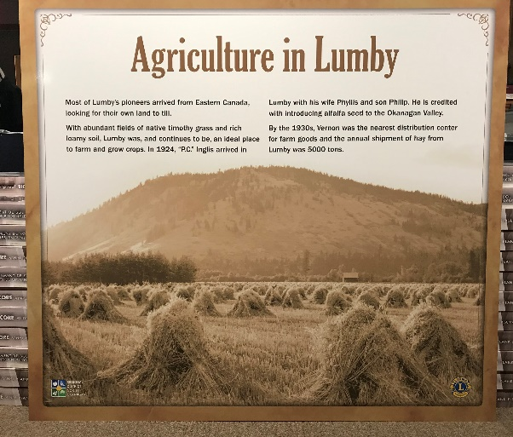
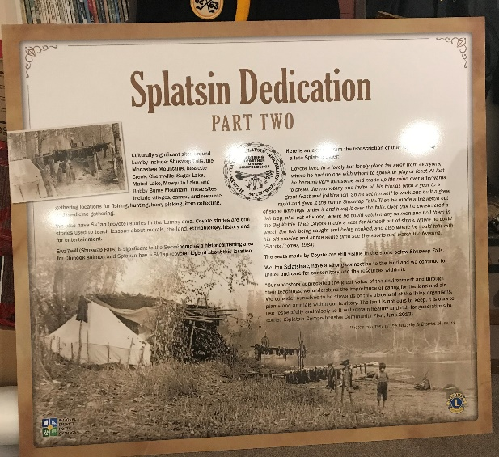
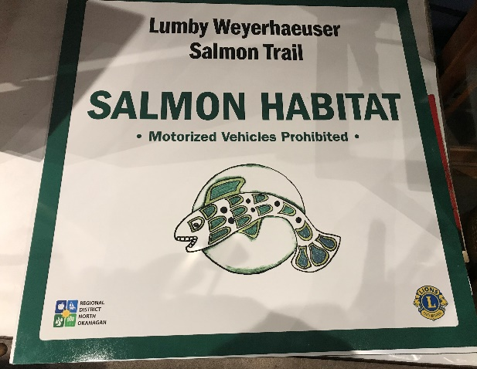

Vernon Lions Club

Vernon Lions continues to hold Zoom meetings. Once a month for Executive and General, and we are getting better all the time.

Members continue to volunteer at COVID safe locations helping the homeless and others in need.
Visitation committee continues to check on the members shut in or ill.
Donations of bottles and cans are picked up by members collecting from neighbors or friends to take them to Chasers and add to our Lions account.
Lion Marnie continues to assist the club with pop tabs and donation of bottles from the Abbeyhouse.

The club continues to assist those in need of glasses and hearing aids and certain dental needs.

No Fundraisers for the month.
Vernon Leo Club

Northwest Lions Leadership Institute
Registration 2021
Welcome to the application process for the 2021 Northwest Lions Leadership Institute. Congratulations on taking the first step in honing your leadership skills! The time you spend at the Institute will not only serve you well in Lions, but in your worksite and your other relationships as well.

Institute Dates:
June 3, 2021 starting at 1:00 PM
June 4 All Day
June 5 ending at 8:00 PM
The cost for the Institute is $350, which covers:
3 nights double occupancy lodging at the Harrison Beach Hotel (single occupancy available on a limited basis for an additional charge.)
Dinner on June 3, Lunch on June 4 and Lunch and Dinner on June 5, coffee breaks and snacks
All training materials
Hotel parking for 3 days
All breakfasts and Friday dinner are on your own
Applicants from Clubs in MD19 can apply for a special fee waiver, which can reduce the cost of the Institute by $200.

The application process includes several steps which all must be complete and submitted by April 1, 2021:

Application data
Candidates Lions history, community service and goals for attending the Institute
Letter of recommendation
Deposit $150 US or Canadian (at par)
Fee reduction request available for Multiple District 19 students only.
Let's get started by downloading the two parts of the application: These forms are available on
http://www.nwlli.org/register.asp

Application form (which includes application data, the candidate's Lions history, and fee reduction request)
Letter of Recommendation form (which should be emailed or mailed directly to the person you have chosen to complete the letter)
Both parts of the application (Application form and Letter of Recommendation) and deposit need to be sent to the Institute Registrar. Upon receipt of all pieces of the application you will be notified of your acceptance into the Institute.

District Cabinet contacts:
District Governor: Joe Nilles
509-669-6766
Email: lionjoed2@gmail.com
1st Vice District Governor: Joyce Stevens
509-670-7527
Email: jstevens98826@gmail.com
2nd Vice District Governor: Debbie Allan
250-554-1498 Cell: 250-319-4293
Email: dandballan@telus.net
Cabinet Secretary: Jeanette Britton
509-548-1947
Email: brittonjeannette@gmail.com
District D Bulletin Editor: Shelley Costello
509-881-5103
Email: shelan1437@aol.com
District D Website Editor: Sharon Cain
250-545-2722
Email: sharoseh43@gmail.com

Websites:
MD19 https://lionsmd19.org
District D https://e-district.org/sites/19d
LCI https://lionsclubs.org
Border Crossing https://lionsmd19.org/newsletters.php
Armstrong Lions Club
https://e-clubhouse.org/sites/armstrong/
Enderby Lions Club https://enderbylionsclub.org/
Lake Country/Winfield Lions Club
https://e-clubhouse.org/sites/winfieldwv/index.php Lumby Lions Club
https://e-clubhouse.org/sites/lumby_bc/
Vernon Lions Club
https://vernonlionsclub.ca

