2021
Zone 1 Newsletter
Zone Chair: Ken Cain Phone: 250-545-2722
Email markencain@telus.net
UPCOMING CLUB, ZONE D1 AND DISTRICT EVENTS
March 5-6 19D Spring Conference
In-person Cancelled
Plans being made for virtual
April 3rd zone meeting -date TBA
June 3-5 Northwest Lions Leadership Institute
Harrison Hot Springs
June 25-29
Online registration is officially open for LCICon 2021. Plans for the Convention may be both in-person and virtual.
ZONE Chair Ken’s message . . .
Please consider writing a letter of intent to become D1’s next zone chairperson.
Qualifications:
• Served at least one term as either club president or club secretary
• Enthusiasm and love of Lions
Duties:
• Attend zone training in June (zoom)
• Hold 3 zone meetings per year
• Attend 3 council meetings per year
• Attend Conferences and Conventions when
possible

• Support quality clubs within your zone
• Strive for excellence and continuous growth
• Be a crucial link between the clubs in the
zone and the district.
• Report to LCI monthly
• Keep clubs in zone informed with a monthly
newsletter (10 are required)
Zone chair is not a difficult position. I personally found that it has been fun, rewarding and I have grown in my own person because of it. The people you meet make this position a life time of memories.
Thank you to everyone who sent get well wishes to me following my surgery. I am recovering well.
- ZC Ken
Club News
Armstrong Lions Club
At the Armstrong Lions Club, we are having our monthly meeting via zoom, our club elections are coming up next month, we are discussing several items and plans are being made to go ahead with these plans in the near future.
Armstrong’s LEO Club
Enderby Lions Club
Lake Country/Winfield Lions Club
In spite of Covid-19 restrictions, Lake Country Lions have been finding ways to serve their community. One couple have donated 75 hours to the Lake Country Foodbank.
Another Lion has volunteered 60 hours at a local Thrift Store. Still another Lion has been spending 3 hours a week (45 hours to date) to support a senior living in his own home.
In addition, Lake Country-Winfield Lions have donated $2,500 to the Lake Country Senior Bus Society.

Lumby Lions Club
Vernon Lions Club
The Vernon Lions continue to do a Zoom executive and a Zoom General meeting monthly.
Lions Brian Barnett and Lions Bobbe and Marnie Mackenzie continue to assist those in need.
Lion Brian puts in hours at the Red Cross and Habitat for Humanity.
Lions Bobbe volunteers at the Mission serving meals to those in need, as well as driving seniors to various appointments.
Lion Marnie continues to pull tabs off cans to donate to the charity that provides wheel chairs to those needing assistance, as well as collecting bottles and cans for our Lions club account.
Various other Lions continue to collect bottles and cans to also add to our account at Chasers.
Al Hedstrom Council Chair MD19 was guest speaker at our Feb 18 General meeting.
A pleasure to have other Lion clubs in our Zone join us as well for this meeting.
The Lions club in Vernon had their parade prop displayed at the Polson Park, among the ice sculptures and carnival western tour. This allowed great exposure for the club as we displayed our Lions emblem.
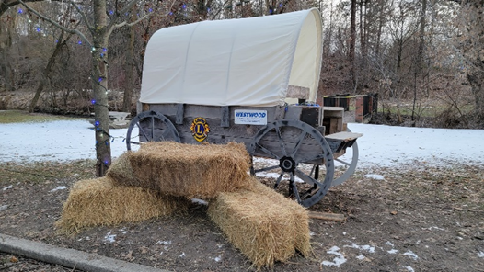
Vernon Lions covered wagon on display for the Vernon Winter Carnival (parade was cancelled)
Funding for Eye exams and glasses were provided during the month.
Vernon’s Leo Club
Vernon LEO’s partnered with the Women’s Transition House/Archway Society to help with their biggest fundraiser of the year! Valentine’s Boxes.
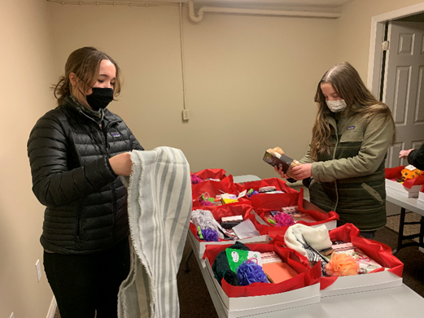
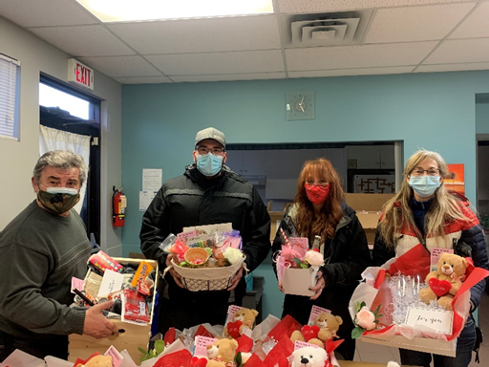

District Cabinet contacts:
District Governor: Joe Nilles
509-669-6766
Email: lionjoed2@gmail.com
1st Vice District Governor: Joyce Stevens
509-670-7527
Email: jstevens98826@gmail.com
2nd Vice District Governor: Debbie Allan
250-554-1498 Cell: 250-319-4293
Email: dandballan@telus.net
Cabinet Secretary: Jeanette Britton
509-548-1947
Email: brittonjeannette@gmail.com
District D Bulletin Editor: Shelley Costello
509-881-5103
Email: shelan1437@aol.com
District D Website Editor: Sharon Cain
250-545-2722
Email: sharoseh43@gmail.com

Websites:
MD19 https://lionsmd19.org
District D https://e-district.org/sites/19d
LCI https://lionsclubs.org
Border Crossing https://lionsmd19.org/newsletters.php
Armstrong Lions Club
https://e-clubhouse.org/sites/armstrong/
Enderby Lions Club https://enderbylionsclub.org/
Lake Country/Winfield Lions Club
https://e-clubhouse.org/sites/winfieldwv/index.php
Lumby Lions Club
https://e-clubhouse.org/sites/lumby_bc/
Vernon Lions Club
Https://vernonlionsclub.ca

