August Bulletin 19 D-8
D8ZC: Karen Bassett
564 Lakeshore Drive,
Chase, BC, V0E-1M0
kb1@telus.net
250-318-4527

D8ZC Karen’s Remarks
We have been faced with some challenging times. First Covid-19, now we are into wild fire season. Many clubs were just starting to get back to normal after Covid and now members may potentially be displaced. If you require information about fire, flood, evacuation etc please go to the EmergencySupportServices website: https://ess.gov.bc.ca/ There you can find planning tools, registration and other useful resources.
Clubs can assist with fire relief efforts by making donations to any of the following:
For a tax receipted donations please send to:
Mount Cheam Lions Charitable Society,
Box 249 Stn Main, Chilliwack, BC, V2P-6J1 Attn: Steve Somerset
Donations can also be made to LCIF attn: Disaster Relief lionsofcanadafundforlcif.ca attn: DisasterRelief
Lions Canada MD19 Alert Fund: c/o PDG Wayne Atkinson
3341 McQueen Rd, Westbank, BC, V4T-1B7
News from all around D8, “Inspire through Service”
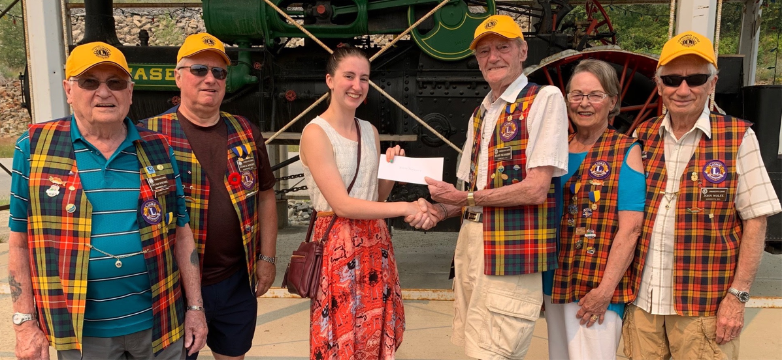
Sorrento Lions Club does annual High School Bursaries of $2000.00. This program is spearheaded by Lion Brian Butcher. They have given out more than $38,000.00 over the years to help support their local students.
Way to go Sorrento Lions.
Sorrento Lions also hold a Pancake breakfast on Saturday Aug 14&28 at the Sorrento Plaza parking lot. Stop in if your going through.

The Chase Lions Club have completed the first 3 Memorial tree plantings. These trees are Dedicated to the Loss of Chase’s last Charter members last Year. Frank & Alice Shelest. Frank was a Charter Lion and his wife Alice was Chase’s first Lady Lion. The next one was for Charter Member Lion Harry Fast. These members dedicated 54 years to the structure and survival of the Chase Lions club, and were dedicated to the service of others. For this we honor them.

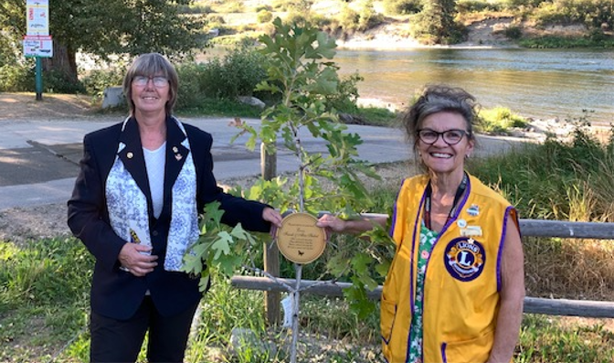
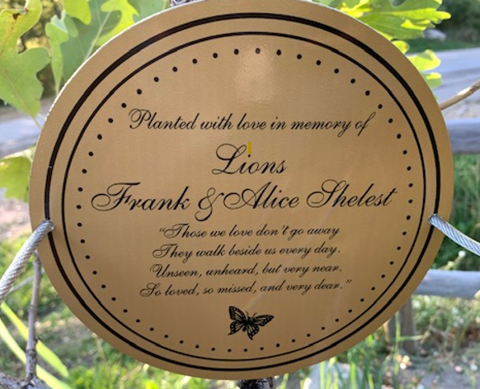

Please let me know what your club is doing. I would love to post your projects in my Monthly Bulletin.
Email me kb1@telus.net

Monthly Membership Reports
Please make sure to do your monthly membership reports before the 20th of each month. You can do them anytime after the first, so do them early. Also please, please report your Service activities on MYLION. If you need help or training with this, I would be happy to help.

Zone Meeting:
I would like to schedule our first Zone meeting for October 2nd. I will discuss will PDG Joe if we can have a zoom meeting that day, hopefully no one else is. I will follow up with changes if that date is unacceptable. I would like to have all your reports in by Sept 24. Thank you.

Visitations:
I would like to start doing visitations in September. Please look at your schedules or maybe you are doing a project or fundraiser that I can attend. I would love to help or participate.
Let me know please and thanks.

Websites for more info and Resources:
MD19: https://lionsmd19.org
District D: https://e-district.org/sites/19d
LCI: https://lionsclubs.org
Border Crossing: https://lionsmd19.org/newsletters.php

District Governor: Joyce Stevens 509-670-7527 jstevens98826@gmail.com
1St Vice DG: Debbie Allan 250-554-1498 dandballan@telus.net
2nd Vice DG: Mike Livingstone 250-497-8486 mickstone2@gmail.com
DG Bulletin Editor: PDG Debbie Bostock Debbie.bostock@gmail.com
D8 Bulletin Editor: Karen Bassett 250-318-4527 kb1@telus.net

