**What’s New in 19D-1 Zone Chair: Lion Sharon Cain MAY 2022**



**District Cabinet contacts:**

District Governor: Joyce Stevens  
 509-670-7527  
 [jstevens98826@gmail.com](mailto:jstevens98826@gmail.com)

1st Vice DG: Debbie Allan   
 250-554-1498  
 [dandballan@telus.net](mailto:dandballan@telus.net)

2nd Vice DG: Michael Livingstone  
res: 250-497-8486 cell: 250-809-6027  
 [mickstone2@gmail.com](mailto:mickstone2@gmail.com)

Cabinet Secretary:

District D Bulletin Editor: Debbie Bostock   
 250-819-6075   
 [debbiebostock@gmail.com](mailto:debbiebostock@gmail.com)

District D Website Editor: Sharon Cain  
 res: 250-545-2722 Cell: 250-540-8270   
 [sharoseh43@gmail.com](mailto:sharoseh43@gmail.com)

Websites:

**MD19** <https://lionsmd19.org>

District D <https://e-district.org/sites/19d>

**LCI** [hts://lionsclubs.org](https://lionsclubs.org)

**Border Crossing** <https://lionsmd19.org/newsletters.php>

**Armstrong Lions Club**<https://e-clubhouse.org/sites/armstrong/>

**Enderby Lions Club** <https://enderbylionsclub.org/>

**Lake Country/Winfield Lions Club**[www.lakecountrylions.com](http://www.lakecountrylions.com)

**Lumby Lions Club**  
 <https://e-clubhouse.org/sites/lumby_bc/>

**Vernon Lions Club**[Https://e-clubhouse.org/sites/vernon_bc](https://e-clubhouse.org/sites/vernon_bc)

Bulletin Editor: Sharon Cain  
250-545-2722  
**Cell: 250-540-8072  
[sharoseh43@gmail.com](mailto:sharoseh43@gmail.com)

**What’s happening in our World…. - ZC *Sharon Cain***

***A NOTE FROM LCIF COORDINATOR, KEN CAIN:*** To help ensure that Lions in Ukraine and neighboring countries are there to support refugees and displaced persons, the Lions Club International Foundation (LCIF) is awarding grants that will enable Lions to help provide immediate relief to those who are struggling to meet their most basic needs.

More than $100,000 in grant funding has already been awarded to Lions serving in Poland, Hungary, Romania, Austria, and the Slovak Republic to help support Ukrainian refugees who have crossed their borders. Lions in Ukraine have also received LCIF grants to address the critical needs of people who remain in the country. Funds will be used by Lions to purchase medicine and medical equipment, as well as other basic necessities such as food and water, clothing, and other supplies. Additional grants will be awarded to help meet the ongoing needs of this crisis.

If you feel it in your heart, please consider a donation to LCIF for this cause. For those of us in Canada, individuals can direct donations to: [www.lionsofcanadafundforlcif.ca](http://www.lionsofcanadafundforlcif.ca) . You can click on the donate button and carry on with your donation. Indicate that your donation is for Refugees in Ukraine. You can donate in Canadian Funds and you will receive a Canadian Tax receipt. As always, every dollar donated goes towards those in need. Clubs can donate in the same way or by mail to:   
**Lions of Canada Fund for LCIF, c/o Stan Durward, Box 38, Sunderland, Ontario L0C 1H0 Canada**

**What’s Happening in our Zone**

An Environmental ZONE PROJECT is recommended in order to help our environment. It should be a project that individual clubs can do. It can be quite diversified, and based on your individual club and area. Perhaps link it up with **EARTH DAY**, which is April 22, 2022. Maybe get, and give seedling trees to elementary schools, perhaps aid in the clean up of forest fires to allow for new trees to be planted. Plant some trees along hiking trails in your area. Have a BBQ in May to support the tree planters in your area. Any project that is somewhat related to trees, and new growth initiatives. Put your thinking caps on, and start planning.



The Zone project should start around Earth day, April 22 and hopefully be completed by the end of the year (June 30, 2022. If you have any ideas, please let me know and I will share with other clubs. Be sure to report any projects you do plan and execute on MyLion.  
   
 Be sure your nominations are completed and the election is held prior to April 15 as a list of new officers is due to **LCI by April 15** and **MD19 by May 15**, and also send a copy to **DGE Debbie Allan** at [dandballan@telus.net](mailto:dandballan@telus.net) . Include your **club administrator** who is appointed rather than elected, in the LCI reporting. As the officers are not automatically carried over for another year, they have to be entered.   
 

A great service project to get involved in is the Camp Winfield Clean up on **Saturday May 7.** The Camp Winfield Improvement meeting is Sunday, **May 8 at 10:00** and this will be followed by DG Joyce Stevens 19 D picnic, social and awards at **1:00 PM**. If you would like to stay over at Camp Winfield, there are some dorms available and also lots of unserviced campsites to set up your trailer or tent. Looking forward to a fun weekend with fellow Lions.  
 

**April 23, 2022 10 AM - The Spring Conference** will be via zoom again this year on April 23rd, and this will be followed up with picnics, 1 on each side of the border. **DISTRICT CELEBRATION PICNIC** 1— The first of two District 19–D picnics to celebrate the 2021–2022 year will be held at Camp Winfield in Lake County, British Columbia Canada on May 8, 2022. All Lions in District 19–D, from both U.S. and Canadian clubs are invited! **DISTRICT CELEBRATION PICNIC** 2 — The second of two District 19–D picnics to celebrate the 2021–2022 year will be held at Lions Club Park in Leavenworth, Washington U.S.A. on June 4, 2022.

***officer Training - Register NOW You have received these flyers by email – click on the email copy to register.***

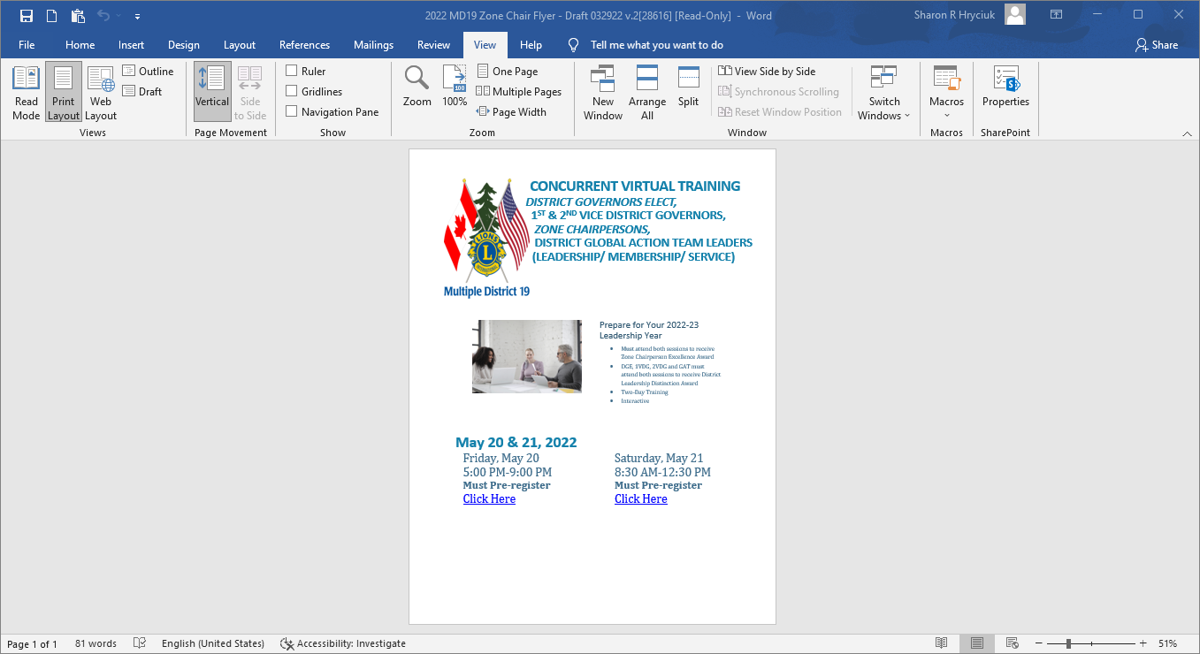 



**June 24-28, 2022 - Lions Clubs International Convention** Every year, lions and leos from around the world gather in one place to celebrate the past, present and future of service. it’s when we catch up with friends from around the world, see what’s going on in the organization, and make decisions about the future.

**Armstrong Lions Club** No rport **Enderby Lions Club**

The Enderby Lions are up and running again. We are buying wood and cutting it and bundling it for sale to local and tourists.  
The Mother's Day Breakfast is in the planning stage. All Mothers do not pay for their breakfast. It is to be held at the Lions Gazebo. More information to come.  
We are having a Shredding Truck come on the 23rd of April at the local Credit Union parking lot 9am - 2:30 to be held in conjunction with the town cleanup. We will be holding a barbeque for all the cleaners.  
We are in the planning stages for our Funtastic Beer Gardens held on the July long weekend.  
Our club is also holding a dinner for the Ukrainian situation on May 28, 2022 at the Splatsin Centre. There will be more information as it comes in.  
Our Garage Sale will hopefully be up and running mid April.

**Lake Country Lions Club**

March 16. Lake County Lions welcomed guests from the former Rutland Lions to attend our first in-person meeting. Coffee and desserts were offered, instead of our traditional meal.  
April 23 Lake Country Lions are co-operating with Winfield Memorial Hall in a Spring Garage Sale and fundraiser.

**Lumby Lions Club**

The Lumby Lions are back to in-person meetings! Come visit us on the first Tuesday of the month at 7:00 pm at the Lumby Legion. The Lumby Lions continue to support children, seniors and events in our community, including this month's recipients Lumby Fire Department Partners in Safety and Lumby & District Wildlife Club Fishing Derby.  
The Lumby Lions campground opens Friday, April 1, 2022 and we are so pleased to welcome this year's campground host, Cheryl Marsden.

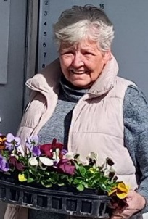 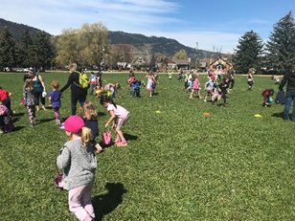 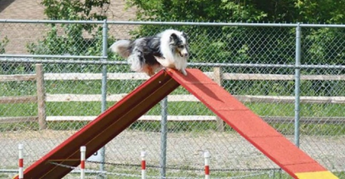  
Cheryl Marsden Easter Egg Hunt Dog Ability Trials

As the province begins easing restrictions and opening up to broad community events, the Lumby Lions are so pleased to get busy again! We will be participating in the following events:  
Friday, April 22, 2022 Earth Day clean-up   
Sunday, April 17, 2022 Community Easter Egg Hunt to be held in the Oval Park   
Friday April 22 to Sunday April 24, 2022 Dog Agility trials   
Friday, June 10 to Sunday, June 12, 2022 Lumby Days

**Vernon Lions Club**March 17th a fabulous St Patrick’s stew was prepared and served by Lions Ralph and Mike. This was followed by the induction of three new members – Greg Poirier, Valene Reckhard and Ron Mare. Nominations for the 2022-2023 Board of Directors gave us a full slate of officers for next year. The evening ended with limericks, prizes and fun.

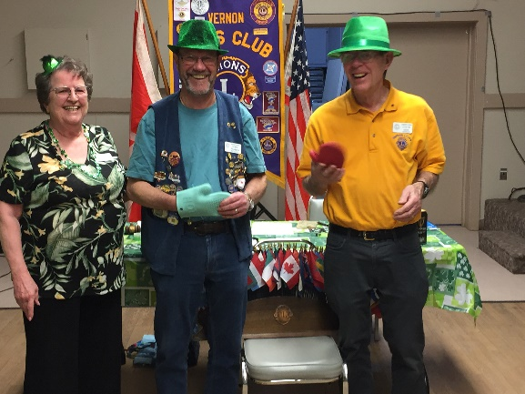 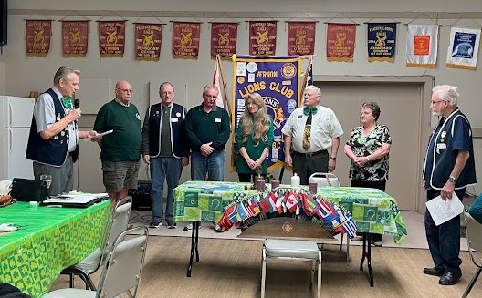  
 Presentation to Chefs Lion Ralph and Lion Mike Candle Light Induction ceremony Lion Bill and Lion Ken  
 Welcome Lions Greg, Valene and Ron.

An upcoming event in April is our bottle drive on April 9 being held at Vernon Storage Center, Upper Lot on 27th Ave. The Vernon Lions are busy securing sponsors for both the Golf Tournament on May 28 and the Ducks for Dogs duck race on June 25. Ticket sales to “Adopt a Duck” began April 2 and are available at various stores in Vernon as well as from our Vernon Lions members. Check our website for more information. <https://e-clubhouse.org/sites/vernon_bc>

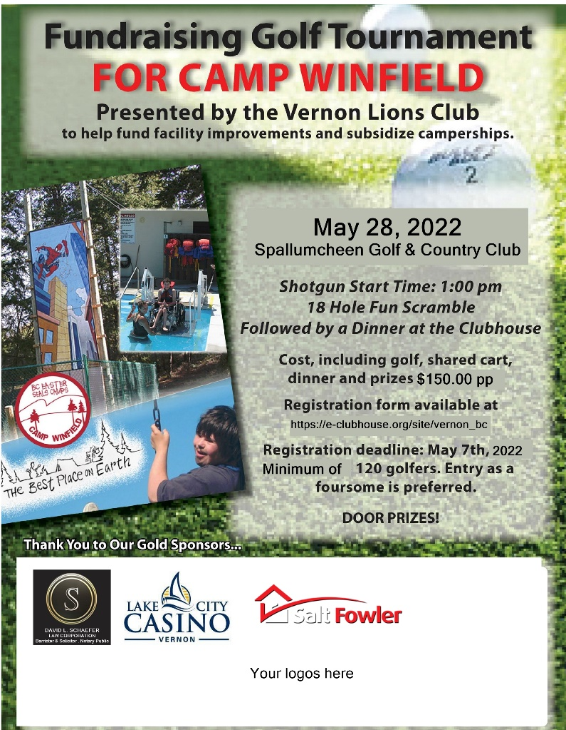 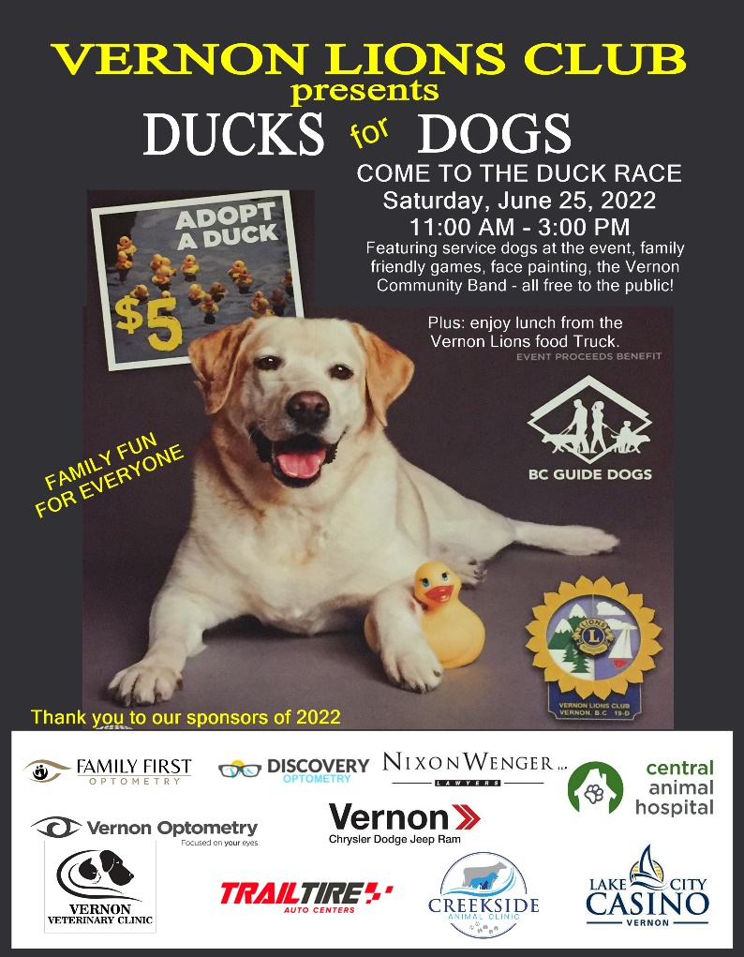

**Important dates to remember**



**April 23, 2022 9 AM–** Cabinet meeting via zoom

**April 23, 2022 10 AM** - Spring Conference via zoom -register at <mailto:19DLions@gmail.com>

**May 7, 2022** – Camp Winfield Clean-up

**May 8, 2022** – Camp Winfield meeting 9 AM – 11 AM

**May 8, 2022** – District D Canada picnic at Camp Winfield 12 noon. Picnic at 1 PM - Watch for registration in your email

**May 5-8, 2022** - Northwest Lions Leadership Institute. For more information visit the website www.nwlli.org

**May 20-21** - VIRTUAL TRAINING - DISTRICT GOVERNORS ELECT, 1ST & 2ND VICE DISTRICT GOVERNORS,   
 ZONE CHAIRPERSONS, DISTRICT GLOBAL ACTION TEAM LEADER

**June 11, July 16 and/or August 27** – Officer Training

**June 24-28, 2022** - 2022 LCI Convention, Montreal.

