**What’s New in 19D-1 Zone Chair: Lion Sharon Cain JUNE 2022**



**District Cabinet contacts:**

District Governor: Joyce Stevens  
 509-670-7527  
 [jstevens98826@gmail.com](mailto:jstevens98826@gmail.com)

1st Vice DG: Debbie Allan   
 250-554-1498  
 [dandballan@telus.net](mailto:dandballan@telus.net)

2nd Vice DG: Michael Livingstone  
res: 250-497-8486 cell: 250-809-6027  
 [mickstone2@gmail.com](mailto:mickstone2@gmail.com)

Cabinet Secretary:

District D Bulletin Editor: Debbie Bostock   
 250-819-6075   
 [debbiebostock@gmail.com](mailto:debbiebostock@gmail.com)

District D Website Editor: Sharon Cain  
 res: 250-545-2722 Cell: 250-540-8270   
 [sharoseh43@gmail.com](mailto:sharoseh43@gmail.com)

Websites:

**MD19** <https://lionsmd19.org>

District D <https://e-district.org/sites/19d>

**LCI** [hts://lionsclubs.org](https://lionsclubs.org)

**Border Crossing** <https://lionsmd19.org/newsletters.php>

**Armstrong Lions Club**<https://e-clubhouse.org/sites/armstrong/>

**Enderby Lions Club** <https://enderbylionsclub.org/>

**Lake Country/Winfield Lions Club**[www.lakecountrylions.com](http://www.lakecountrylions.com)

**Lumby Lions Club**  
 <https://e-clubhouse.org/sites/lumby_bc/>

**Vernon Lions Club**[Https://e-clubhouse.org/sites/vernon_bc](https://e-clubhouse.org/sites/vernon_bc)

Bulletin Editor: Sharon Cain  
250-545-2722  
**Cell: 250-540-8072  
[sharoseh43@gmail.com](mailto:sharoseh43@gmail.com)

**What’s happening in our World…. - ZC *Sharon Cain***

**REDISTRICTING APPROVED —** The club delegates to the MD19 Special Convention on June 4, 2022 voted to approve the MD19 Redistricting Plan by a vote of 283 “Yes” (60%) to 189 “No” (40%). Check the Redistricting page for details on the proposed redistricting plan and the redistricting process.

**A New Address for the MD19 Office!** Same location – new street name.

MAY 1, 2022, our VIRTUAL move will be completed and the official address of our Multiple District 19 Office will be:

**4141 Bennett Drive  
Bellingham, WA 98226**

**What’s Happening in our Zone**

***officer Training - Register NOW***

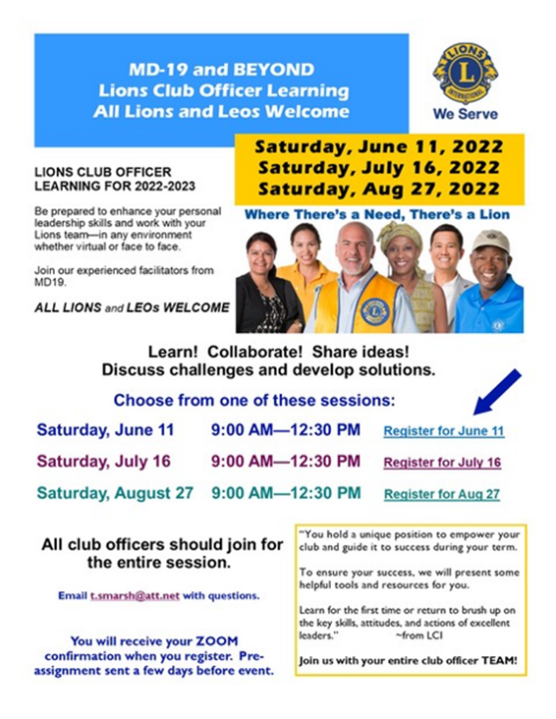

**Sunday June 12 – Zone meeting/BBQ at 3708 Razorback Crt, Vernon. Please send in your numbers. Have heard from Lumby, Vernon and Enderby.**

**Armstrong Lions Club**

No new events. On-line Bingo continues.

**Enderby Lions Club**

The Enderby Lions had a Mothers Day breakfast on a really chilly day with several hundred people attending. They helped with the school breakfast (drive through) for the Graduating class from A. L. Fortune School. And of course, our Garage Sale is up and running again on Fridays, Saturdays and Sundays through out the summer.

We the Enderby Lions held a dinner last Saturday for the Ukraine selling 500 tickets (sold Out). Look on our website for pictures. <https://www.facebook.com/media/set/?set=a.5061165457285979&type=3>

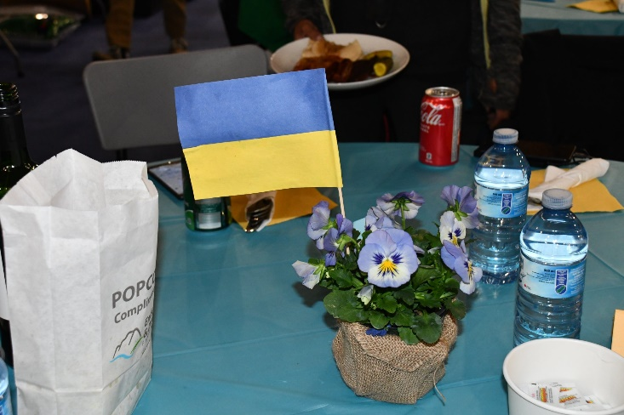 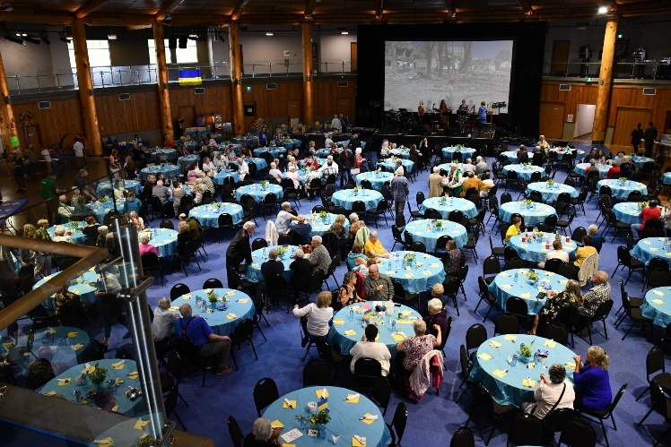

**Lake Country/Winfield Lions**

June will be a busy month for Lake Country Lions;

Sunday June 5, the Lake Country Lion will be in the Oyama Day Parade. We have candies for the kids, and a donation to Oyama Community Club.  
This year, Lake Country-Winfield Lions have donated $3,000 to complete landscaping project and the Oyama Community Hall.  
Our last meeting will be June 15 at the Lions Den; then the wind-up BBQ on June 29.  
At our BBQ we will install the new president and executive. We will also welcome two new Lions who are transferring from the Rutland Lions Club.

**Lumby Lions Club**

The Lumby Lions will once again host the beer garden during Lumby Days June 9-12. Lumby Days will be an exciting time as it is the Village of Lumby's "Finally" 65th birthday.

Come enjoy the cheapest beer in the Okanagan, midway rides, Duck Race for the Health Society, Show and Shine Car Show, live music, fabulous food and many, many more fun activities.

The Lumby Lions will wind up the year on July 10th as we celebrate our annual picnic and installation of officers

**Vernon Lions Club**The Vernon Club has been busy organizing the food truck and grill trailer for upcoming events in June.



Big thanks to Mike Herrling and Eric Reckhard for the wonderful job restoring the grill trailer.

Several Vernon Lions participated in the clean up at Camp Winfield planting flowers and raking and other maintenance repairs.



Mike Herrling has volunteered to be on the board of directors for Camp Winfield - a big task and a big thank you from the Lions.

A Golf Tournament was held on May 28 to raise money for the children at Camp Winfield, this was a major signature event and required a great deal of work by all the club members, although this was a success due to everyone helping, the big gratitude goes to Michele Materia-Baker and Erick Reckhard as they put hours and hours into this event and because of this effort the event raised $17,000.00 for children’s camperships. Well done.

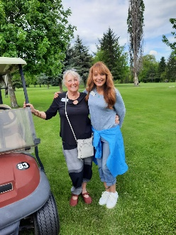 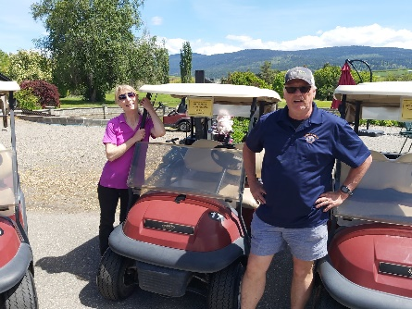 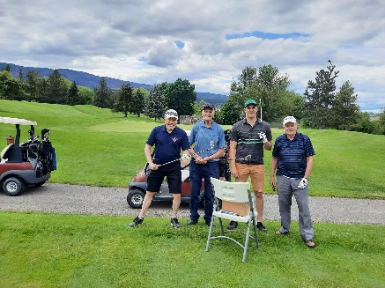 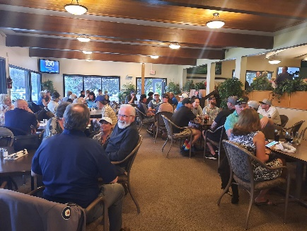  
Bobbe MacKenzie & Eric & Valene Reckard Brian Barnett, Nick Shaigec (90 yrs) The dinner crowd  
 Michele Materi-Baker Nick’s grandson and Brian Willows

For more great golf pictures visit our Facebook page at: <www.facebook.com/Vernon-Lions-Club-Vernon-BC>

We are looking forward to the Creative Chaos event in June and another big signature event Ducks For Dogs. We are closing in on selling our 4000 duck tickets so if you want some, better hurry.

Two of our club members have been honored by Lions International for their years of service. Bill Friend has served for 60 years and Brian Willows has served 35 years.

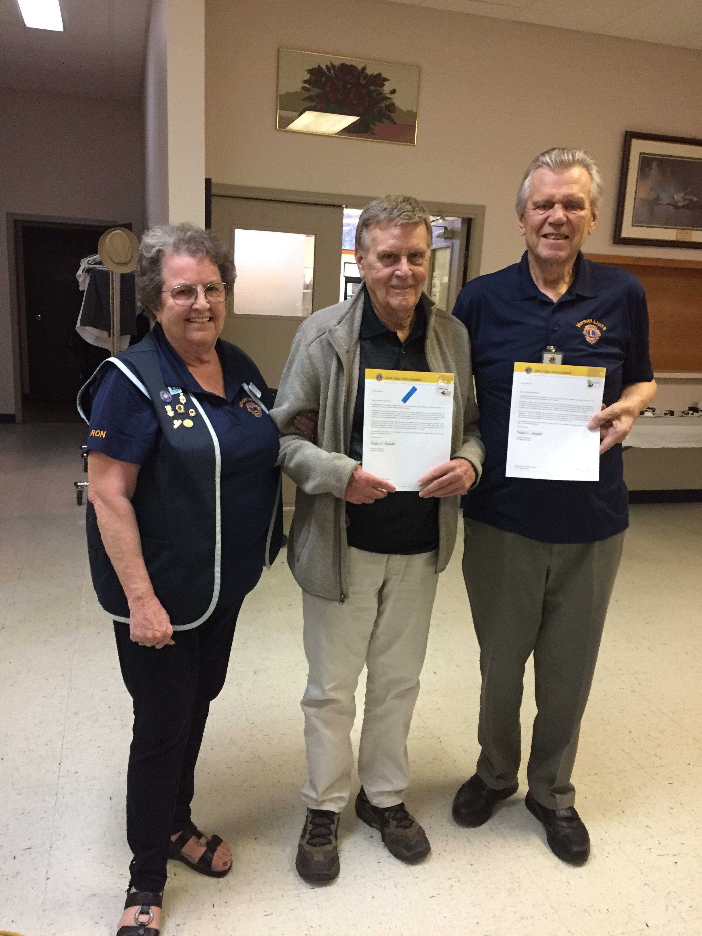

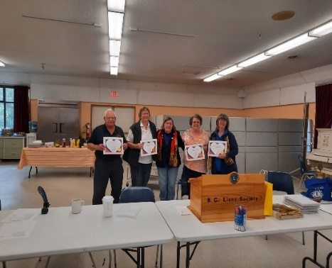 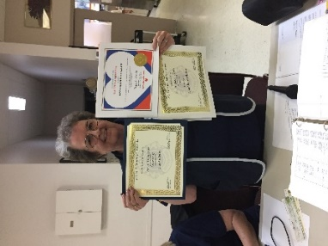

Our own Zone Chair Sharon Cain received several awards for outstanding service at the District Picnic May 8 in Winfield. The awards were presented by District Governor Joyce Stevenson, Zone Chair Sharon has worked so hard and has done so much for our Zone not only doing all the many tasks of a Zone Chairperson but encouraging and mentoring others in the different clubs, Well Done Zone Chair Sharon Cain. Vernon Lions stand proud.

**Important dates to remember**

**June 11, July 16 and/or August 27** – Officer Training

**June 12** – 4th Zone Meeting – Zone Chair’s back yard at 11 AM - BBQ, awards, socializing

**June 24-28, 2022** - 2022 LCI Convention, Montreal.

In June......

𝐖𝐞 𝐜𝐨𝐦𝐦𝐞𝐦𝐨𝐫𝐚𝐭𝐞 𝐍𝐚𝐭𝐢𝐨𝐧𝐚𝐥 𝐈𝐧𝐝𝐢𝐠𝐞𝐧𝐨𝐮𝐬 𝐇𝐢𝐬𝐭𝐨𝐫𝐲 𝐌𝐨𝐧𝐭𝐡. 𝐃𝐮𝐫𝐢𝐧𝐠 𝐭𝐡𝐢𝐬 𝐦𝐨𝐧𝐭𝐡, 𝐭𝐚𝐤𝐞 𝐭𝐢𝐦𝐞 𝐭𝐨 𝐫𝐞𝐜𝐨𝐠𝐧𝐢𝐳𝐞 𝐭𝐡𝐞 𝐫𝐢𝐜𝐡 𝐡𝐢𝐬𝐭𝐨𝐫𝐲, 𝐡𝐞𝐫𝐢𝐭𝐚𝐠𝐞, 𝐫𝐞𝐬𝐢𝐥𝐢𝐞𝐧𝐜𝐞 𝐚𝐧𝐝 𝐝𝐢𝐯𝐞𝐫𝐬𝐢𝐭𝐲 𝐨𝐟 𝐅𝐢𝐫𝐬𝐭 𝐍𝐚𝐭𝐢𝐨𝐧𝐬, 𝐈𝐧𝐮𝐢𝐭 𝐚𝐧𝐝 𝐌é𝐭𝐢𝐬 𝐏𝐞𝐨𝐩𝐥𝐞𝐬 𝐚𝐜𝐫𝐨𝐬𝐬 𝐂𝐚𝐧𝐚𝐝𝐚. 🍁   
 