**What’s New in 19D-1 Zone Chair: Lion Sharon Cain September, 2021**

**District Cabinet contacts:**

District Governor: Joyce Stevens  
 509-670-7527  
 [jstevens98826@gmail.com](mailto:jstevens98826@gmail.com)

1st Vice DG: Debbie Allan   
 250-554-1498  
 [dandballan@telus.net](mailto:dandballan@telus.net)

2nd Vice DG: Michael Livingstone  
res: 250-497-8486 cell: 250-809-6027  
 [mickstone2@gmail.com](mailto:mickstone2@gmail.com)

Cabinet Secretary: Jeanette Britton   
 509-548-1947   
 [brittonjeannette@gmail.com](mailto:brittonjeannette@gmail.com)

District D Bulletin Editor: Shelley Costello   
 509-881-5103   
 [shelan1437@aol.com](mailto:shelan1437@aol.com)

District D Website Editor: Sharon Cain  
 res: 250-545-2722 Cell: 250-540-8270   
 [sharoseh43@gmail.com](mailto:sharoseh43@gmail.com)

Websites:

**MD19** <https://lionsmd19.org>

District D <https://e-district.org/sites/19d>

**LCI** <https://lionsclubs.org>

**Border Crossing** <https://lionsmd19.org/newsletters.php>

**Armstrong Lions Club**<https://e-clubhouse.org/sites/armstrong/>

**Enderby Lions Club** <https://enderbylionsclub.org/>

**Lake Country/Winfield Lions Club**[www.lakecountrylions.com](http://www.lakecountrylions.com)

**Lumby Lions Club**  
 <https://e-clubhouse.org/sites/lumby_bc/>

**Vernon Lions Club**[Https://e-clubhouse.org/sites/vernon_bc](https://e-clubhouse.org/sites/vernon_bc)

Bulletin Editor: Sharon Cain  
250-545-2722  
**Cell: 250-540-8072  
[sharoseh43@gmail.com](mailto:sharoseh43@gmail.com)



The future depends on YOU!  
Ask someone to become a Lion!

**What’s happening in our zone**

Looking with optimism for a successful Lions year for our D1 clubs. Some clubs in our area are starting to meet in person and COVID is still restricting others. I am looking forward to setting up a schedule to visit each club starting in October so watch your next newsletter for dates.

The **Vernon Lions Club** are hosting a Shredding event on Sept. 18. They have been using Facebook to advertise for the event and also for new members.

  
  
Both ads seem to be attracting lots of attention – thanks to Lion Eric for your dedication. Several members continue to do volunteer work in the community and are racking up the Service hours. Congratulations to those members.

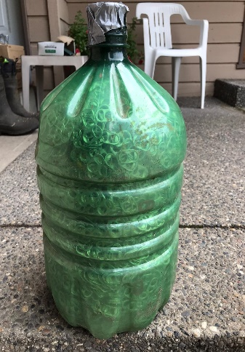

Lion Ralph Whittle and his friends in Cold Lake Alberta have been collecting these tabs for a couple of years. This is what 5 gallons of tabs looks like. These will go a long way to helping someone get a wheel chair. Thank you to Lion Ralph.

The **Lake Country/Winfield Lions Club** are holding their first meeting on September 8 and they will be hosting our first Zone meeting on Sunday, September 19.  
August 31, Lions Rod, John, Dave, Bonnie, Jerome, Alf and Anne helped the Animal Rescue (CDART) move out of the Winfield Hall to the Easter Seal Camp. They worked about 4 hours each. There were a few other trucks hauling but it looks like the Lions Club hauled the “Lions Share”. Great job Lake Country Lions!

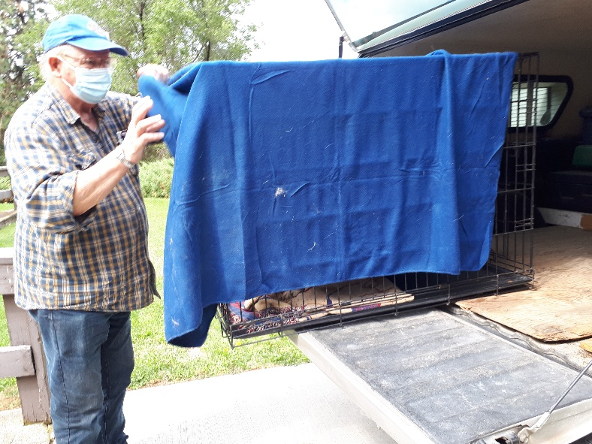 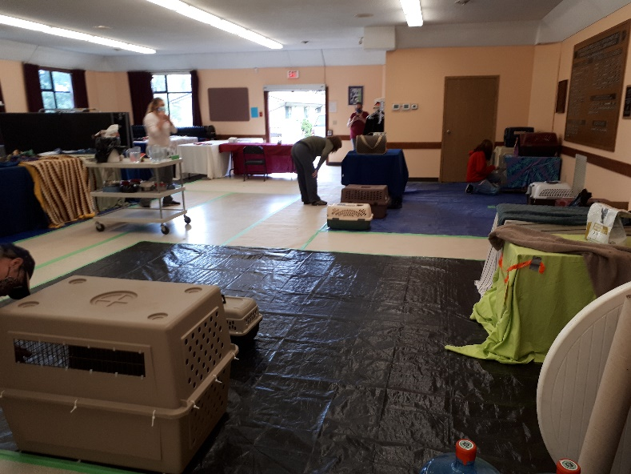

The **Enderby Lions Club** are having in person board meetings but not General Meetings yet. They are just winding up their successful annual garage sale on Sept. 5.

The **Armstrong Lions Club** are continuing with their Bingo nights.

The **Lumby Lions Club** are busy with their campsite and have been hosts to several evacuees this summer. They also are active volunteering in their community.

If your clubs have anything to report, send your items and pictures along anytime throughout the month. Love hearing all your news and sharing it with others.

*Until next month - ZC Sharon Cain*



**MD19 2021-22 First Half Dues Statements**: On July 12th through the 14th the 1st Half MD19 Dues Statements were emailed or mailed as a hard copy if no email address was provided, to Club Treasurers or Secretary-Treasurers. If your club has not received your dues statement, please call or email the MD19 Office. If you email, please indicate to which club you belong. You can also contact me and I can look up your statements for you.

**MMRs**Secretaries – don’t forget to always get your membership reports in by the 20th of each month.

**A note from D19 North LCIF Coordinator – Ken Cain**The LCIF Campaign 100 is in its final year, heading towards our goal of raising $300 million dollars. The first of July weekend, we had the opportunity to receive a $10,000 emergency grant from LCIF to help deal with the people evacuated from the forest fire in Lytton, BC. The grant was approved within 24 hours, which is reasonably typical for emergency grants. The Hope Lions club in BC, near Lytton, became the focal point of representing Lions and the distribution of funds. Lions Clubs and private individuals across Canada have stepped up to provide financial assistance. It is amazing to see that a village can be destroyed in moments notice.

With 100% of donations going towards grants and programs, LCIF empowers the compassionate service of Lions and those who need our help. Although those benefitting from your support may never know of your generosity, Lions Clubs International Foundation and our beneficiaries are grateful for your support.

 In Canada you can make an online donation here [https://lionsofcanadafundforlcif.ca/#donate](https://lionsofcanadafundforlcif.ca/%23donate)

**ALERT FUND**

We are facing some challenges with fires in our own back yards. All areas do not meet qualifications for funds from LCIF. That is where our ALERT program comes in. If anyone wishes to help, donations can be made to **Lions Canada MD19 ALERT Fund**, attn: PDG Wayne Atkinson, 3341 McQueen Rd., Westbank, BC V4T 1B7. As needs are assessed, the funds will be distributed accordingly.

**Musings of the Council Chair – John Moralek**

Perhaps some of you have heard the term REDISTRICTING. What is it and why should we do it?

The multiple district is looking at changing the boundaries of the districts. The reason is that the membership in some of the districts is getting too small to provide the necessary leadership such as new Zone Chairpersons, Vice District Governors and District Governors.

By combining and realigning some of the districts, it is hoped that the larger pool of available persons will allow us to fill all vacancies. The strategic planning committee at the request of PCC Al Hedstrom started the process last year when the multiple district had almost 11,000 members. Currently, the membership is just under 10,000, so you can see why we may need this change. The committee is working with the districts to come up with a plan that will be viable and workable.

How will this affect you as a Lion? Well, probably only minimally as your club will stay in its current zone, but the zone number will change. For example, if you are now in zone B3 you may be in zone O8 or something like that. As Lions you will have the final say at your spring convention to approve the amalgamation. For more details and a power point presentation visit the MD website [www.lionsmd19.org](http://www.lionsmd19.org)

**Advice from International Director, Allan Hunt**   
I hear stories about how Lions are the best kept secret in the world. That is relatively true, but does anyone wonder why that is? We will wear a shirt or jacket professing our support to our favorite sport or team. We dutifully wear our Lions Club shirt and pin to our meetings or when we are working on a project. Why not wear your pin always and your Lions shirt whenever you can? Do not let your shirt wear out in the closet. Stop keeping Lions a secret!

**Important dates to remember**



**September 6 –** Labor Day  
**September 9 -** 2021 USA CANADA LIONS LEADERSHIP FORUM — No, it is not too soon to make plans for the fall, in general, or in particular for the 2021 USA/Canada Lions Leadership Forum. So save the date— September 9 to 11, 2021. The place: Des Moines, Iowa USA. The Forum is open for online registration right now. ***Check out COVID–19 restrictions and precautions, travel guidelines, and registration information.***   
**September 19** - 1st Zone Meeting: 10:00 AM at Lake Country Lions Den. With the current COVID restrictions the den is allowed 20 people. All people entering the den must be double vaccinated, wear a mask and use hand sanitizer and of course practice social distancing.   
The Lake Country Lions will provide coffee and a sweet and a light lunch for the event.  
Our guest speaker for the meeting is **Michael Livingstone**, Global Membership Team. The theme will be membership and so I would like your clubs to attend with President, Secretary, Membership Chair and one other member of your club if possible.   
Please reply stating name, club position and contact information. Reply to me at [sharoseh43@gmail.com](mailto:sharoseh43@gmail.com) or President Michele Chartrand at [vmcharty@telus.net](mailto:vmcharty@telus.net) . Remember – only 20 people allowed so reply early.  
**September 25** – 3rd Officer Training via Zoom  
Have you taken the Multiple District Officer Training this year? It has been offered on three different dates. May 22, we had TEN District D clubs attend the training! Excellent! The 2nd was held on July 24th. There is one more training date offered: September 25. The training is four hours via Zoom, 8:30-12:30. It is recommended that several officers from a club attend together, therefore being set to support each other during the ensuing year. Email [t.smarsh@att.net](t.smarsh@att.net%20) to register. **October 11** – Thanksgiving – Canada  
**October 25** – DG Joyce Stevens visitation at Enderby  
**October 30** – 19D Cabinet Meeting – West Bank Lions Club

**November 4 – 6** - 100th MD Annual Convention, Virtual  
**December 5** – 2nd Zone Meeting via Zoom  
Everyone welcome. Focus of this meeting will be service.

**March 6, 2022** – 3rd Zone Meeting  
Everyone welcome. Come meet our GLT – Learn about leadership, elections and much more.

**April 22-23, 2022** District D Spring Conference – Icicle Village Resort, Leavenworth, WA

**May 5-8, 2022**– Northwest Lions Leadership Institute. For more information visit the website [www.nwlli.org](http://www.nwlli.org)

**June 24–28, 2022** - 2022 LCI CONVENTION MOVED TO MONTREAL — Due to the ongoing challenges presented by the coronavirus (COVID-19), the LCI board of directors voted to relocate the 2022 Lions International Convention from New Delhi, India to Montréal, Canada. Details will follow as they become available.



Zone 19D-1