**What’s New in 19D-1 Zone Chair: Lion Sharon Cain December, 2021**

**District Cabinet contacts:**

District Governor: Joyce Stevens  
 509-670-7527  
 [jstevens98826@gmail.com](mailto:jstevens98826@gmail.com)   
1st Vice DG: Debbie Allan   
 250-554-1498  
 [dandballan@telus.net](mailto:dandballan@telus.net)   
2nd Vice DG: Michael Livingstone  
res: 250-497-8486 cell: 250-809-6027  
 [mickstone2@gmail.com](mailto:mickstone2@gmail.com)   
Cabinet Secretary: Jeanette Britton   
 509-548-1947   
 [brittonjeannette@gmail.com](mailto:brittonjeannette@gmail.com)   
District D Bulletin Editor: Debbie Bostock   
 250-819-6075   
 [debbiebostock@gmail.com](mailto:debbiebostock@gmail.com) District D Website Editor: Sharon Cain  
 res: 250-545-2722 Cell: 250-540-8270   
 [sharoseh43@gmail.com](mailto:sharoseh43@gmail.com)

Websites:

**MD19** <https://lionsmd19.org>   
**District D** <https://e-district.org/sites/19d>   
**LCI** <https://lionsclubs.org> **Border Crossing** <https://lionsmd19.org/newsletters.php>

**Armstrong Lions Club**<https://e-clubhouse.org/sites/armstrong/>

**Enderby Lions Club** <https://enderbylionsclub.org/>

**Lake Country/Winfield Lions Club**[www.lakecountrylions.com](http://www.lakecountrylions.com)

**Lumby Lions Club**  
 <https://e-clubhouse.org/sites/lumby_bc/>

**Vernon Lions Club**[Https://e-clubhouse.org/sites/vernon_bc](https://e-clubhouse.org/sites/vernon_bc)

Bulletin Editor: Sharon Cain  
250-545-2722  
**Cell: 250-540-8072  
[sharoseh43@gmail.com](mailto:sharoseh43@gmail.com)



The future depends on YOU!  
Ask someone to become a Lion!

**What’s happening in our zone** ZC Sharon Cain

December always brings out joy and happiness – colored lights, festive activities and dinners, children’s excitement for Santa – all making the season bright. These things are wonderful but what I really want for everyone is health, happiness and peace. Lions truly make a difference in people’s lives and our reward is first happiness for those we help and more importantly for ourselves – second is health (glasses, teeth, diabetes aide, etc.) and hopefully peace. We set an example in our communities by working together for the good of all. Thank you to the Lions of D1 for making a difference in each of your communities and may the Merry Christmas of this year continue to be safe and merry for 2022.

Christmas will not be so merry for all the folks displaced with floods. First with forest fires and now with flooding issues. Please keep these people in your thoughts and prayers, and if there is anything you hear that we as Lions can help with, please make an effort to make that happen. Our District Governor is working on a grant from LCIF for the longer term needs but if there are some immediate needs anyone knows about that we can help with, let’s do that too. A contribution to LCIF is one way to help – as a club or as an individual.

We had a great convention at the beginning of November. It was well done with lots of great ‘panels’ and we were able to listen to all of them in the 30 days following the convention. Our guest speaker, International Vice President Patty Hill, was terrific. What a great speaker. If you did not attend you missed a wonderful opportunity. Fun night was a very informative trivia-based evening. Those of us who attended had lots of fun and Trudy Parke, Vernon Lions Club won a prize. Although not the same as having an in-person convention, it was still so good to see familiar faces and to catch up with our fellow lions and friends.

I had the pleasure of visiting all of clubs in D1 with DG Joyce Stevens in October and 2nd VDG Michael Livingstone throughout November. Both DG Joyce and 2VDG Michael spoke about the structure of our district, District goals are Service, importance of a Club Administrator, LCIF in times of disaster, Leadership, Membership, and Redistricting coming in the future. It was announced that the Spring Conference will once again be by ZOOM on April 22-23 and will be followed by picnics – one on each side of the border.

Our second zone meeting was held on Dec. 5 with special guest GST Dorothy Nellis speaking to us on Service. When we provide service to another it is then when one truly feels fulfilled. She stressed that it is important to enter all club and member service on MyLion. We will grow as long as we serve.

**Armstrong Lions Club**ZC Sharon Cain and 1VDG Michael Livingstone visited the Armstrong club on Nov. 27. It was our pleasure to perform the induction ceremony for Lion Gordon who was sponsored by Lion Dave. Welcome Gord. Bingo remains the main fundraiser for the club and they have undergone a complete overhaul and are now successfully calling Bingo every Tuesday night. You can join in the Bingo by searching for Armstrong Bingo Facebook page. The Armstrong Club are donating $500 to each of the Christmas Toy Drive and the Christmas Hamper Drive.  
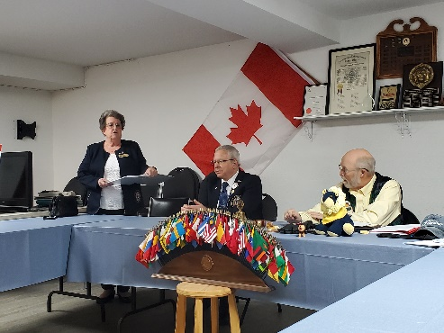 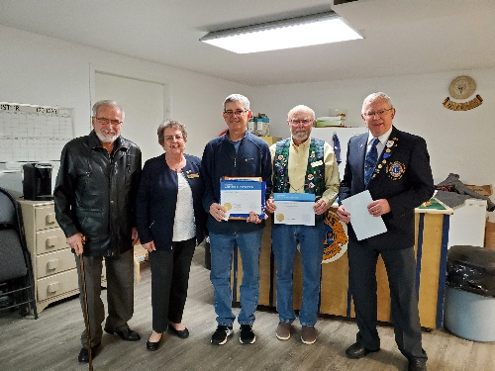 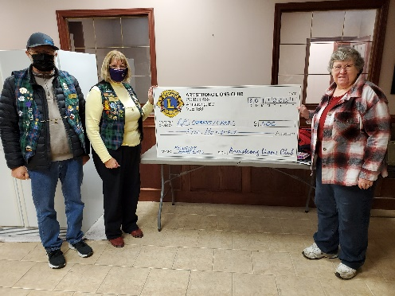

**Enderby Lions Club**   
The Enderby Lions are challenging clubs and individuals across Canada. Join the challenge if you can. You can send a cheque to: Lions of Canada fund for LCIF  
 c/o Stan Durward  
 Box 38  
 Sunderland, Ontario L0C 1H0

Or you can go on-line at <https://lionsofcanadafundforLCIF.ca> to make a donation with a credit card.

**Be sure to attach a note that the donation is for “Flood Disaster Relief” in British Columbia, Canada**

The Enderby Lions wood crew keep busy – they built 75 bundles Dec. 1 in approximately 2 hours.

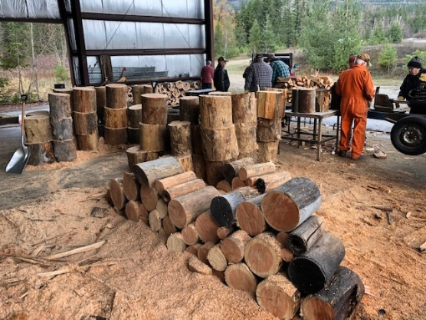 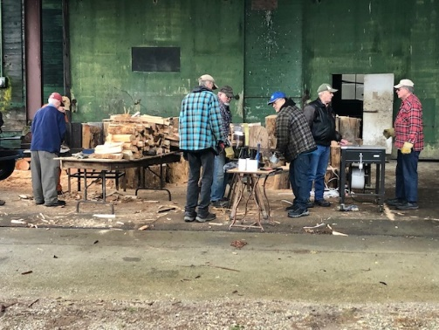 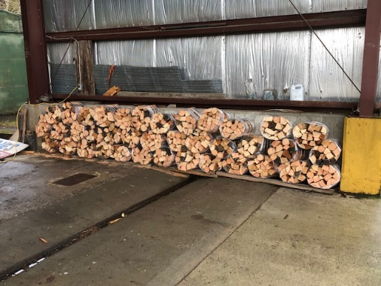

**Lake Country Lions Club**

ZC Sharon Cain and 1VDG Michael Livingstone visited Lake Country club on November 10  
Lake Country-Winfield Lions have collected, sorted and delivered 440 pair of glasses; our Fall contribution to Vision Care. Thank you to Lion Al and his wife, Cheryl for their time and efforts.  
Lake Country-Winfield Lions fund-raising project, catering at Lake Country Winter Craft Fair, raised $336 to purchase a popcorn dispenser for Lake Country Blue Heron Care Home. Popcorn is a simple treat for seniors which they can serve for themselves. This treat can brighten a day.  
Lake Country-Winfield Christmas Toy Project in support of Lake Country Food Bank has begun. Our club donates $1000 worth of toys and collects, sorts and distributes other gifts from the community. The project is just beginning; a special thanks to Lion Deb and her group of community and Lions volunteers who have begun this month-long project.

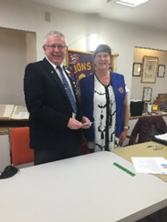 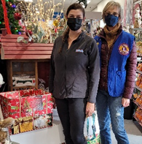 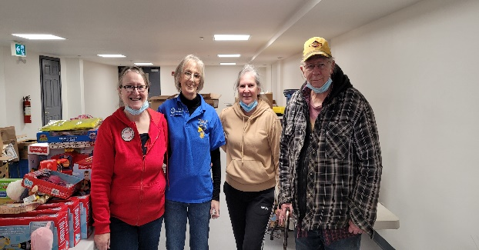  
 2VDG Michael, Pres. Michele Lake Country Lions Toy Drive

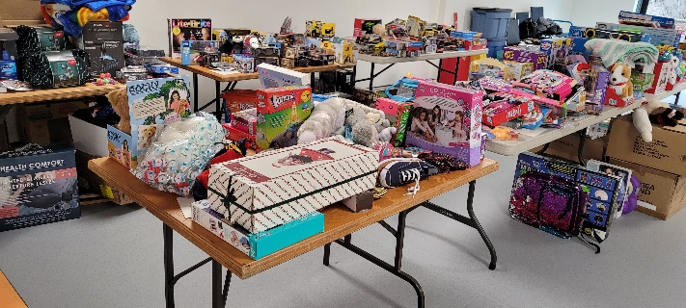 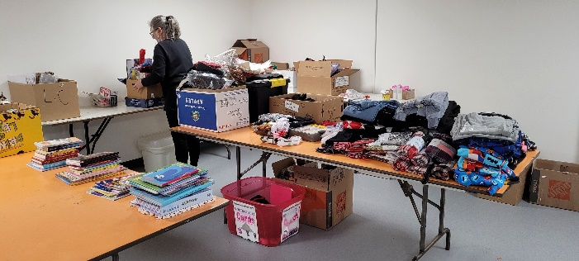

Thanks to Lion members Anne, Jerome Rod, and Michelle for helping plus Cindy Hargreaves and KT Timchuk both volunteers of the food bank. Thanks also goes to Barb Fisher, Shirley's daughter for volunteering as well.

**Lumby Lions Club**ZC Sharon Cain and 1VDG Michael Livingston attended the Lumby Lions November 2nd, 2021 General Meeting. 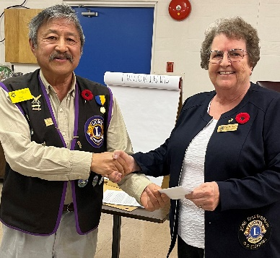 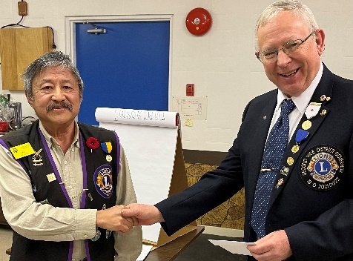

The Lumby Lions supported the No Stone Left Alone ceremony on November 9th, 2021 at the Lumby Cemetery.  
The club is busy preparing for the Salvation Army Kettle Campaign beginning November 26, 2021.  
The Lumby Lions will play a key role in preparing and serving Christmas dinner to Lumby seniors on December 17, 2021.

**Vernon Lions Club**

The Vernon Lions took part in “No Stone Left Alone” at Coldstream Cemetery on Nov. 8. This remembrance ceremony provided an opportunity to educate students about Canada’s rich history of service to country and to remember our fallen by placing the Legion symbol of remembrance, the poppy, at each veteran’s headstone. The Grade 7 class at Coldstream Elementary participated. Those taking part were the Vernon & District Family History Society, Royal Canadian Legion Branch 25, Vernon BC, Vernon Lions Club, The British Columbia Dragoons, and several volunteers who attended and participated including Lawrna Meyers, Bill Carr, Lieutenant Col. Larry Gilchrist, MLA Harwinder Sandu and Mayor Garlick.

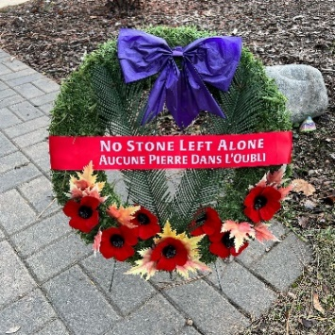 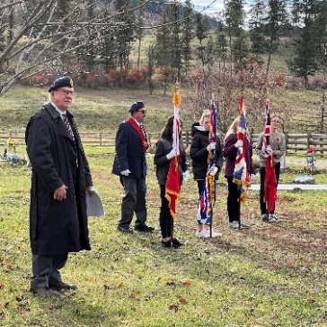 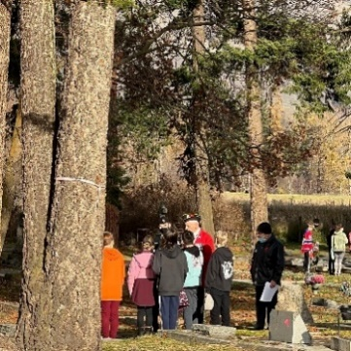 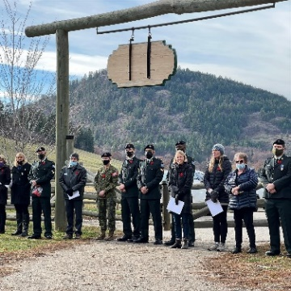

The Vernon Lions teamed up with Project Christmas Elf to adopt one family to provide Christmas gifts and food for them. Project Christmas Elf lends a hand to any families in the Okanagan/Shuswap areas looking for some support this Christmas. The Vernon Lion “Elves” had a ton of fun with this project.  
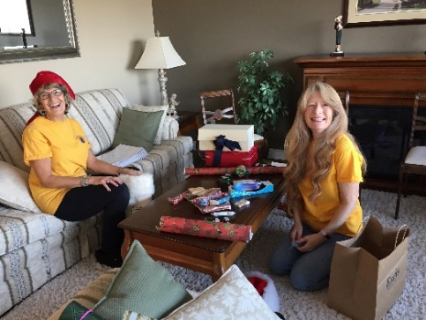 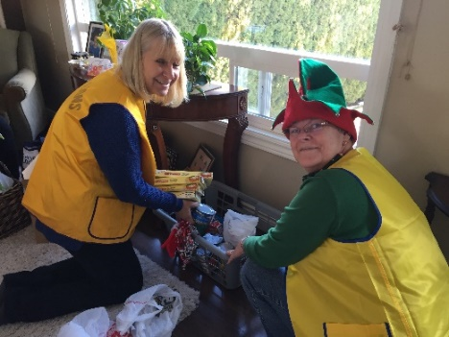 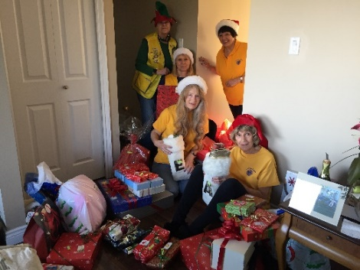

1VDG Michael Livingstone and ZC Sharon Cain visited the Vernon club on Nov. 18. 1st Vice President Carolynn presided at the meeting.

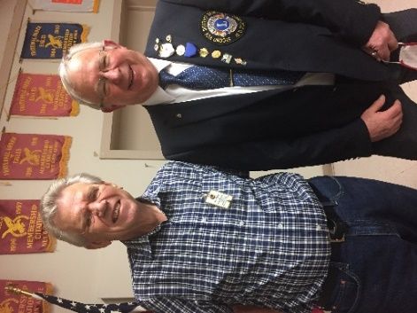 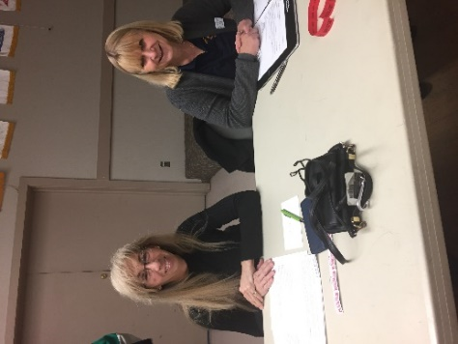 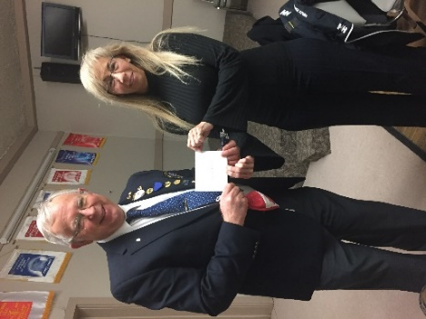  
 Lion Bill and 2VDG Michael Lions Carolynn and Judy 2VDG Michael and Lion Carolynn

**Important dates to remember**



**March 6, 2022** – 3rd Zone Meeting. Everyone welcome. Come meet our GLT Bob Ayotte– Learn about leadership, elections and much more.

**April 22-23, 2022** - District D Spring Conference – Virtual followed by picnics in Washington and in BC.

**May 5-8, 2022** - Northwest Lions Leadership Institute. For more information visit the website www.nwlli.org

**June 24-28, 2022** –

2022 LCI Convention moved to Montreal. Due to the ongoing challenges presented by the coronavirus (COVID 19), the LCI board of directors voted to relocate the 2022 Lions International Convention from New Delhi, India to Montreal, Canada.

