**What’s New in 19D-1 Zone Chair: Lion Sharon Cain January 2022**

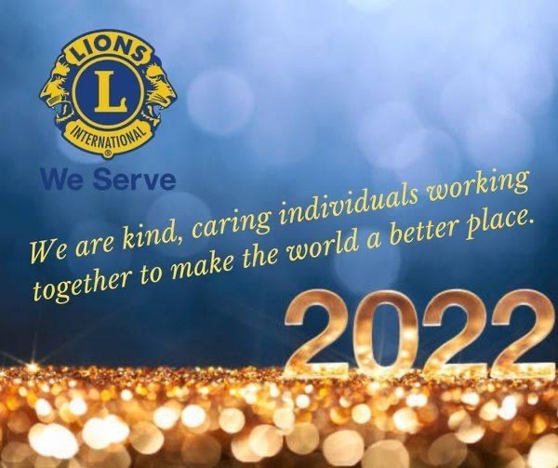

**District Cabinet contacts:**

District Governor: Joyce Stevens  
 509-670-7527  
 [jstevens98826@gmail.com](mailto:jstevens98826@gmail.com)

1st Vice DG: Debbie Allan   
 250-554-1498  
 [dandballan@telus.net](mailto:dandballan@telus.net)

2nd Vice DG: Michael Livingstone  
res: 250-497-8486 cell: 250-809-6027  
 [mickstone2@gmail.com](mailto:mickstone2@gmail.com)

Cabinet Secretary: Jeanette Britton   
 509-548-1947   
 [brittonjeannette@gmail.com](mailto:brittonjeannette@gmail.com)

District D Bulletin Editor: Debbie Bostock   
 250-819-6075   
 [debbiebostock@gmail.com](mailto:debbiebostock@gmail.com)

District D Website Editor: Sharon Cain  
 res: 250-545-2722 Cell: 250-540-8270   
 [sharoseh43@gmail.com](mailto:sharoseh43@gmail.com)

Websites:

**MD19** <https://lionsmd19.org>

District D <https://e-district.org/sites/19d>

**LCI** <https://lionsclubs.org>

**Border Crossing** <https://lionsmd19.org/newsletters.php>

**Armstrong Lions Club**<https://e-clubhouse.org/sites/armstrong/>

**Enderby Lions Club** <https://enderbylionsclub.org/>

**Lake Country/Winfield Lions Club**[www.lakecountrylions.com](http://www.lakecountrylions.com)

**Lumby Lions Club**  
 <https://e-clubhouse.org/sites/lumby_bc/>

**Vernon Lions Club**[Https://e-clubhouse.org/sites/vernon_bc](https://e-clubhouse.org/sites/vernon_bc)

Bulletin Editor: Sharon Cain  
250-545-2722  
**Cell: 250-540-8072  
[sharoseh43@gmail.com](mailto:sharoseh43@gmail.com)

The Best Is Yet to Come

The future depends on YOU! Ask someone to become a Lion!

**What’s happening in our zone**

This time of the year often brings about introspection, reflection and contemplation of what is to come. 2021 has been a year of uncertain recovery and consolidation as society takes stock and re-imagines the post-pandemic world. The status quo is shifting, technology is driving change in unprecedented ways, and the future is fraught with distinct global, economic and environmental challenges. Yet, within this myriad of changes and challenges, opportunity lies ahead for 2022.

Climate change is a global emergency, with citizens pressuring governments and organizations to take action. This shift in values drives a circular economy intending to eliminate waste and pollution by circulating products and materials. Lions can address environmental and social needs through sustainable initiatives that offer considerable opportunities to make a difference and profit.

All of the clubs I visited in October and November are optomistic about 2022 and getting our clubs back on track. We are in another wave of the pandemic; however, the consensus seems to be that we must learn to live with it and move on. Several of our clubs are doing just that and I am so proud of them.

Best of wishes for a successful 2022 and beyond, may all your projects hold and be profitable, may all your service activities help to make better communities, may you all live in health and happiness. Happy New Year.

- ZC Sharon Cain

**Armstrong Lions Club** No report

**Enderby Lions Club** No report

**Lake Country Lions Club** No report

**Lumby Lions Club**

Lumby Lions braved November and December freezing temperatures to ring the bells for the Salvation Army. $4,157.55 was collected in Lumby to help the Salvation Army support vulnerable people in our region. Pictured is Carla Lee, Lumby Lions Tail Twister.

The Lumby Lions also provided financial assistance and helping hands to Lumby seniors during the holiday season, including the Seniors Christmas concert (pictured are Linda Vlasveld and Rhea Abney - Bev Lawrence is missing from the photo). Linda Vlasveld, Elsie Campbell and Smiley Greeno were on hand to prepare and serve Christmas dinner to over 60 dine-in and take-out Lumby seniors.

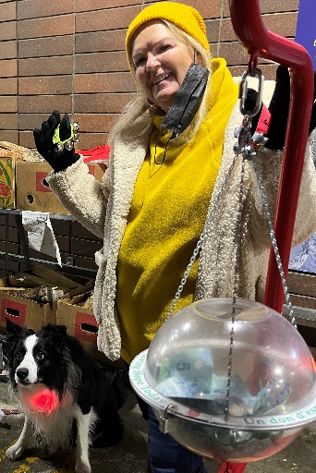 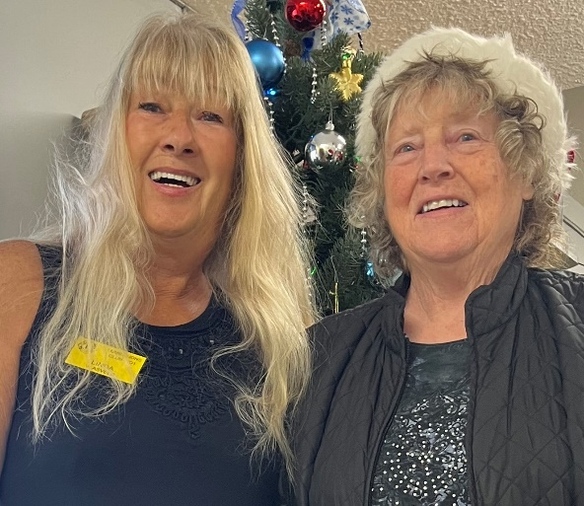 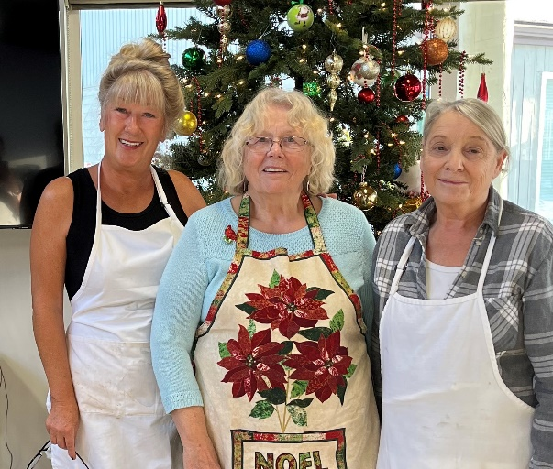

**Vernon Lions Club**

Vernon continued to have in person meetings in December and executive meetings on Zoom.

December 16 was the Lions Christmas party which was a lot of fun. Lion Simon and Partner Sarah provided a lovely Turkey dinner with all the fixings.

Lions Ralph, Mike Smith, Lion June, Lion Jackie and Helper Elf Valene and Lion Judy did a great job decorating the hall. Lions Carolyn, Ralph and Mike Smith provided some fun games with commentator Carolyn doing a fun job. Lion Michele provided our Christmas music. All in all, it was a team effort that turned out great giving everyone’s spirit a big boost.

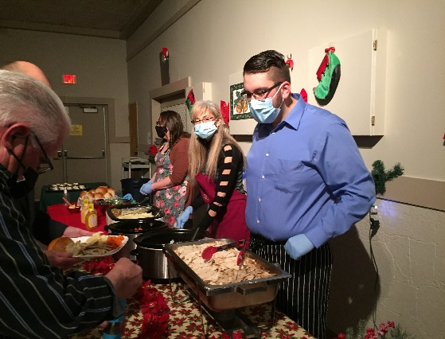 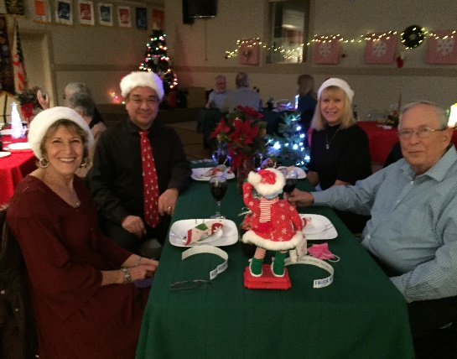 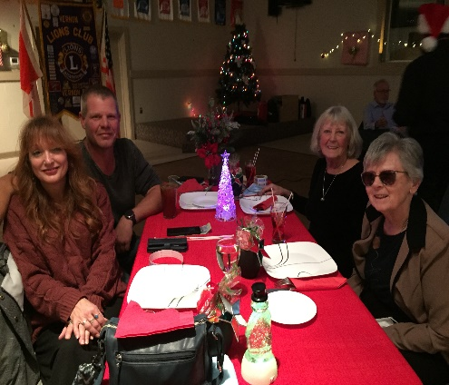

Lion’s Bobbe, Harjinder, Brian B, Marnie, during a busy time still continued to provide many volunteer hours to so many in need.

We all look forward to a New Year filled with Joy and Peace for everyone and a chance to get back out there providing even more services to those in need.

From all of us at the Vernon Lions we wish Happiness and good health to all our Lion friends and families

**Important dates to remember**



**March 6, 2022** – 3rd Zone Meeting. Everyone welcome. Come meet our GLT – Learn about leadership, elections and much more.

**April 22 –** Cabinet meeting via zoom

**April 23, 2022** - District D Spring Conference via Zoom. Picnics to follow in both USA and Canada

**May 5-8, 2022** - Northwest Lions Leadership Institute. For more information visit the website www.nwlli.org

**June 24-28, 2022** - 2022 LCI Convention moved to Montreal. Due to the ongoing challenges presented by the coronavirus (COVID 19), the LCI board of directors voted to relocate the 2022 Lions International Convention from New Delhi, India to Montreal, Canada. Details will follow as they become available.



You have permission to place this ad on your web, Facebook, twitter, etc. pages.

Let’s make our zone grow this year.