**What’s New in 19D-1 Zone Chair: Lion Sharon Cain March 2022**

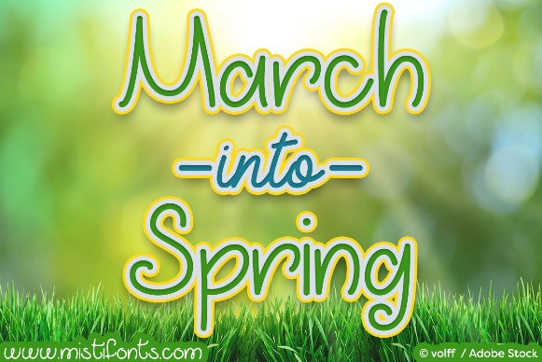

**District Cabinet contacts:**

District Governor: Joyce Stevens  
 509-670-7527  
 [jstevens98826@gmail.com](mailto:jstevens98826@gmail.com)

1st Vice DG: Debbie Allan   
 250-554-1498  
 [dandballan@telus.net](mailto:dandballan@telus.net)

2nd Vice DG: Michael Livingstone  
res: 250-497-8486 cell: 250-809-6027  
 [mickstone2@gmail.com](mailto:mickstone2@gmail.com)

Cabinet Secretary: Jeanette Britton   
 509-548-1947   
 [brittonjeannette@gmail.com](mailto:brittonjeannette@gmail.com)

District D Bulletin Editor: Debbie Bostock   
 250-819-6075   
 [debbiebostock@gmail.com](mailto:debbiebostock@gmail.com)

District D Website Editor: Sharon Cain  
 res: 250-545-2722 Cell: 250-540-8270   
 [sharoseh43@gmail.com](mailto:sharoseh43@gmail.com)

Websites:

**MD19** <https://lionsmd19.org>

District D <https://e-district.org/sites/19d>

**LCI** [hts://lionsclubs.org](https://lionsclubs.org)

**Border Crossing** <https://lionsmd19.org/newsletters.php>

**Armstrong Lions Club**<https://e-clubhouse.org/sites/armstrong/>

**Enderby Lions Club** <https://enderbylionsclub.org/>

**Lake Country/Winfield Lions Club**[www.lakecountrylions.com](http://www.lakecountrylions.com)

**Lumby Lions Club**  
 <https://e-clubhouse.org/sites/lumby_bc/>

**Vernon Lions Club**[Https://e-clubhouse.org/sites/vernon_bc](https://e-clubhouse.org/sites/vernon_bc)

Bulletin Editor: Sharon Cain  
250-545-2722  
**Cell: 250-540-8072  
[sharoseh43@gmail.com](mailto:sharoseh43@gmail.com)

**What’s happening in our zone**-

It was great to see a good attendance at our zone meeting in Lumby with members from Armstrong, Enderby, Lumby and Vernon attending. What great hosts the Lumby club are – thank you, thank you! Our GLT Bob Ayotte was our guest speaker and gave us an inspiring presentation on leadership and the qualities required in successful leaders. Always nice to see Bob and learn from him. Thank you to GLT Bob.  
  
Our clubs all reported excellent service and fundraising since our last zone meeting. I am happy to learn that our clubs are keeping as active as restrictions allow. Most have been very creative and started a few new activities to keep the clubs active.

Our membership overall is at 149 for D1. We have dropped 16 and have added 10. Some of our clubs are recruiting new members so if we keep this up we may at least break even by year end (June 30) and perhaps even exceed 155 members.

Most clubs are meeting in-person and having dinner meetings. Time to get our visiting hats on and join the meetings of our fellow zone clubs.

Have a super successful March, April, May and June. See you all at our year end awards and picnic in June – date to be announced.

- ZC Sharon Cain

The following reports are excerpts from the zone reports. I was too late to ask for pictures from you this time.

**Armstrong Lions Club**With 18 members this club has ongoing eyeglass collection, Lifeline for Senior, hearing aid relief, on-line Bingo and the blood service clinic. The club, along with the hopefully growing Leo club will be selling garden boxes as a fundraiser. They are in the planning stages of a legacy park or playground in Armstrong.

**Enderby Lions Club**

With 65 members, the club keeps busy with wood bundles for the community; however, have a challenge to relocate their operation and get more volunteers working this project. They too have on-going eyeglass collection and the popular garage sale. They will be having a Mother’s Day breakfast and the Dog walk in May, will be running beer gardens at Funtastic.

**Lake Country Lions Club**

Unfortunately, none of the 22 Lake Country Lions were able to attend the zone meeting. We missed you. The upcoming events for Lake Country include an Easter Egg hunt, a garage sale and catering the Winfield Craft sale.

**Lumby Lions Club**

With 13 members, the Lumby club are very active. They look forward to the opening of the camp ground and are looking for new caretakers for this season. Several donations were made to Senior hospice services, Senior’s annual lifeline, a student for extended eye examination, food hampers.  
Spring and summer will see them active at the Lumby Days beer garden, the Easter Egg Hunt and of course the camp ground.

**Vernon Lions Club**

With 30 members, the club entered the Vernon Winter Carnival parade featuring the club and its activities and promoting new membership. They have 5 potential new members from this as well as several people interested in the club from Facebook. The float won first prize for a Service Club.

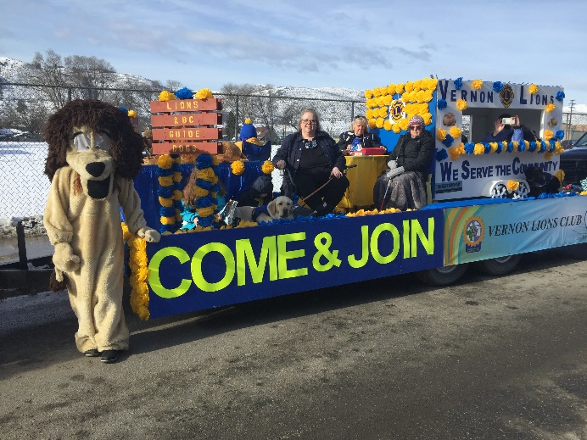 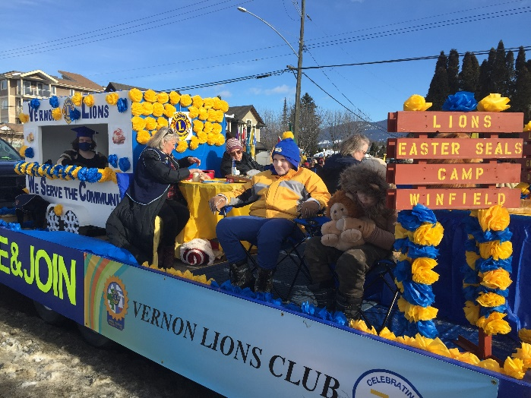

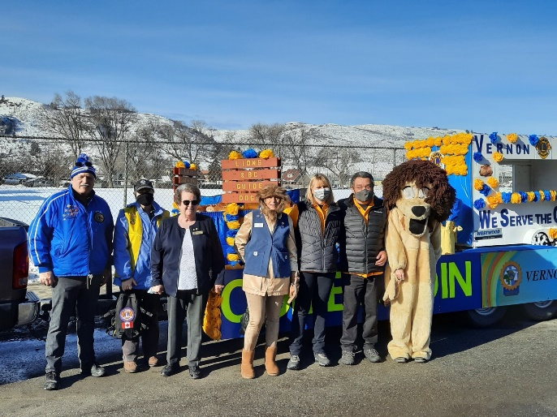 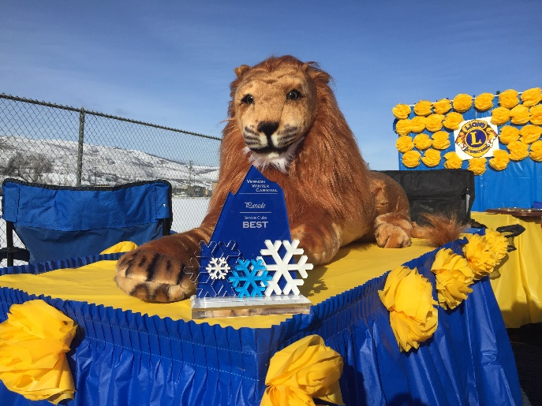

The club continues to assist people in need with eye exams and glasses, hearing aids and dentures. Many of the club members volunteer in the community with feeding the hungry, Red Cross, Crisis hotline and assisting seniors.

Upcoming events are Creative Chaos breakfast, Crusin’ in the park pancake breakfast, golf tournament May 28, Duck race for a service dog – June 25 as well as another bottle drive, paper shredding event and a garage sale.

**Important dates to remember**



**April 23, 2022 9 AM–** Cabinet meeting via zoom

**April 23, 2022 10 AM** - The Spring Conference will be via zoom again this year on April 23rd, and this will be followed up with picnics, 1 on each side of the border. The first will be in BC at Camp Winfield and is planned for May 8th. The second will be in Leavenworth, Washington on June 4th. There will be more information to follow in the March bulletin. Everyone is welcome to attend both picnics if they so desire. They will be focused on fun and fellowship. DG Joyce will also be able to present any awards that she has at these picnics.

**May 7, 2022** – Camp Winfield Clean up

**May 8, 2022** – Camp Winfield meeting 9 AM – 11 AM

**May 8, 2022** – District D Canada picnic at Camp Winfield 12 noon. Picnic at 1 PM

**May 5-8, 2022** - Northwest Lions Leadership Institute. For more information visit the website www.nwlli.org

**June 24-28, 2022** - 2022 LCI Convention moved to Montreal. Due to the ongoing challenges presented by the coronavirus (COVID 19), the LCI board of directors voted to relocate the 2022 Lions International Convention from New Delhi, India to Montreal, Canada. Details will follow as they become available.

