**What’s New in 19D-1 Zone Chair: Lion Sharon Cain JUNE 2022**



**District Cabinet contacts:**

District Governor: Joyce Stevens  
 509-670-7527  
 [jstevens98826@gmail.com](mailto:jstevens98826@gmail.com)

1st Vice DG: Debbie Allan   
 250-554-1498  
 [dandballan@telus.net](mailto:dandballan@telus.net)

2nd Vice DG: Michael Livingstone  
res: 250-497-8486 cell: 250-809-6027  
 [mickstone2@gmail.com](mailto:mickstone2@gmail.com)

Cabinet Secretary:

District D Bulletin Editor: Debbie Bostock   
 250-819-6075   
 [debbiebostock@gmail.com](mailto:debbiebostock@gmail.com)

District D Website Editor: Sharon Cain  
 res: 250-545-2722 Cell: 250-540-8270   
 [sharoseh43@gmail.com](mailto:sharoseh43@gmail.com)

Websites:

**MD19** <https://lionsmd19.org>

District D <https://e-district.org/sites/19d>

**LCI** [hts://lionsclubs.org](https://lionsclubs.org)

**Border Crossing** <https://lionsmd19.org/newsletters.php>

**Armstrong Lions Club**<https://e-clubhouse.org/sites/armstrong/>

**Enderby Lions Club** <https://enderbylionsclub.org/>

**Lake Country/Winfield Lions Club**[www.lakecountrylions.com](http://www.lakecountrylions.com)

**Lumby Lions Club**  
 <https://e-clubhouse.org/sites/lumby_bc/>

**Vernon Lions Club**[Https://e-clubhouse.org/sites/vernon_bc](https://e-clubhouse.org/sites/vernon_bc)

Bulletin Editor: Sharon Cain  
250-545-2722  
**Cell: 250-540-8072  
[sharoseh43@gmail.com](mailto:sharoseh43@gmail.com)

**What’s happening in our World…. - ZC *Sharon Cain***

One thing I am passionate about is working with the entire community to make it a better place to live. In that spirit it is my belief that all the Lions clubs in a zone should work together and in support of what each club does. When we accomplish this, we better serve our community. Therefore, my theme for the 2022-2023 year is “We Serve Better Together”. Thank you for your confidence in me to serve as your Zone Chairperson for another year.

I look forward to serving all of the clubs in my zone, concentrating on retention of our members, working on membership ideas to help our clubs grow. Let’s reach out to community members and invite them to assist us in our projects.

UPCOMING CLUB OFFICER TRAINING

Upcoming Dates: July 16 or August 17

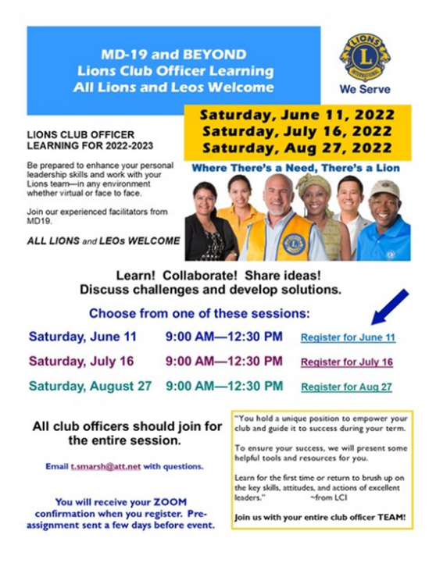

**What’s Happening in our Zone**

**Armstrong Lions Club**

The Armstrong Club have a very impressive Facebook ad for their Tuesday night Bingo.

**Enderby Lions Club**

**Lake Country/Winfield Lions**

The fundraising activities included: Annual Garage Sale, concession activities and Oyama Days knife sales. The major fundraiser, a Golf Tournament is planned for September 17, 2022.

**Lumby Lions Club**



The Lumby Lions are pleased to announce Sylvia Fiset has been named as the Lumby Lions 2022 Citizen of the Year. Sylvia worked many years as a senior home care worker and also found time to volunteer for figure skating, Lend a Hand and the Anglican Church. Sylvia was also one of the original members of the Lumby Historians group who published the historical Grassroots of Lumby and Grassroots to Treetops.

The Lumby Lions, along with their partner the Village of Lumby donated $5,000.00 to support services provided by the Lumby & District Health Services Society (LDHSS). L to R: Mayor Kevin Acton, Nancy House (LDHSS representative) and Lumby Lions Carla Lee and Linda Vlasveld.

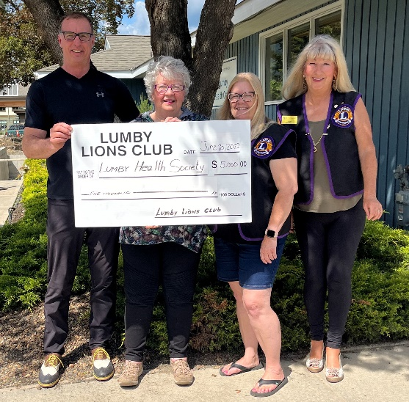 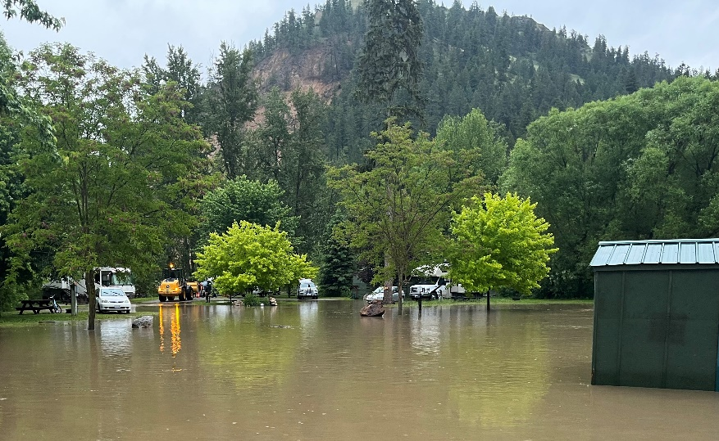

The Lumby Lions campground flooded in the early morning of June 14th, 2022 due to high water. Search and Rescue assisted campers trapped on the other side of the fast moving water. Providing mother nature cooperates, the campground will be open once again for the July long weekend.

The Lumby Lions are resting after hosting a very busy and successful beer garden during Lumby Days festivities. Regular meetings will commence on Tuesday, September 6, 2022. The summer bar-b-que and picnic will be held at the Lumby Golf Course on Sunday, July 10th, 2022.

Happy summer fellow Lions!

**Vernon Lions Club**It has been a busy month of June for Vernon Lions beginning the month with our first time out with the food trailer to serve breakfast to the Creative Chaos vendors.

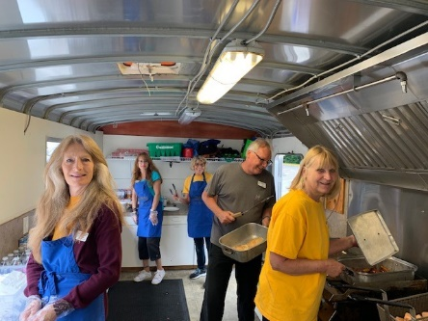 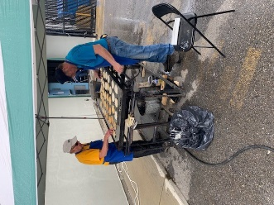

The AGM meeting on Thursday, June 23 included awards and installation of new Board members. Highlight of the evening was guest VDG Michael Livingstone presenting Pres. Sharon Cain with the Judge Brian Stevenson Fellowship award.

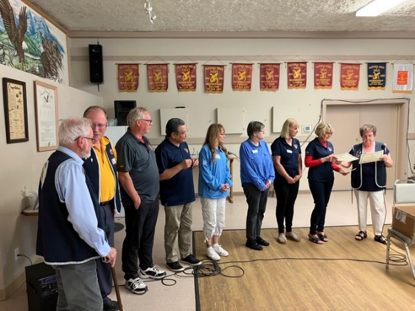 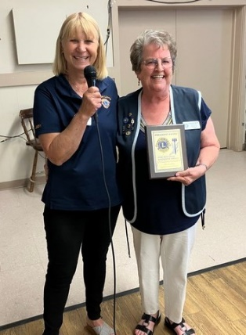 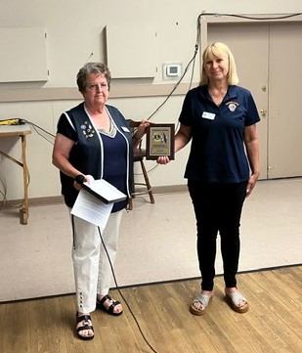 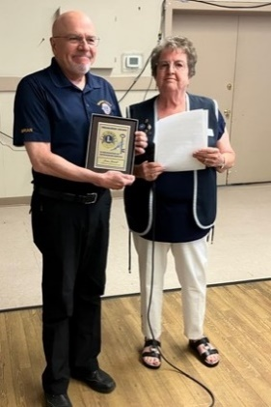   
 Service certificates President award – Sharon Cain Secretary award – Judy Louis Treasurer award - Brian Barnett

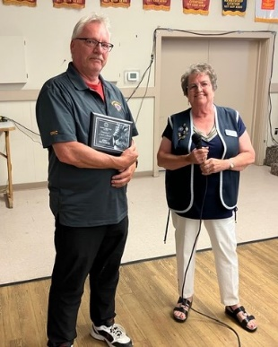 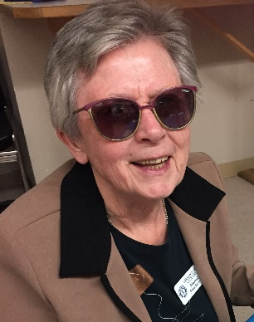 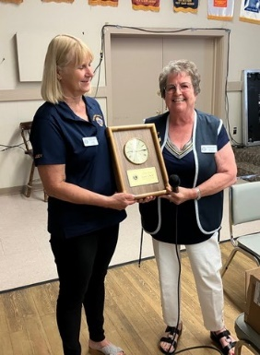   
President Choice – Eric Reckhard President Choice – Marnie MacKenzie Lion of the Year – Judy Louis

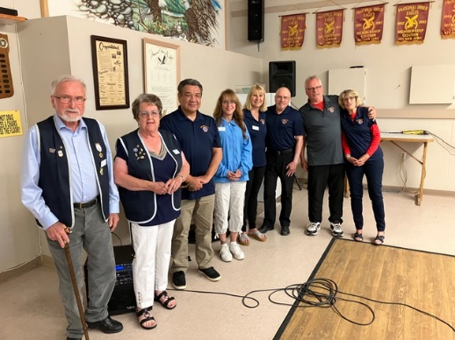 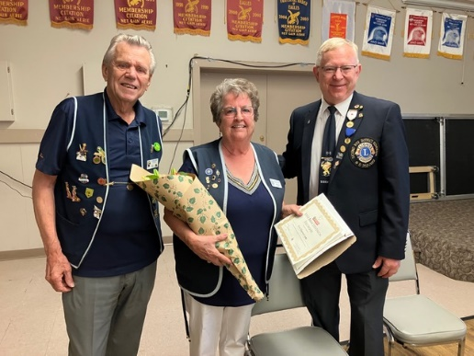  
 2022-2023 Executive Judge Brian Stevenson Fellowship – Sharon Cain

The Vernon Lions Club held a very successful “Ducks for Dogs” event at Polson Park on Sat. June 25. There were games for children, a fish pond, and several of our sponsors set up a tent to display their products and services as well as draws for our guests and fun things for children. The race itself had to be moved to the pond as the Vernon Creek was running too fast and too deep to be safe for the Fly Fishermen who were retrieving the ducks. We sold out our 4000 tickets and along with some donations were able to donate $21,531 to BC & Alberta Guide dogs to bring another dog to Vernon for an autistic child. Silver Star Mountain are matching $1 for every ticket sold and have a donation to our cause of $4,000. Universal Packaging chose the Vernon Lion Club as their charity for the month of June and so have donated $250 to our cause as well. We thank all of our wonderful sponsors and ticket buyers for this great success.

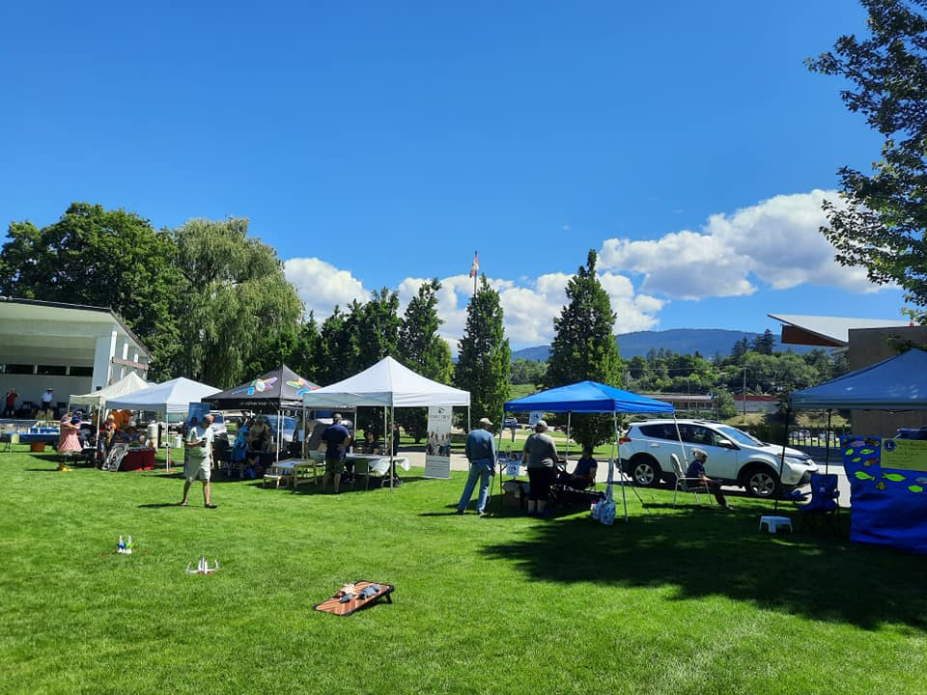 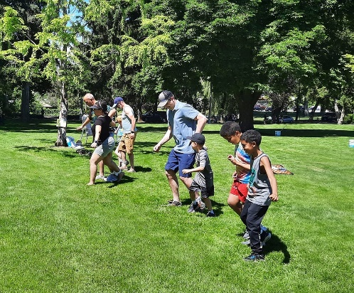 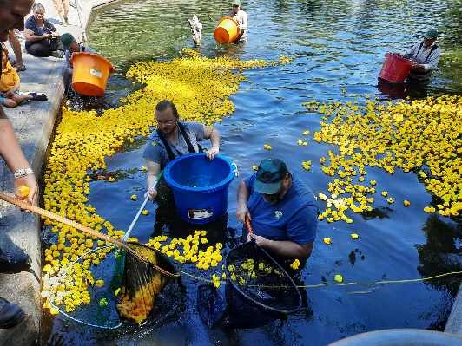

Sponsor tents & displays Three-legged race Retrieving the ducks

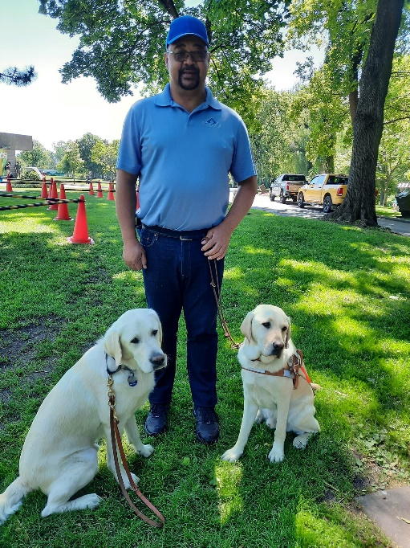 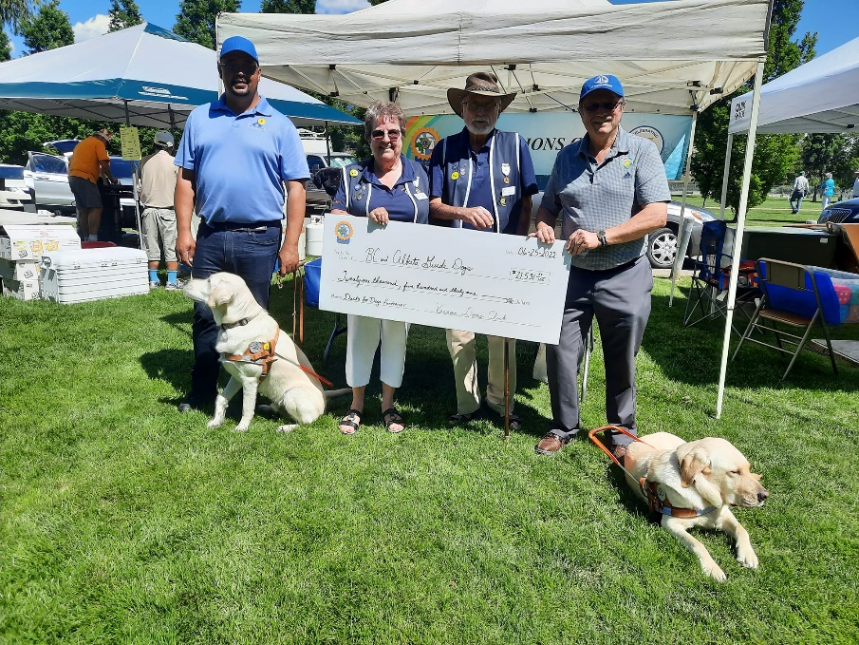

Joel and Service dogs from BC & Alta Guide Dogs Lions Sharon & Ken presenting $21,531 to Joel, trainer & Bill Thornton CEO of   
 BC & Alta Guide Dogs.

Upcoming events for our summer include a BBQ at Woodtone, breakfast for the Show ‘n Shine exhibitors, breakfasts and lunches for 3 day at the Military Tattoo. Then it looks like we may have August to be with our families more.

**HAPPY SUMMER TO EVERYONE!!**

**Important dates to remember**

**July 16 and/or August 27** – Officer Training

**June 24-28, 2022** - 2022 LCI Convention, Montreal.