LCIF D NORTH
Since August, I have been in communication with Cec Specht re LCIF duties and responsibilities. What I have been concentrating on is that every club make an effort to support this very worthwhile aspect of Lions.
LCIF is the primary funding source for Lions’ worldwide. It has enabled Lions and clubs to exponentially expand their service and carry out more life-altering missions globally in areas such as vision, youth, disaster relief and humanitarian efforts.
We are often asked why should we donate to LCIF? Canada has received more in grants than ever donated. British Columbia has received the major share of these grants not only for disaster but for projects in the communities such as:
- Sight Grants,
- Matching Grants (formerly called Standard Grants) for capital construction and equipment
- Diabetes Grants
- Disaster Relief Grants and Disaster Preparedness Grants
- Lions Quest Grants
- Designated Grants – restricted to a specific need such as refugee assistance
- LCIF Leo Service Grants
- District & Club Community Impact Grants
- Humanitarian Awards
- Hunger Grant Program
- Childhood Cancer Grant Program
My job is to convince clubs and individuals to donate to LCIF. There are many levels of donations for reward; but my suggestion is to just donate what you can.
With an accumulation of $1000 US someone in your club can be named a Melvin Jones Fellowship. An individual can donate $1000 US for the same fellowship.
Your club can support Campaign 100 by donating to LCIF – small donations are appreciated but larger donations receive recognition. I recommend that all clubs make an effort to become a Campaign 100 Model Club. Commit to a level of the Model Club as outlined below.
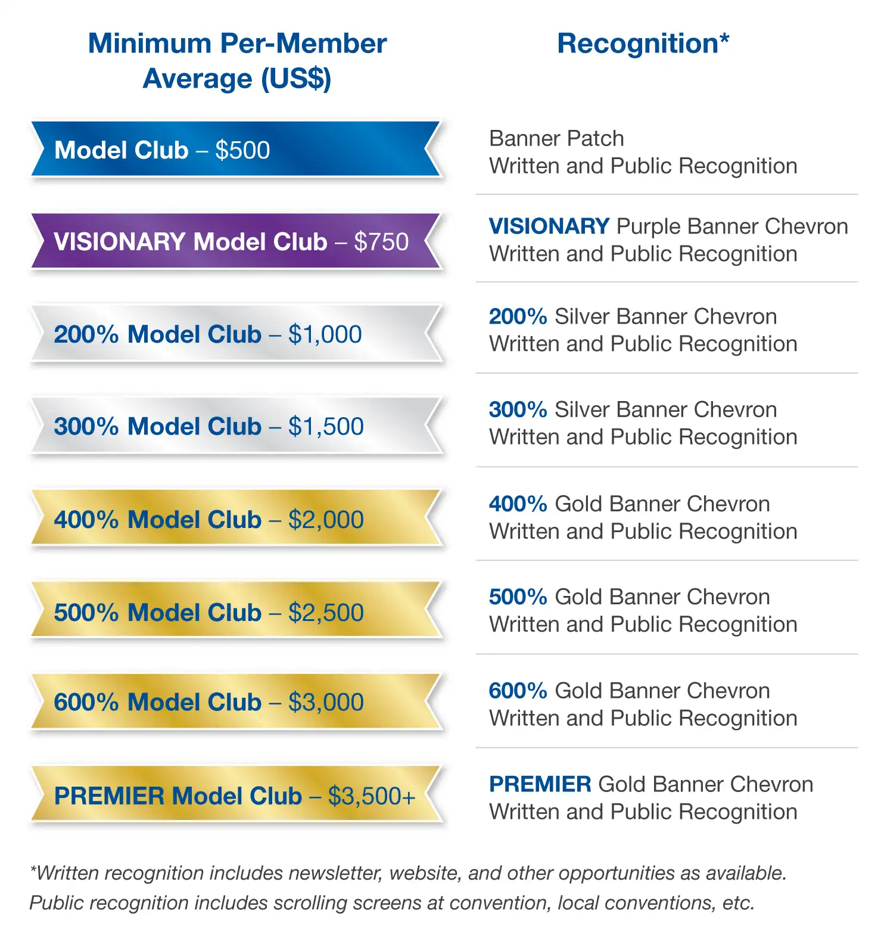

Respectfully submitted,
Ken Cain
LCIF Coordinator D North

