What’s New in 19D-1 Zone Chair: Lion Sharon Cain November, 2021
District Cabinet contacts:
District Governor: Joyce Stevens
509-670-7527
jstevens98826@gmail.com
1st Vice DG: Debbie Allan
250-554-1498
dandballan@telus.net
2nd Vice DG: Michael Livingstone
res: 250-497-8486 cell: 250-809-6027
mickstone2@gmail.com
Cabinet Secretary: Jeanette Britton
509-548-1947
brittonjeannette@gmail.com
District D Bulletin Editor: Debbie Bostock
250-819-6075
debbiebostock@gmail.com
District D Website Editor: Sharon Cain
res: 250-545-2722 Cell: 250-540-8270
sharoseh43@gmail.com
Websites:
MD19 https://lionsmd19.org
District D https://e-district.org/sites/19d
LCI https://lionsclubs.org
Border Crossing https://lionsmd19.org/newsletters.php
Armstrong Lions Club
https://e-clubhouse.org/sites/armstrong/
Enderby Lions Club https://enderbylionsclub.org/
Lake Country/Winfield Lions Club
www.lakecountrylions.com
Lumby Lions Club
https://e-clubhouse.org/sites/lumby_bc/
Vernon Lions Club
Https://e-clubhouse.org/sites/vernon_bc
Bulletin Editor: Sharon Cain
250-545-2722
**Cell: 250-540-8072
sharoseh43@gmail.com
The future depends on YOU!
Ask someone to become a Lion!
What’s happening in our Zone by Sharon Cain
I have had a wonderful month visiting clubs in October and with DG Joyce Stevens on Oct. 25 at Enderby. Looking forward to visiting the remaining clubs with 2nd VDG Michael Livingstone in November. What a great way to get to know your club members better. Thank you for your hospitality and comradery. It is good to see that D1 clubs are meeting in person at least once a month. They have completed many service projects and fundraisers and with vaccinations and things opening up a bit, clubs are planning to resume some projects that have been on hold for the past couple of years.
Most clubs are planning to remember our veterans on Nov. 11 by purchasing a wreath. We are still waiting to hear the protocol this year during Covid
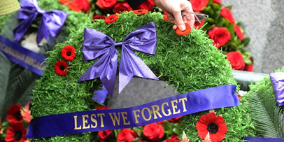
Some of you have asked about the redistricting. Redistricting must be approved by a majority vote of the delegates at a Multiple District Convention (a regular convention or a special convention called). If the MD19 delegates vote to redistrict, an application for redistricting and the redistricting plan will be submitted to Lions Clubs International for final approval. Here is a map of the proposal so far. As you can see with the latest map, District D will remain similar with the addition of the north portion of District E. Go on line at https://lionsmd19.org/redistricting.php for more information.
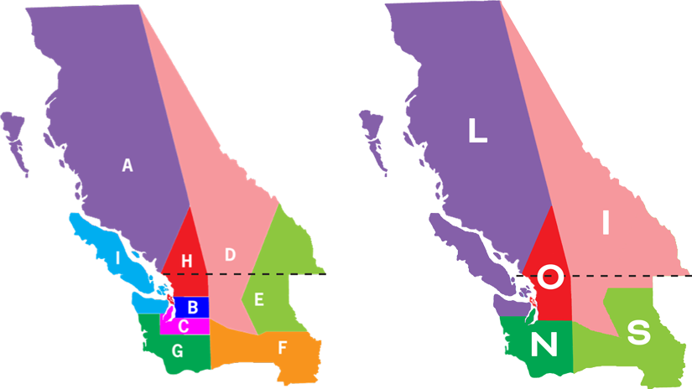

Musings of the Council Chair John Moralek
Today, I would like to talk about the Lions that have left our clubs in good standing.
Why are they leaving? Many Lions who have left had been members for many years, what happened to change their minds? Did they not feel appreciated? Did their job situation change? Did someone in the club do something they did not agree with?
These are many questions that we need to find an answer to. How do we stop losing members? I think a big part of it is recognition. Most Lions if asked why they are members would answer that they want to help their community not because they want to be recognized; however, a little recognition goes a long way. If you are the president of your club be sure to thank the members that take part in any program. A simple way to do this would be at your meeting. Ask them to stand and let everyone know that they did a “job well done” and ask the club to give them a round of applause. You will be surprised at the smiles you will see. Other more formal ways are a certificate of appreciation or an award of a fellowship or a pin.
My suggestion for those members who left is to ask them to come to a meeting, perhaps buy them dinner and present them with a certificate of appreciation for their years of service in your club. Let them know that they are missed and that your club would be proud to have them as members again. Be sure to have member applications handy.
What’s Happening in our Clubs
The Armstrong Lions Club
Some of the Armstrong Club members put on a very successful covid-safe Pancake Breakfast for the community on Oct 9th
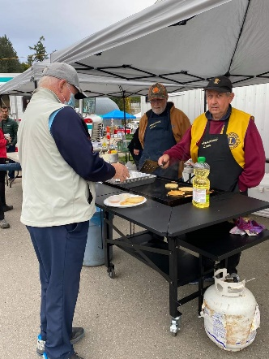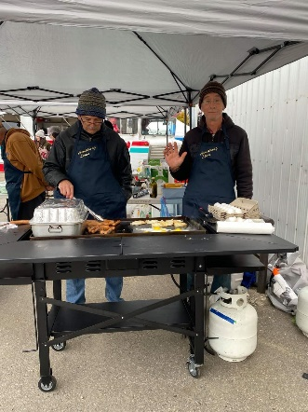
The Enderby Lions Club
The Enderby Club have started in person meetings. Zone Chair Sharon Cain visited them on Oct. 18 and District Governor Joyce Stevens visited on Oct. 25. Congratulations on introducing 2 new potential members.
The Lake Country/Winfield Lions Club.
Lake Country-Winfield Lions participated in a Community Building Project, sharing with Lake Country Rotarians in a cemetery clean-up of the Winfield Cemetery in Lake Country. On Saturday, October 16, 9 Lions and 9 Rotarians gathered to clean the community cemetery for Remembrance Day. Sharing a community project with other service clubs was encouraging to both groups. It was a reminder that we are not the only group working to make Lake Country a better place to live.
There is a renewed interest in this historical cemetery. The Lake Country-Winfield Lions have completed a Spring and Fall Clean-up which includes other community groups such as Scouts, but this year was a highlight. A community volunteer has recovered some historical headstones and trenched and cleaned some specific grave sites.
The Lake Country-Winfield Lions are creating a permanent display which will identify some specific graves and include additional historical information.
ZC Sharon visited Lake Country Lions Club on Oct. 18.
The Lumby Lions Club
Zone Chair Sharon Cain visited the Lumby Lions Club on Oct. 19. The campground closed October 31. Many service projects have been completed including cemetery cleanup, the Santa’s Anonymous Toy Run, Lumby Food Bank Drive and preparing meals for seniors once a week.
The Vernon Lions Club continue to hold in person general meetings twice a month, following the COVID restrictions in place by Interior Health and PHO. The executive also meets once a month by ZOOM.
During the month of October Lion Bobbe and Lion Brian continue to help various community organizations from feeding the hungry, assisting Red Cross and numerous other community needs.
Lion Marnie continues to pull pop tabs and this has paid off over the year as Lion Ralph and Lion Mike Smith have taken Lion Marnie’s tabs and tabs from other places to Kamloops recycling and were able to give a cheque to Camp Winfield for equipment.
We also did a bottle drive and raised $2,577.00 (including bottles and donations) for Vision needs. A lot of hard work but a heck of a lot of fun, all Lions participating by either working the event or donating to it.
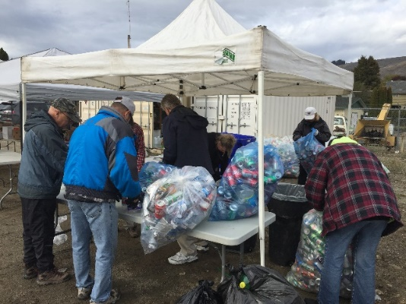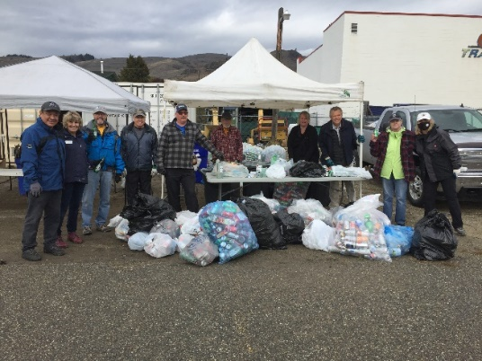

A lovely candle lighting induction ceremony was done at our Oct. 21 meeting, by Lion Bill and Lion Nick, welcoming our new member Harjinder Janka, and our new associate member Gertrude Parke. Zone Chair Sharon Cain visited the Vernon Lions Club for this occasion. She congratulated the club for continuing service and for all reporting being up to date. She presented Lion Nick with his well-earned Diamond Campaign 100 pin.
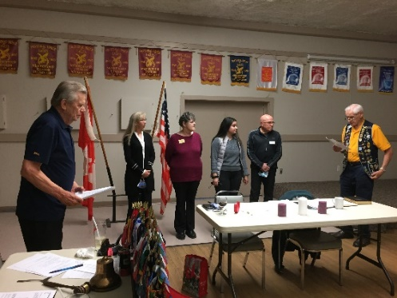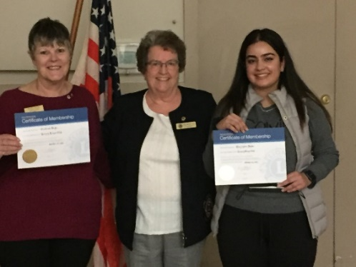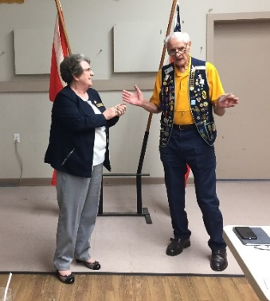
Pumpkins with treats and big smiles on the jack lanterns, were given to 5 of our Lions fighting illness or recovering. Thank you to Lion Jackie, Lion June and Lion Judy.
ZC Sharon visited her home club on Oct 21.
********************************************
If your clubs have anything to report, send your Items and pictures along anytime throughout the month. Love hearing all your news and sharing it with others. See you at your Nov. meetings with 2VDG Michael Livingstone.
Until next month - ZC Sharon Cain

DG Joyce Stevens suggests these contacts you might use for help with ideas for projects
Environment: Angus Benedict environmentangus@gmail.com LCIF: Ken Cain markencain@telus.net
Children’s Cancer: Linda Schaffrick schaffrick@persona.ca Leadership: GLT Bob Ayotte bob.ayotte@gmail.com
Diabetes: Val Clemont valclemont2@gmail.com Service: GST Dorothy Nilles skihilldln@gmail.com
Hunger: PDG Wayne Atkinson rwa51@shaw.ca Membership: GMT Michael Livingstone mickstone2@gmail.com

Here are the Canadian addresses for anyone wishing to make donations:
LCIF Lions of Canada Fund for LCIF, c/o Stan Durward, Box 38, Sunderland, ON L0C 1H0
CARE (checks payable to MD 19 CARE), PO Box 1621, Aldergrove, BC V4W 2V1
Lions Foundation of Canada Dog Guides, 152 Wilson Street, Oakville, ON L6K 0G6
Lions Quest c/o Dundas McLaren,PO Box 27016, Cambridge, ON N1R 8H1

A note from 19D North LCIF Coordinator – Ken Cain
In Canada you can make an online donation here https://lionsofcanadafundforlcif.ca/#donate
100% of your donation directly supports LCIF’s global causes.
About Lions Share: Lions Share is an annual program that recognizes individual donors for three levels of support: US$50, US$100 and US200. Lions Share donations are receipt eligible and are used to support LCIF humanitarian grant programs. Clubs are awarded a 100% Member Support Banner patch and chevron when every member makes a minimum contribution of US$50. For each subsequent ear of 100% Member Support, clubs receive a chevron. The address to mail a cheque to in Canada is: Lions of Canada Fund for LCIF, c/o Stan Durward, Box 38, Sunderland, Ontario L0C 1H0
Important dates to remember
Tues., November 2 – 2nd VDG Michael Livingstone visitation to Lumby
Thurs. – Sat., November 4 – 6 - 100th MD Annual Convention, Virtual
Wed., November 10 – 2nd VDG Michael Livingstone visit to Lake Country
Thurs., November 18 – 2nd VDG Michael Livingstone visit to Vernon
Wed., November 24 – 2nd VDG Michael Livingstone visit to Armstrong
December 5 – 2nd Zone Meeting via Zoom
We will be hosting GST Dorothy Nilles and SERVICE is our theme.
March 6, 2022 – 3rd Zone Meeting
Everyone welcome. Hoping to invite GLT Bob Ayotte – Learn about leadership, elections and much more.
April 22-23, 2022 District D Spring Conference – Icicle Village Resort, Leavenworth, WA
The Conference promises to be a celebration of our year back together! In addition, we will celebrate PDG Debbie Co were forced to cancel or adjust their conferences: PDG Debbie’s 2020 Kamloops Conference and PDG Joe’s 2021 Kelowna conference which was converted to virtual. Bostock and PDG Joe Nilles. Both were forced to cancel or adjust their conferences: PDG Debbie’s 2020 Kamloops
May 5-8, 2022– Northwest Lions Leadership Institute. It is just confirmed the Northwest Lions Leadership Institute will return to Canada. This year’s Institute is scheduled for May 5–8, 2022 at Harrison Hot Springs. The course is designed to help improve leaders' abilities to prepare for new challenges, opportunities and responsibilities. It’s also a great networking opportunity. This is open to all Lions that want to improve their leadership skills or have not yet achieved the position of District Governor. For more information visit the website www.nwlli.org
June 24–28, 2022 - In 2022, you can unite once again with Lions and Leos in historic, yet modern Montréal, Canada — with stunning architecture and a buzzing art scene — to celebrate all that we’ve achieved over the last year. Join us as we come together, look back at our experiences and accomplishments from the last year, celebrate the final year of Campaign 100, and much more! Did you know that you can save money with early bird registration? Go on line to register.

