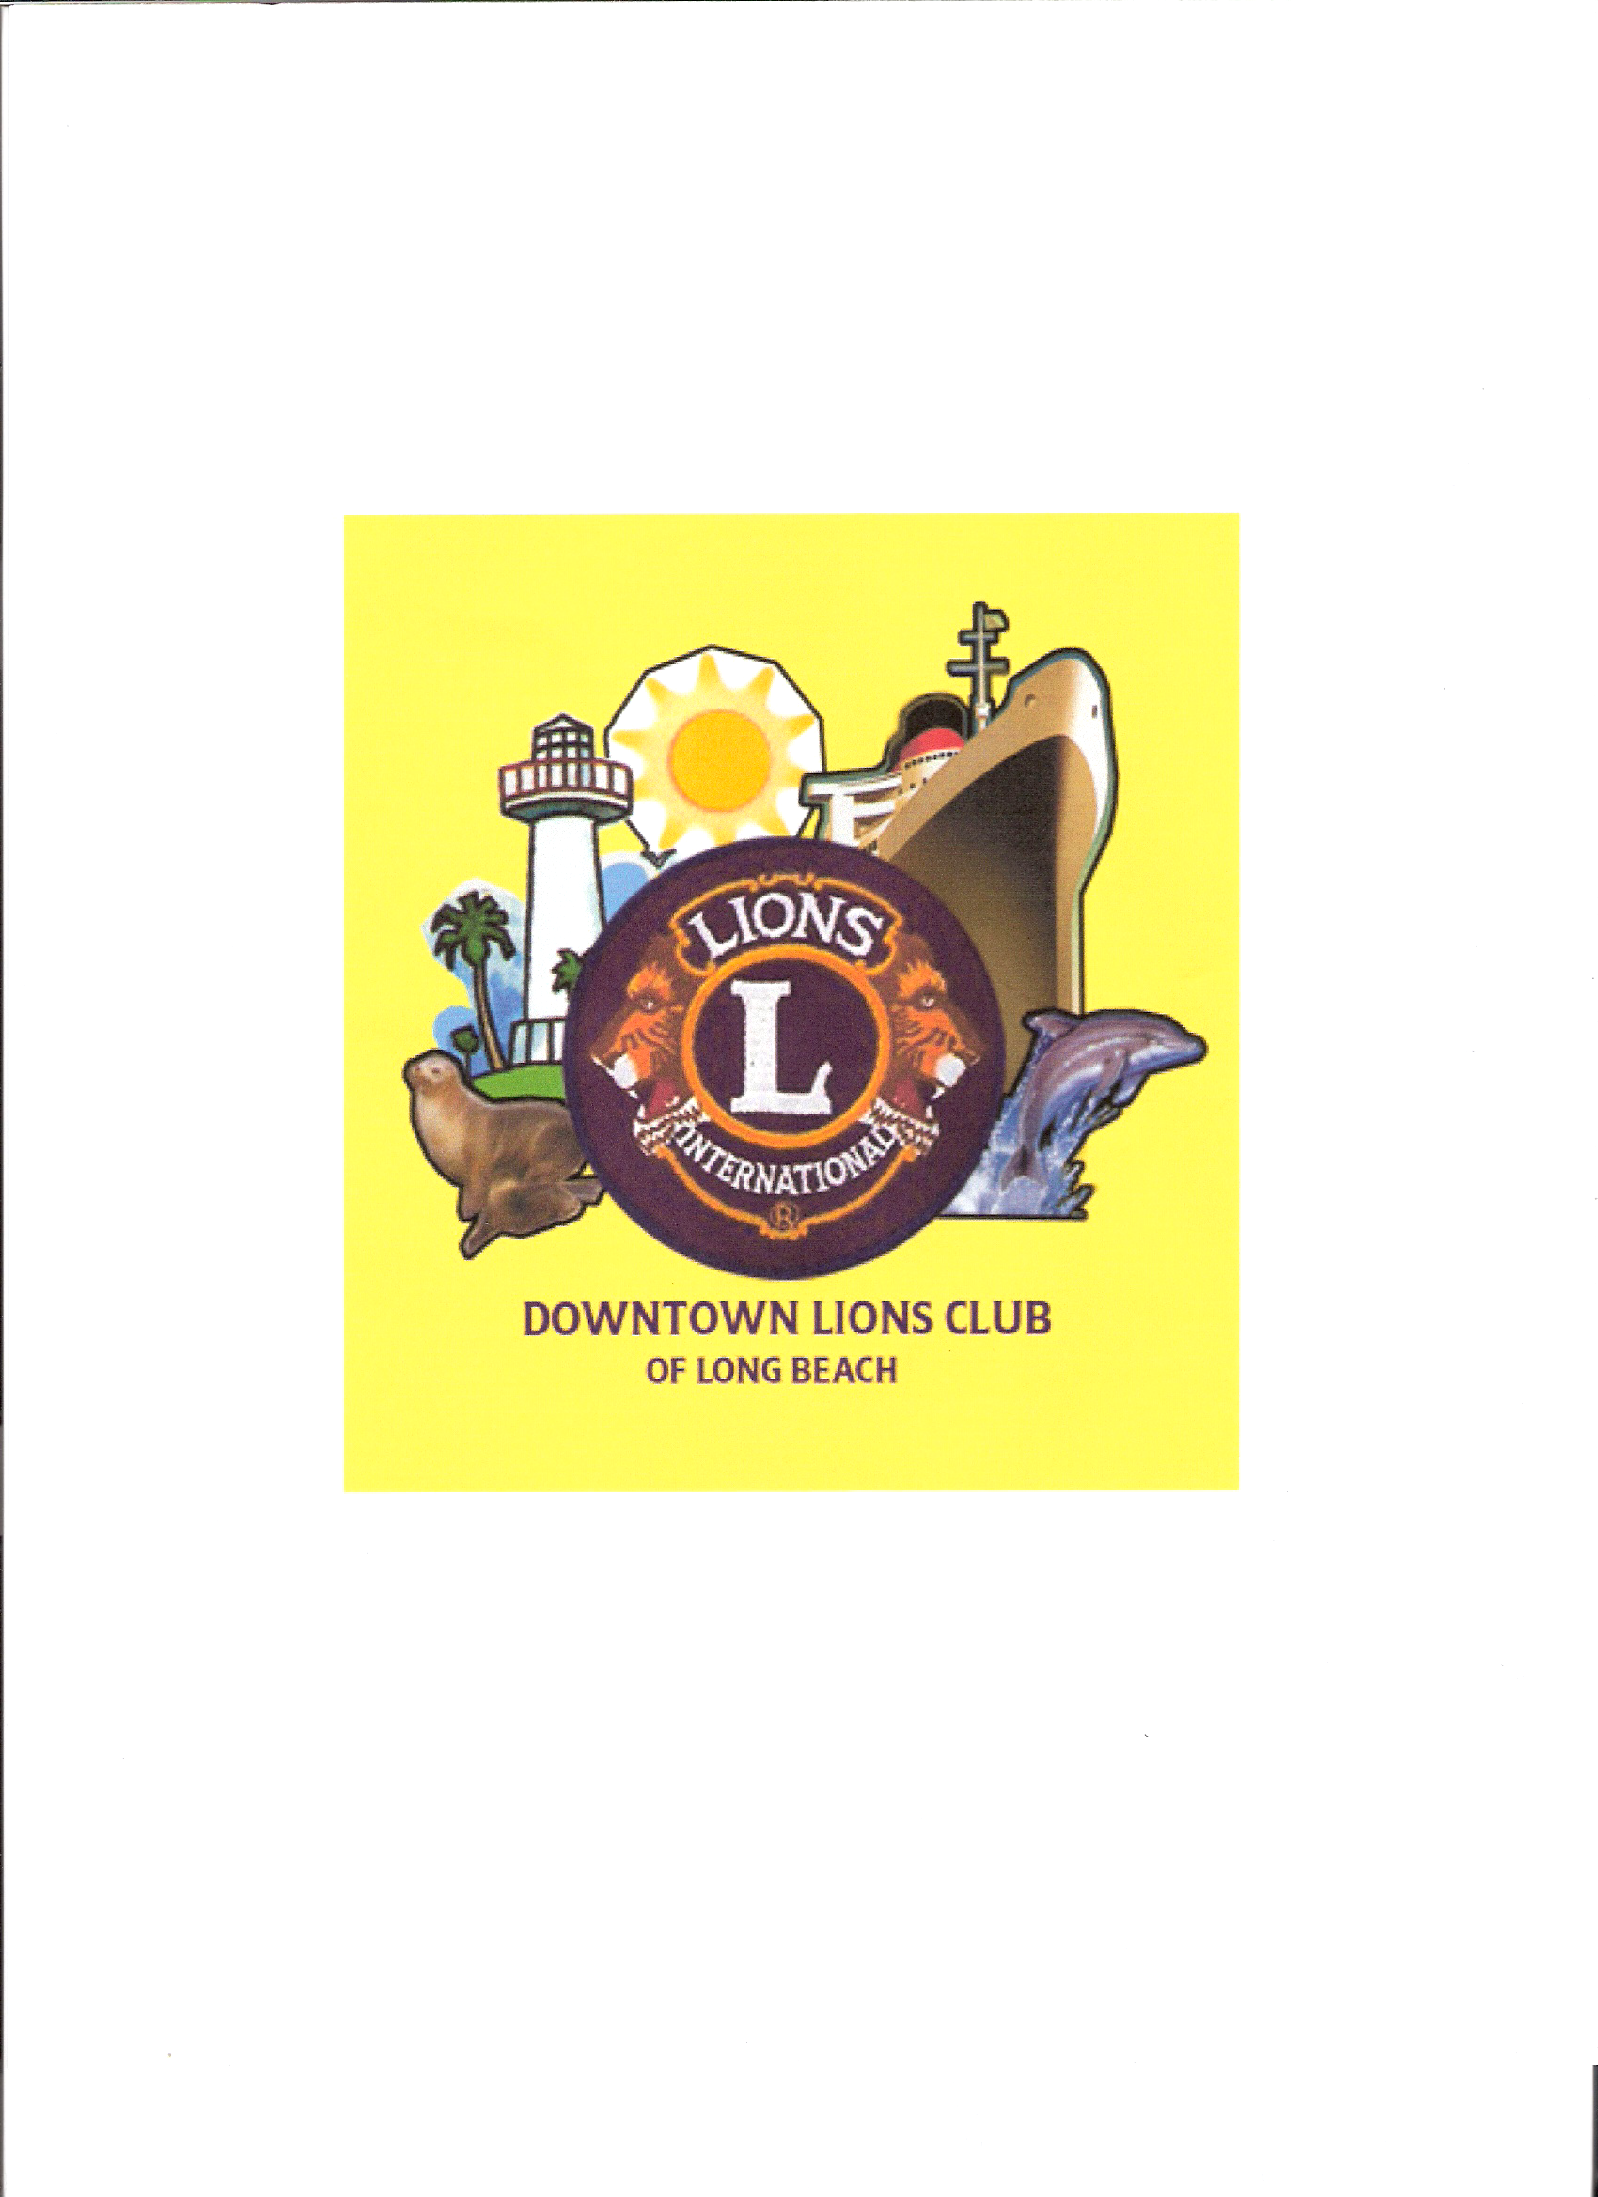
COME JOIN THE FUN

DOWNTOWN LIONS CLUB OF LONG BEACH

27th ANNUAL WESTERN BARBEQUE

LIONS EYE MOBILE with FREE EYE EXAMS

AND CHOLESTEROL SCREENING

SATURDAY AUGUST 17, 2013

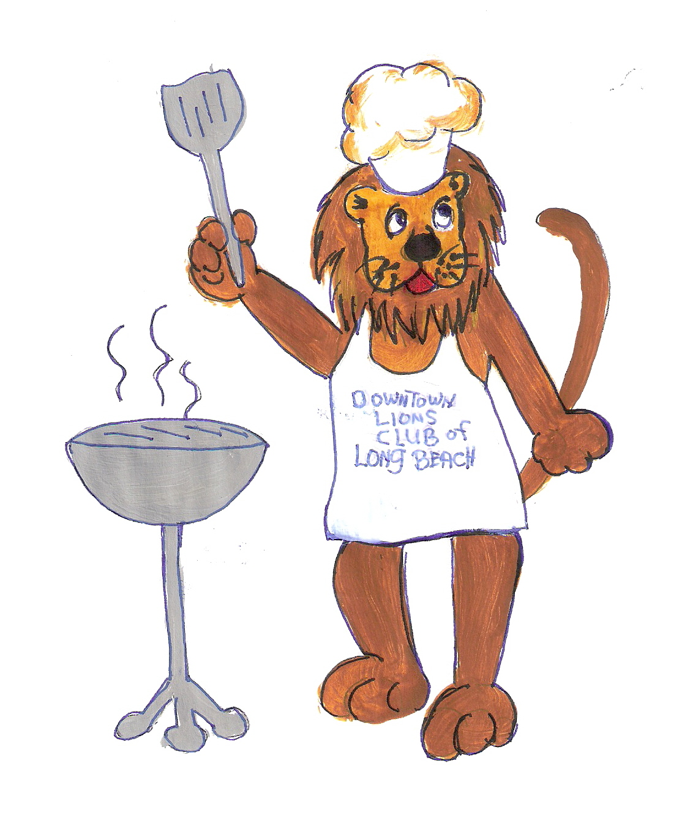
1:00 PM TO 5:00 PM DINNER 1:00 - 3:00 PM

ENTERTAINMENT:

LIVE MUSIC- Featuring the

BACK HOME – C&W BAND

RAFFLE-PRIZES

SILENT AUCTION

MONEY HATS

MOON BOUNCE

KIDS CRAFTS

FACE PAINTING

And much more….

MENU:

BBQ HAMBURGERS

HOT DOGS

BAKED BEANS & SALADS

COOKIES

BEER-WINE-SODA - Available

TICKET PRICES: DOOR PRIZES:

Adults $10 First Prize……$400.00

Five and Under---Free Second Prize…$200.00

(WINNER NEED NOT BE PRESENT)

WHERE: LONG BEACH TOWNE CTR - OFF CARSON at 605 FWY.

LONG BEACH POLICE ACADEMY-POA PARK – BEHIND LOWE’S

For Information and tickets call Lions Office: 562-370-1205

