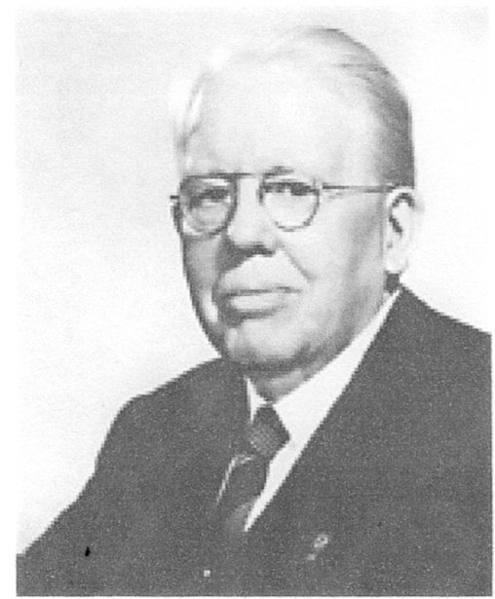
Lions Clubs International
DISTRICT 4L-2
Melvin Jones
Celebration and Dinner
Honoring the life and accomplishments of Lions Founder,
Melvin Jones. We will also recognize and honor current
Melvin Jones Fellows and new recipients

Tuesday March 13, 2012
6PM Cocktails
$55.00 per person
Business Dress or Optional Black Tie
Pasadena Tournament of Roses Mansion
391 South Orange Grove Blvd. Pasadena

MC
Lion Tom Kester

Seating Limited to 100 Guests
______________________________________________

Name:___________________ Club:______________________________
Phone:___________________ E-Mail:____________________________
Please make______ reservations at $55.00 each for a total of $________ enclosed.
Make check payable to: District 4L2
Mail Checks to: CS Nancy McAfee
5156 East Ebell St
Long Beach, Ca 90808

For more information please contact CS Nancy McAfee (562) 810-1841
Please respond prior to March 10, 2012. Pre-Paid Admittance Only.

