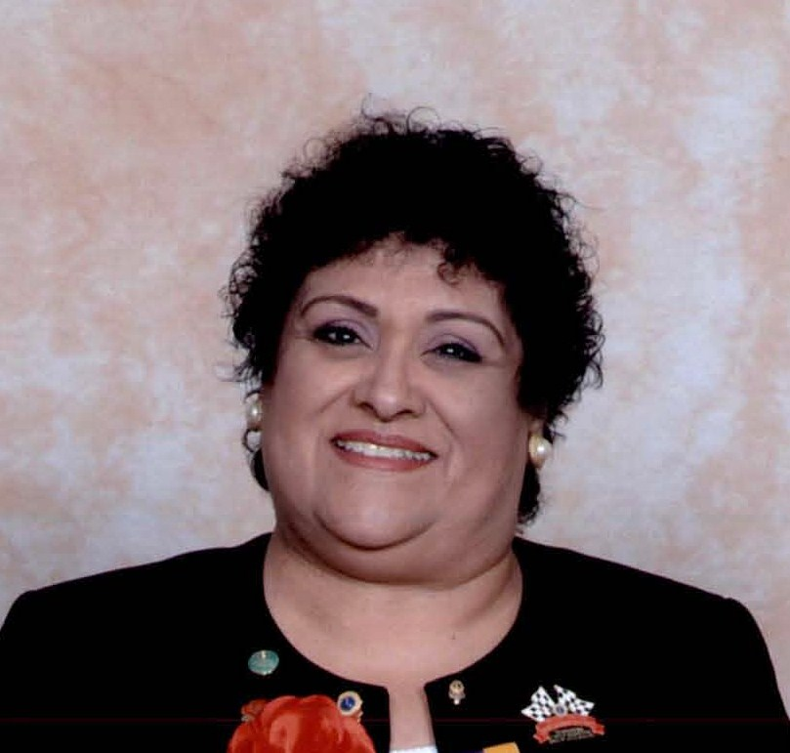

Lion Sally was born in San Francisco; however, grew up in Los Angeles and Gardena with her parents and younger siblings - two sisters & two brothers. After graduation from high school with an Art major, Sally attended Business College at The Fashion Institute, majoring in Marketing. Her business career has ranged from customer service/claims dept, purchasing agent, marketing coordinator, facilities manager, consulting, to finding her niche as an Executive Administrator for the past 25 years

Married for 34 years to husband Gilbert until his death, Sally states she has many good memories to cherish. They were very involved with their god-children from Scout Leader and Den Mother in Cub/Boy Scouts, and assistant coach and team mom for 8 seasons to their god-daughters softball teams, as well as school & church activities

In 2000, Sally was invited to join the Lions Club of Montebello, where she held the office as: Director, 2nd V.P., 1st V.P., and Secretary for three terms, Leo Advisor since 2005, and 81st President in 2005-06. She continues to serve on numerous club projects and chairperson for Budget & Finance, and Constitution & By-Laws.

Lion Sally is recipient of the “Fred Baird Memorial Trust” as “Lion of the Year” for 2003 & 2004; President’s Appreciation Award, a Progressive Melvin Jones Fellow, awarded Life Membership to So. CA Lions Eye Foundation; Graduate of the MD-4 Lions Leadership Institute in 2004 & 2011; attended USA/Canada Forum in Reno, CA & Anchorage, Alaska; International Convention in Boston, Seattle, and Busan, Korea; serving also as delegate, MD-4 Conventions since 2002, District Conventions since 2001, District Cabinet meetings since 2001, and has 100% Club Attendance since 2003.

She has been involved at the District Level since 2003 serving on numerous committees: Lions Rose Float Decorating Coordinator, Peace Poster Chair, Women’s Membership Development Chair, Youth Outreach Chair, Leo Co-Advisor since 2006; served as Directory Coordinator 2008-09, and Cabinet Secretary for 2007-08.

Lion Sally served as Area 4 Representative on the MD-4 Youth Outreach Committee 2009-10; elected 2nd Vice District Governor in 2010-11, where she served on the MD-4 Woman’s Membership Development Committee 2010-11, and continues to serve on the Youth Outreach Committee; and MD-4 Chairperson for Lions Children’s First Project since 2010.

Lion Sally has been recognized for her accomplishments by both the District and International: President’s Secretary Award, Donald E. Banker Fellowship #22, Lions International President Excellence Award, Lions International Achievement Award, and International President’s Medal of Merit,

She attributes her career in community service commencing with her involvement with the East L.A. Chapter of the Jaycees (Junior Chamber of Commerce), developing leadership through community service, where she served as Management V.P and Chapter President, winning numerous awards for her Chapter and recognized as “Top Chapter President of the Year” and Area ”Key Person of the Year” by the California Jaycees; going on to the State level as District Governor for two terms and awarded twice “District Governor of the Year”. As California Executive Administrative V.P. Sally was recognized by both the California Jaycees and U.S. Jaycees as "Executive Vice President of the Year” recipient of the “Dennis Hamilton Memorial Award”; holds the title of California Pearl #96; Lifetime Member of “Order of the Tiger”; U.S. Jaycees 10th Degree Graduate and Prime Graduate.
Her activities also included service in the City of Montebello: Parks & Recreation Commission, as Vice-Chair & Chairperson and active within numerous inner-committees; City Investment Committee for 4 years, and a Stage Committee Chair for Heritage Festival, and enjoyed 8 seasons as "Team Mom" for her goddaughter's, Alicia and Andrea, city softball teams.

“TEAMWORK FUELS SUCCESS“

