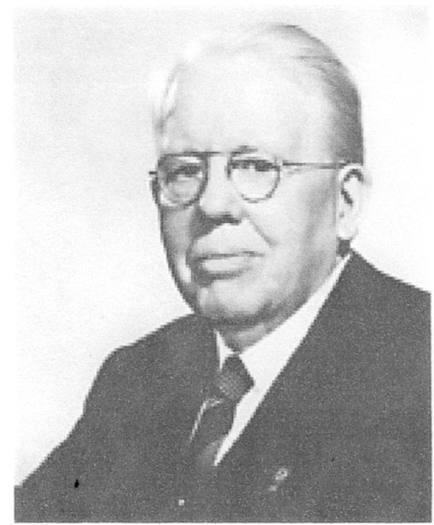
Lions Clubs International
DISTRICT 4L-2
Melvin Jones
Celebration and Dinner
Honoring the life and accomplishments of Lions Founder,
Melvin Jones. We will also recognize and honor current
Melvin Jones Fellows and new recipients

Sunday January 27, 2013
2PM to 5PM
$35.00 per person
Tables of 8 are available for purchase
Business Dress
Friendly Hills Country Club
8500 S. Villaverde Drive
Whittier, Ca 90605

MC
LCIF Chair Dave Williamson

With a special appearance by Helen Keller
Don’t miss this monumental experience

_______Club Tables of 8 for $280.00

________Shared Club Tables of 4 for $140.00

________Reservations at $35.00 each for a Total of $________

Name(s)_______________________Club________________________District___________
(Use back of form for additional names)
Make checks payable to: District 4L2
Mail to: 5156 East Ebell St. Long Beach, Ca 90808

All Reservations may be confirmed by E-Mail by Jan. 25th by 5:00PM and pay at door
E-Mail to Nancy McAfee at CS4L2@msn.com

Jan 26, 2013 Late Reservations Pay at Door $50.00 per seat.

