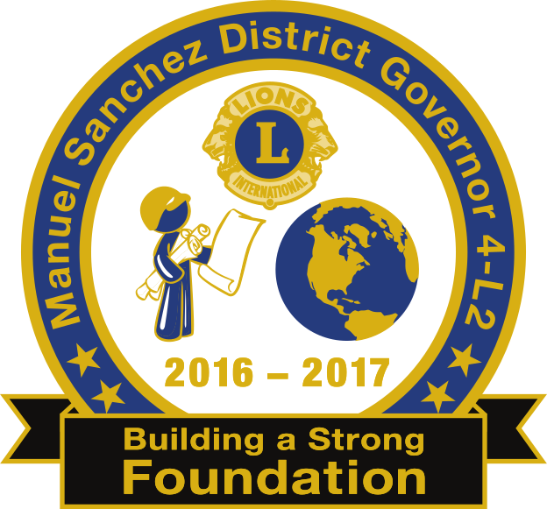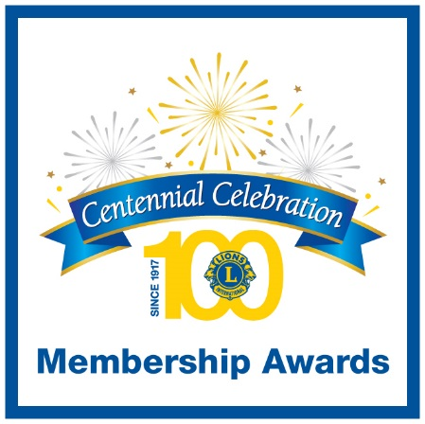

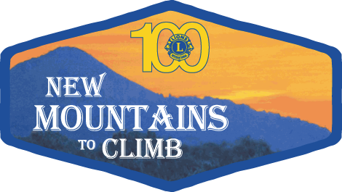

**79th Annual Lions District 4-L2 Convention**

# *“Centennial Celebration”*

***100 Years of Service***

**Crowne Plaza Hotel, 2270 Hotel Circle North, San Diego, CA 92108**

**Thursday through Sunday, May 18 - 21, 2017**

**Hotel Registration by Phone**

**1-888-233-9527\*** Ask for the “**Lions Club District 4L2**” rate when calling

District 4-L2 discounted room rate is $115.00 tax is not included

Attendees have a choice of a King Size Leisure bed or Two Queen Size Beds. Rates been extended on both sides of the convention to enjoy San Diego from May 15 through 24, 2017. The deadline for hotel registration with the discounted District 4-L2 rates will be available until May 5th, 2017. *Call in reservations hours are from 7am-11pm EST. No resort fee, no fee for parking and free in room Wi-Fi.

**Hotel Registration Online**

Click Here: <https://aws.passkey.com/go/fe127a34>

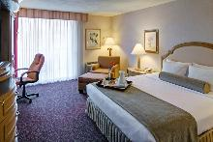

**Option A - *Top of Form***

***1 King Size Leisure Bed*** - With 322 sq ft plus balcony, high speed internet, with sleep advantage amenities which includes 7 pillows, a pillow top mattress pad and duvet, coffee maker, hair dryer, iron and ironing board, free USA Today on weekdays, video check out and room climate control.

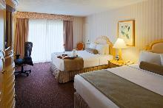

**Option B - *Two Queen Size Beds*** - With 322 sq ft plus balcony, high speed internet, with sleep advantage amenities which includes 7 pillows, a pillow top mattress pad and duvet, coffee maker, hair dryer, iron and ironing board, free USA Today on weekdays, video check out and room climate control.