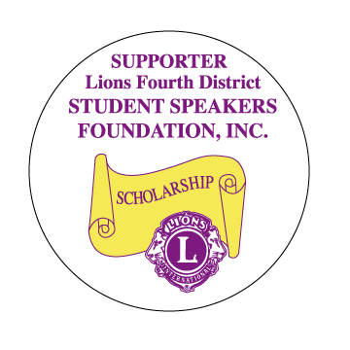

**REGION CHAIRS & ZONE CHAIRS**

**NEED TO ATTEND THIS CLASS**

Student Speaker Training for Club Chairs and any Lion who would like to attend.

**November 12, 2016 9:30AM to 11:15 AM**

(Before District Meeting)

PIH Health Hospital

12401 Washington Blvd.

Whittier, CA

**PLEASE RSVP TO PDG CHRIS OHRMUND**

**BY NOVEMBER 7, 2016**

**Email:** [**ohrmu@aol.com**](mailto:ohrmu@aol.com)