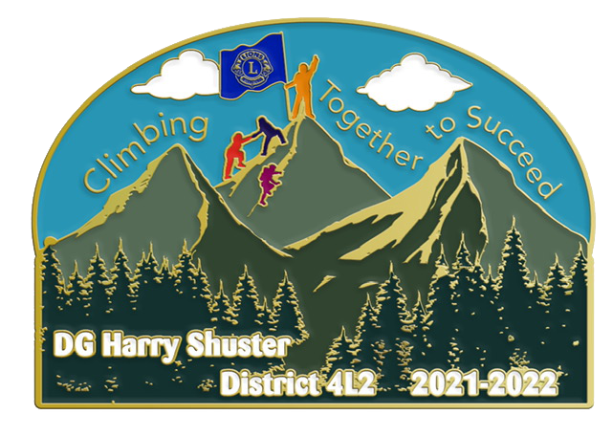
You and Your Club are invited to
participate in our Convention Opportunity Drawing

Each Club/Lion is requested to bring one
or two gifts for the drawing
(wrapped or unwrapped), value $10-$20.
Please bring gifts to Convention Registration Table

Saturday - May 14 & 15, 2022
Holiday Inn - Carlsbad

Each person preregistered will receive a free ticket.
Ticket will be placed in Registration Packet.

Sponsored by District 4-L2

