“Aloha”
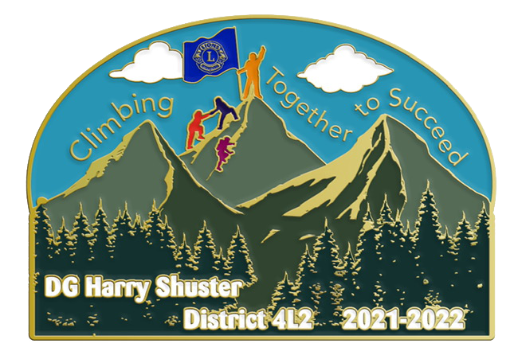
Lions District 4-L2 Convention Packet
‘Celebrating Success in Service’

Location: Holiday Inn, Carlsbad, CA
2725 Palomar Airport Road (off of Innovation)

Dear Lions:

It’s Convention Time! Please plan to attend our District Convention on May 13, 14, and 15th.

Enclosed in this Convention Packet is:

Registration Form (please share with your members
and make additional copies if necessary).

Memorial Service Form
(If your Club had a Lion who passed away since our last Convention).

Parade of Club Banners Information Form

Proposed District Budget for 2022 – 2023

Display Table Reservation Form

Tentative Convention Agenda

Golf Tournament Flyer

Opportunity Drawing Flyer

All forms are also available on our District Website – www.Lions4L2.org
Note: Delegate Letter and Form, and Proposed Bylaw changes
will be sent separately.

++FREE Opportunity Drawing Ticket (one per each preregistered guest),
will be put in your Registration Packet.

Yours in Lionism,
District 4-L2 Convention Committee
PCC Roger Powell, Chair – C: 562-708-2409
DG Harry Shuster, Advisor – C: 626-392-9529
PDG Chris Ohrmund, Registration – C: 909-646-0673
PDG Manny Sanchez, Technology – C: 562-708-9061
CS Nancy McAfee, Credentials – C: 562-810-1841
Lion Anthony Garcia, Elections – C: 562-505-9778

