MD22 Regional Lions Institute for 2019
Friday, March 15, 2019,
Saturday, March 16, 2019, &
Sunday, March 17, 2019

Comfort Inn Conference Center
4500 Crain Highway
Bowie, MD 20716

The $150.00 registration fee covers cost of training, materials, hotel and meals.

Please register by returning the completed registration form to
Lion Martin Bonura at md22rlli@gmail.com

Send the $150 registration fee to:

MD22 Lions Institute
1743 Deer Park Road
Finksburg, MD 21048

MD 22 Lions Institute Courses

Collaboration to Promote Harmony – Learn how collaboration can promote harmony within the club. Collaboration allows sharing of ideas and decision making responsibility. Harmony reduces conflict and promotes a Lion’s team focus for the club.
Servant Leadership – A servant leader is a person of character serving a higher purpose who puts people first. The servant leader is a skilled communicator, a compassionate collaborator with foresight and a systems thinker comfortable with complexity. The servant leader leads with moral authority that is granted by others. Learn the characteristics of Servant Leadership and how to implement them into your volunteerism.
Leadership from the Club Level to the Multiple District Level Roundtable – An interactive discussion on Lion leadership needs. Discussion of the leadership skills needed to manage a project at your club, the district, and at the multiple district.
Writing and Speaking for Effect – Communication includes being able to write and speak in a way that allows for understanding by all who read what you write or hear what you say. Effective communication is presenting information with confidence and clarity. In writing or speaking you must evaluate how the information you are conveying is received by your audience.
Identifying the Right Leaders for Each Position – Projects need leaders. This includes an individual Lion elected to a club office, the chair of a service project or fundraiser, a committee or subcommittee chair, and anyone who has an idea they want brought before the club. Identify the leadership skills of your Lions and how to nurture those skills.
Marketing & Communications Ideas – Public relations is every Lion’s responsibility. Marketing & communications involves communicating information about your Lions club to the community, including the media; keeping your club aware of marketing efforts and results; and promoting your club’s service and fundraising projects.
Closing the Back Door for Greater Retention of Existing Lions – The only way to increase membership is to recruit more members than we lose. Learn tools to retain members by identifying their satisfaction, why they leave, and what we can do to keep them as successful Lions.
Promoting Hands-On Service Projects – Is your club known for service or for fundraising? Our organization’s moto is “We Serve”. Learn projects where we serve and how our hands-on service can promote your club.

How to serve more and be a better Lion!

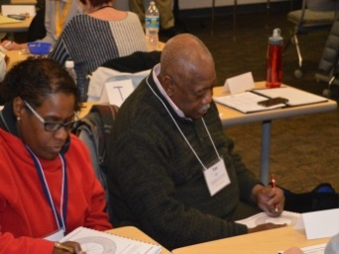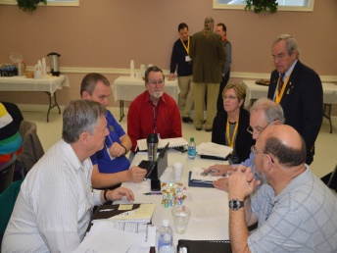

Registration fee is $150 for each participant

Name: Name on name tag:

District 22- Member of Lions Club

Years a Lion Member #
Your club Secretary has your number

Address: City:

State: Zip:

Telephone: Email:

Highest office/position held in Club:

Highest office/position external to Club:

Please send your $150 registration fee to:
MD22 Lions Institute, 1743 Deer Park Road, Finksburg, MD 21048

************************************************************

Registration fee is $150 for each participant

Name: Name on name tag:

District 22- Member of Lions Club

Years a Lion Member #
Your club Secretary has your number

Address: City:

State: Zip:

Telephone: Email:

Highest office/position held in Club:

Highest office/position external to Club:

Please send your $150 registration fee to:
MD22 Lions Institute, 1743 Deer Park Road, Finksburg, MD 21048

