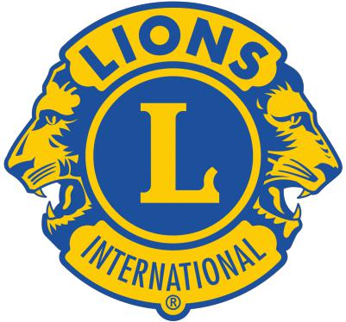
Oklahoma 3NW District

Mike Banks Spirit Award
NOMINATION FORM

Applicant: This completed nomination form must be returned
to the District Governor no later than Monday, January 1, 2024.
Please email completed form to admn.ok.district3nw.lions@gmail.com
Eligibility: Nominee must be in good standing with her club.
This is a distinctive award in honor of Past International Director Mike Banks who is a member of the Stillwater Noon Lions club. Each year, the Oklahoma Lions honor an individual in his name who has advanced the development and progress of Lionism in a tangible and meaningful way. The individual should be active in his/her club, should be involved at the district and/or state level, should support one of the Oklahoma Lions State Projects, support LCIF and display the spirit of Lions. This award will be given during the NW District Convention.

NOMINEE’S INFORMATION

FIRST NAME FIRST NAME LAST NAME

STREET ADDRESS CITY STATE

/ /
PHONE NUMBER EMAIL

Nominating Club: Nominee in Good Standing:

REASON FOR NOMINATION

In 350 words or less, briefly describe the reason for nomination.

