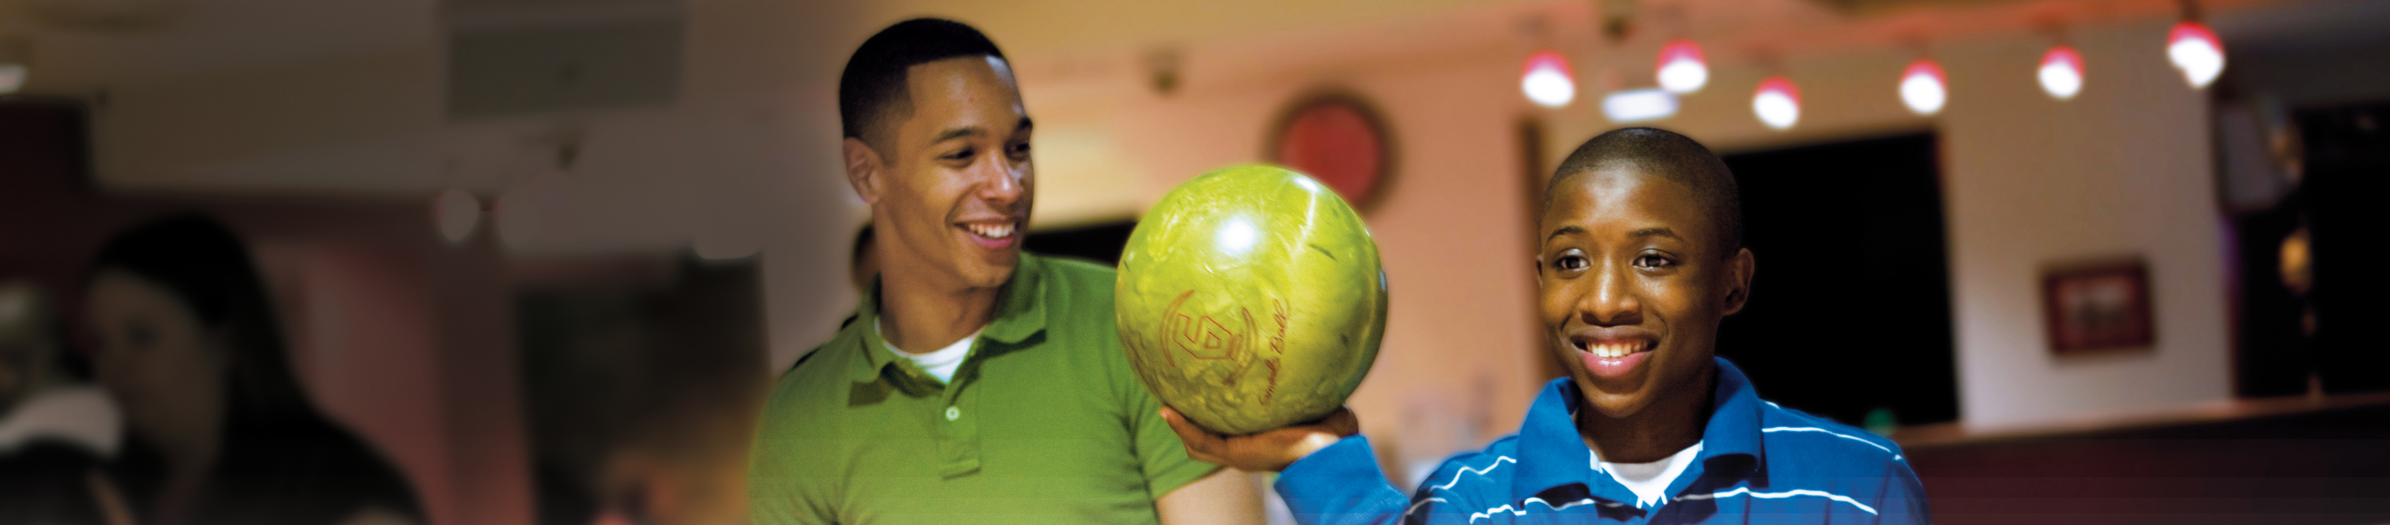




Stanton Lanes
Wilkes-Barre

March 23, 2013
9 a.m. – 5 p.m.

For more information, call:
570-824-8756
or
1-800-955-4376
Visit our website at:
www.bbbsnepa.org

Big Brothers Big Sisters is a program of Catholic Social Services
