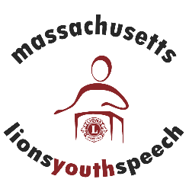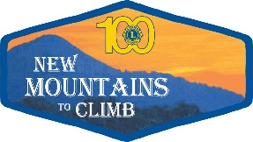

Sponsors Needed!
2016-2017 Lions District 33N Youth Speech Competition
Topic: Being Politically Correct: is it taken too far?
Looking for individuals, Lions Clubs, business owners and other organizations to help support this valuable program for high school students. All sponsorships will be recognized in program book and banner at the District 33N Youth Speech Competition on February 4, 2017.
Sponsorship Levels:
Spokesperson - $25.00
Motivator- $75.00
Keynoter- $150.00
Orator-$250.00
To become a sponsor, please complete the bottom portion and send along with your payment to Marie Wagner , P.O. Box 101, North Andover Ma. 01845. All checks should be made payable to Lions District 33n.
Name______________________ Phone_________________
Sponsorship Amount$____________ Please indicate how you would like your name to appear in program and on banner.
_____________________________________________________________

