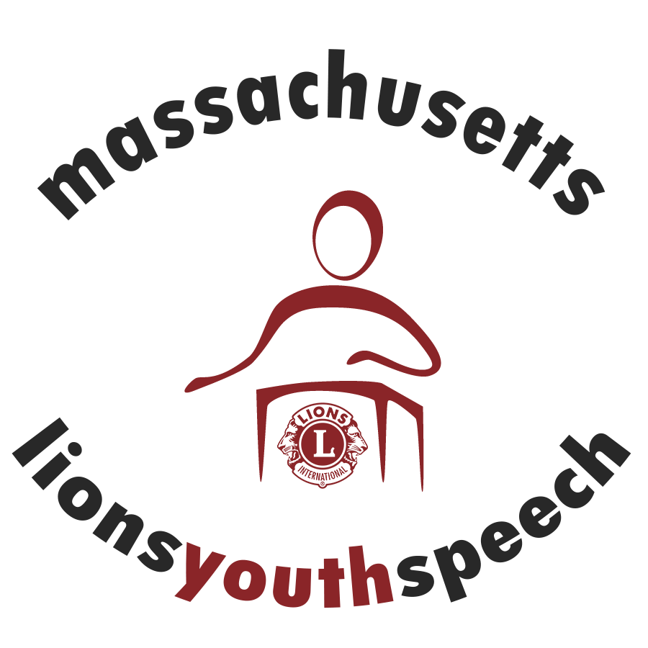

***2016-17 Youth Speech Competition***

* **Is your club interested in holding a Youth Speech competition? It’s easy! Visit lionsyouthspeech.org for competition guidelines and forms.**
* **Reach out to your local public/private high schools, advertise at your local library, etc.**
* **Schedule your competition. Notify District Chairperson Marie Wagner of the date, time and location of your competition.**
* **All Club competitions must be completed by 12/15/16. All Zone Competitions must be completed by 12/30/16. All Region Competitions must be completed by 1/15/17.**
* **If you need help planning your competition, please reach out to any member of the Youth Speech Committee and/or your Zone/region chair.**

**\*\*\*\*Sponsoring a club or zone speech competition gives your club Centennial Service Challenge credit for Engaging Youth\*\*\*\*\*\*\*\*\*\***