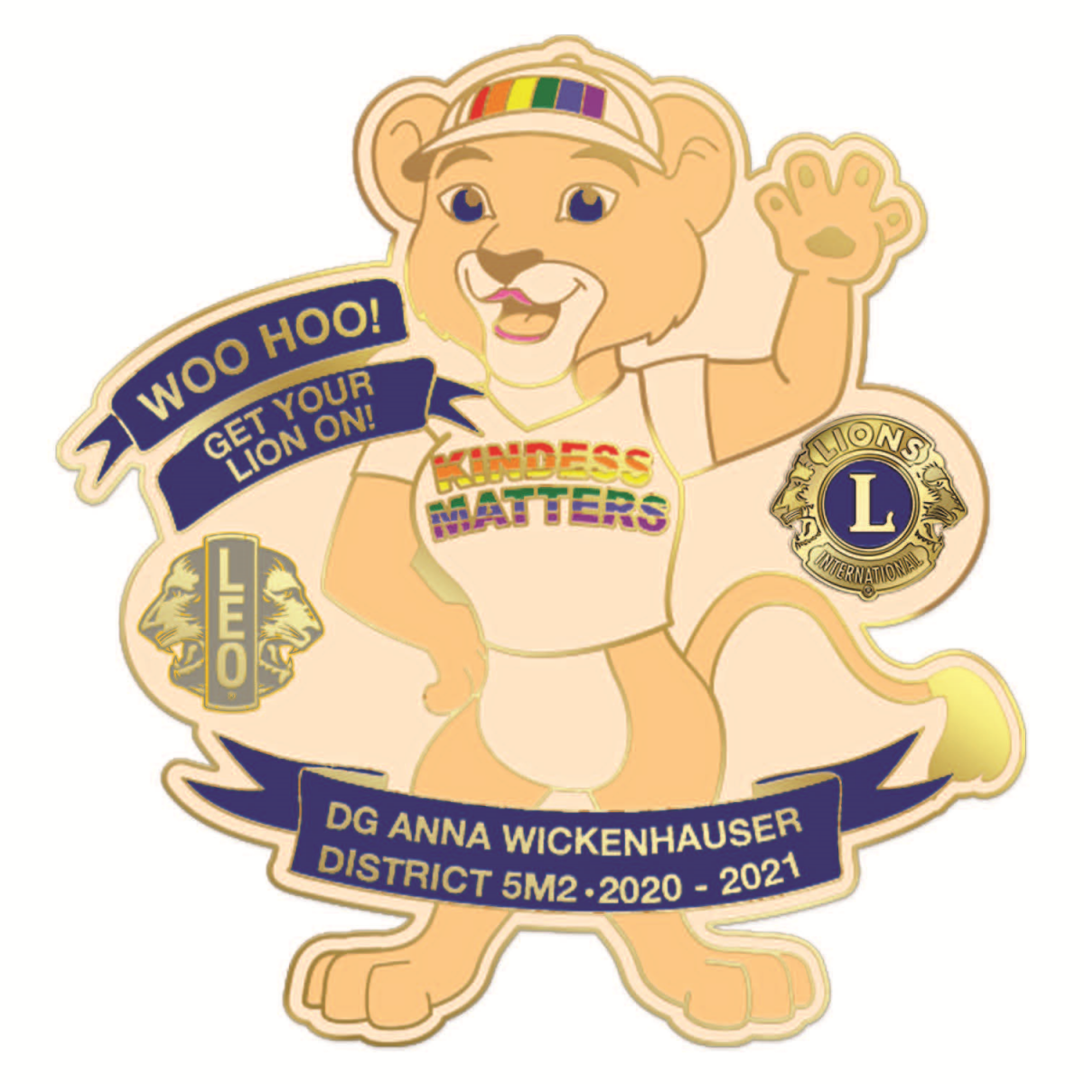
5M2 Club Request for Governor’s Visit

Fill out this form and send it to me at the address below. Dates fill fast. I will confirm your request as soon as I receive it.

Today’s date: ______________________

Club Name___________________________________________________

Name and address of meeting place location: _______________________

____________________________________________________________

Dates in order of preference: 1st_______________________________

2nd______________________________

Time of meeting: _____________ If social, time? ___________________

Dinner: Yes/No and Time______________________________________

Joint meeting with another club? Yes or No

Which club? __________________________________________________

Contact person: (Name, address, telephone, email)

List any functions you would like the Governor to do while present: (Awards, inductions, installation of officers, etc.)

Send this request to me at soon as possible:
DG Anna Wickenhauser
13650 Co. Rd. 41
Cologne, MN 55322
Cell Phone or Text: 952-913-1467
Email me at: lionannaw@gmail.com

