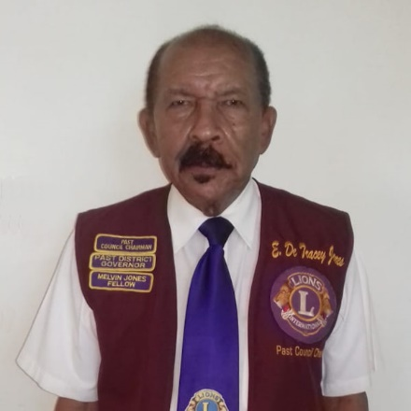
Edwin De Tracey Jones PMJF
Council Chairperson: 1994-1995
District Governor: 1993/1994

Past Council Chair Edwin “Tracey”, jointed the Association in 1975. His Home Club is the Lions Club of Barbados South of which he became the President in 1982/1983. He served as Zone and Region Chairperson in 1986/1987 and 1990/1991 and Cabinet Secretary Treasurer 1987/1988 and Council Secretary Treasurer in 1988/1989. Lion Tracey served as Multiple District Convention Chairperson in 1985/1986, Multiple District Leadership Development Chair in 1998/2001and as Multiple District Long Range Planning Chair 2002 to 2005.
PCC Tracey has received numerous awards including, over 30 years of awards from Club Presidents, Zone and Region Chairpersons, several District Governors and Council Chairperson Awards, award from International President Jean Behar and several Certificates of Appreciation from International President.
Professionally, he is the Managing Director of T.J. Auto Supplies Limited, an Importer and Distributor of Automobile Accessories. He is a Graduate of Combermere School in Barbados. Additionally, he has been trained as a Lions trainer through Lions International TRAIN THE TRAINER in St Vincent and the Grenadines in 1986 and the Lions International Four (4) day Leadership Development Training Course in the Cayman Islands May 1998.
Lion Tracey is happy to have hosted as District Governor 60B International President James Coffey on a four (4) day Official Visit to Jamaica in 1993/1994; and as Council Chair First International Vice President Judge Paterson on a three (3) day Official Visit to St Lucia

