IZETT MCCALLA, MJF
District Governor 2013-14
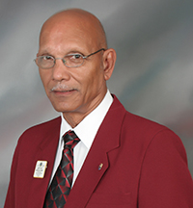
Lion Izett McCalla MJF, who hails from the island of Jamaica, has been elected to take over the leadership reins for the administrative year 2013 – 2014. A Lion for many years, he has served in many offices in the Lions Club of St. Andrew, Jamaica and has also served at the Cabinet level.
Today he joins his many predecessors who have walked this path.
It is said that Caribbean people often tend to see themselves as belonging to more than one Caribbean island and with Lion Izett’s over twenty (20) years in lionism, he sees himself fitting comfortably in this category.

