Professional Picture
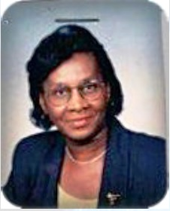
Joan Jordan MJF
District Governor 60B - 2008-2009
Lion Joan, Melvin Jones Fellow (1998) joined the Association in February,1988. She is a member of the Lions Club of Barbados East. She served as Club President in 1993-1994, in addition to serving as Vice President, Treasurer, Secretary, Membership Director, Leo Advisor and Chairperson of several Committees.
She also served as Zone Chairperson Zone 3A (Barbados) and Region Chairperson for Barbados, Grenada, St. Lucia and St. Vincent and the Grenadines, and has supported many District Governors as District Chairperson for several committees. She also was trained as a Lions Trainer.
For her dedication, Lion Joan has received recognition from all levels of the organization. She has received awards at Club level - Lion of the Year. At the level of the Zone she received Secretary and Leo Advisor of the year awards. At the District level, she received several District Governors’ appreciation awards. She supports the International and District Meetings by regularly attending them. She has also attended the Latin American and Caribbean Forum.
Professionally, Lion Joan worked in the Government Service, Ministry of Education as Personnel Officer, and Secretary Treasurer at a Secondary School in Barbados.
She is an avid sports enthusiast, and played both indoor and outdoor games. She enjoys listening to all types of music but prefers Jazz and “Oldie Goldies”.
She’s an active member at the St. Cyprian’s Church, in Barbados; she is a member of the Church Council, a member of the Ushers Guild, as well as the Health Ministry Committee.
Lion Joan is a mother of two children, grandmother of three – two (2 ) girls and one (1) boy) and great grandmother of one, a boy.

