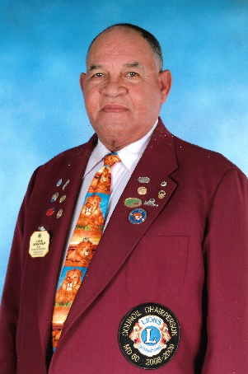
JOHN EBANKS
District Governor 2007-2008

John E. Ebanks PMJF, held the position of District Governor 60B in 2007-2008. He joined the association in March 6, 1973, and has been a member of the Lions Club of Grand Cayman since then. He has been an active Life Member since 1994. PCC Ebanks has held every position on the Board except Secretary and Treasurer, and headed several committees including Building, Fund Raising, Geriatrics, Social Services and Sight First, and Club LCIF Coordinator. He has been very active in District 60B through his chairmanship of several committees including Disaster and Safety, LCIF, Sight First, Geriatrics, Membership and Leadership, in addition to serving as Zone Chairperson (Zone 4B) and Region Chairperson (Region 4).
PCC Ebanks over his Lionistic career received many awards including four (4 )“Lion of the Year” awards; one “Invaluable Service” and one “Unselfish Dedication” from Leo Club of Grand Cayman. He received the “President of the Year” award in 1995-96; many “Lion of the Month” awards and many “President’s Awards”; He also received the “Journey for Sight” award. Lion Ebanks has received awards from outside of his club including:
- Tropical Gardens’ Club - “Invaluable Service” award in 1999;
- “Citation Award” in 1999 from Kingston Club;
- “Disaster Preparedness Award” from Cayman Brac Club in 1999 and Tropical Gardens Club in 2000;
- “LCIF Presentation” from Tropical Gardens Club in 2001, and
- “Leadership Development Presentation” award from Cayman Brac Club in 2001.
PCC John Ebanks is particularly proud of his accomplishments as a Lion especially Rejuvenating Sight Screening in Schools during his year as President of the Lions Club of Grand Cayman 1995-96 and serving as a Guiding Lion for 2 years (1998-2000) for the Lions Club of Cayman Brac which was very successful, during his year as Zone Chairperson in 1998-99.
Professionally Lion Ebanks is a Civil Engineer with specialization in Roads Construction. He has excelled here as in his Lionistic career. He received several certificates including: Nuclear Density Equipment from Bartow, Florida; Roads/Highways Construction, Miami, Florida; Equipment Management, Miami, Florida; APWA Nashville, Tennessee; APWA Orlando, Florida; Asphalt Concrete, Gainesville, Florida; APWA on Labour Management, St. Petersburg, Florida; Airport Runway Construction, Barbados, WI; and the Queen’s Certificate and Badge of Honor (Cert. Hon.)

