JUNE McCATTY, MJF
DISTRICT GOVERNOR 2010 – 2011
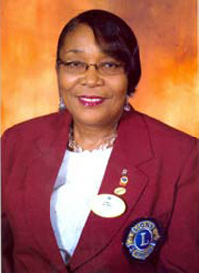
Today is a special day. Today I have the distinct honour and pleasure of introducing my friend, a daughter of the town of Mandeville, Jamaica, a mother, an educator and most importantly, an outstanding Lion.
Just about 30 years ago, I was introduced to the McCatty family. At that time our families had a lot in common. We were raising small children who attended the same school and we had husbands who worked with the same company. Very soon thereafter we added another layer to our association when we became members of the same Lions Club, the Lions Club of Mandeville.
Over the years many things have changed, but we have maintained a closeness that only some sisters are lucky enough to share. Our names have become synonymous and so we answer to each others’ name without missing even a single beat.
My sister has been a dedicated mother to her two children, Sohini and Diallo. and to many other children, including my three, who were always welcomed into her home with creative and tasty meals. I remember how she would pack her car with several children and travel the length and breath of Jamaica each summer.
This educator is now working as the Director of Belair Schools but started her career as a kindergarten teacher. She has taught at all levels in the education system in Jamaica and has excelled in each assignment
The Lions movement is a driving force behind this Lion. A Lion for over 28 years, she keeps a number of books in which she makes copious notes on plans and strategies she dreams up for the movement. In our Club she has served as President three times and has held every other position on the board of directors. Her first position at the District level was in 1988 and since then she has consistently been asked to serve on the Cabinet or to hold a District position. She has received numerous awards including Zone Chairman of the Year, Region Chairman Award, Lion of the Year and International President’s Service Award.
This marks Lion June McCatty’s passage into an arena for which she has prepared herself over many years. The words of a song come to mind “It’s been a long time coming, but it’s been worth the wait”.

