Professional Picture
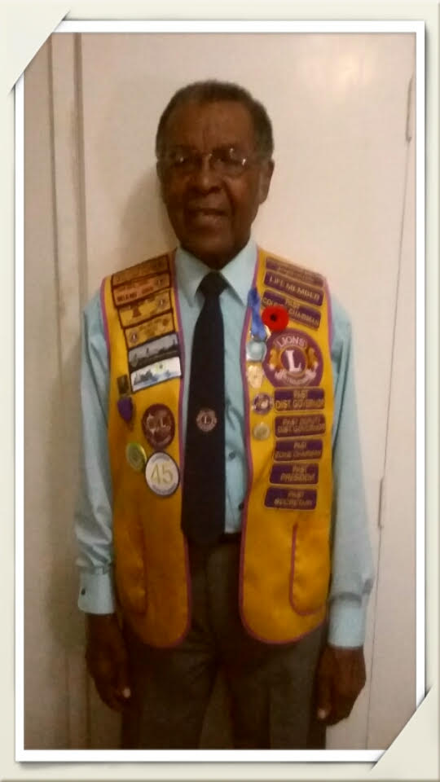
Karl G. Francis PMJF
Council Chair - 1990-1991
District Governor - 1989-1990

Profession: Retired
Past Council Chair, Karl Francis, Life Member joined the Association in 1969. He is a member of the Lions Club of North St Catherine.
At his club, PCC Karl served as Director, Secretary, 1st 2nd and 3rd Vice President and President. At the District Level he served as District-Lioness Chair, Zone Chair and Deputy District Governor.
Lion Karl received many awards including Lion of the year and notably at the end of his year as District Governor, Millennium Lion Award 2001.
PCC Karl was inducted into the Lioness movement in 1990.
Lion Karl is retired.

