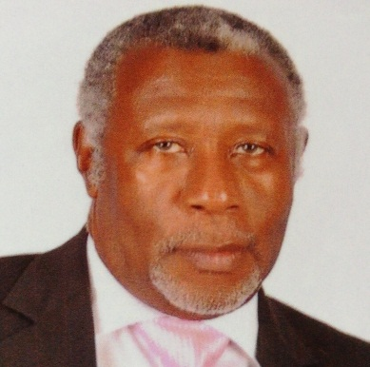

Past District Governor, Lindel U. Smith served as District Governor for District 60B in 2001-2002 He joined the association in 1984 and is a Member of the Mandeville Lions Club. Throughout his career as a Lion, PDG Lindel has had numerous accomplishments, including Lion of the year (1985), Region Chairperson (1995) and many District Governors’, Council Chairpersons” and International Presidents’ awards.
Lion Lindel Smith is an Attorney-at-Law by profession. He holds a Bachelor of Laws (Hons) Legal Education Certificate.

